Russian securities market: January to June 2010

Events and facts

Contents

Introduction 3
Major indicators and trends on the Russian stock market in the first half of 2010 5
1. Instruments 8
1.1. Stocks 8
1.2. Corporate bonds 16
1.3. Public, subfederal and municipal bonds, bonds of the Bank of Russia 25
1.4. Investment units 30
1.5. Futures and stock options and stock indices 32
1.6. Stock indices 40
Stock index 41
Bond index 46
Public bond index 48
Unit investment fund indices 50
2. Institutional Structure 51
2.1. Issuers. Public Offerings 51
2.2. Investors 53
a) Population 53
b) Unit investment Funds 55
c) Bank Managed Mutual Fund 59
d)Non-Governmental Pension Funds 60
e) Investment of Pension Assets 61
f) Commercial Banks 63
g) Foreign Investment Funds 64
2.3. Professional Participants on Securities Markets 65
a) Brokers, Dealers, Trust managers 66
b) Trading and Clearing Infrastructure 71
c) Accounting System 78
3. Regulatory framework and activities 80
Taxation at the Securities Market 87
3.1. Federal Financial Markets Service of Russia 89
3.2. The Central Bank of the Russian Federation 90
3.3. The Ministry of Finance of the Russian Federation 91
3.4. The Ministry of Healthcare and Social Development of the Russian Federation 91
3.5. Other State Authorities 92
3.6. Self-Regulatory Organizations 92
4. Calendar of the Main Events of the First Half of 2010 93

Introduction

We offer for your consideration the latest overview of the Russian securities market.
The purpose of such overviews we have been issuing twice a year since 2007 is to provide a generalized representation of the Russian stock market and its key elements such as instruments, players, infrastructure, regulatory and monitoring system, and major market events that took place during this period.
Reviews are prepared by Russian National Association of Securities Market Participants (hereinafter referred to as “NAUFOR”) with active participation of Moscow School of Management SKOLKOVO.
A few important notes are listed below:
Firstly, in the review we try to avoid comprehensive comments and evaluative judgments, except those that are required in order to understand the figures provided in the review, their dynamics, and peculiarities of the Russian securities market;
Secondly, in most cases we provide the figures as of at the end of June 2010. However, in some cases, when such figures were missing at the time of preparing the review, we provide the available figures that are the closest to this date;
Thirdly, we do not intend to demonstrate a long-term period of the development of the Russian market that precedes 2010. Taking into account temporary nature of the review, in most cases we provide the figures as of for 2009 – the first half of 2010. When necessary to show long-term trends we provide historical figures since 2005;
Fourthly, in the review numerical indicators are represented both in the national and a foreign currency. This is determined by the peculiarities of making transactions and representing their results;
Fifthly, in some cases we provide figures from various sources in order to demonstrate the existing differences in estimates or calculations.
When in table and in graphics, figures are presented as of the end of the period.
We thank MICEX Group, RTS Group, REGION Group, Stock Market Development Center, Standard&Poor’s, Interfax Business Service, CJSC, Interfax, CJSC (SPARK Database), Finmarket, CJSC (RusBonds project), DerEX, CBONDS and National Rating Agency for the provided materials and assistance.
Prepared by:

A. Tregub, Advisor of the Chairman of NAUFOR Board;

In association with:

A. Timofeev, Chairman of NAUFOR Board;

T. Manukova, Head of NAUFOR Legal Department;

S. Kondrashkin, Deputy Head of NAUFOR Legal Department;

D. Shubochkin, Chief Specialist of NAUFOR Department of Monitoring and Ensuring Professional Activities.

Copyrights for selecting and allocating materials belong to NAUFOR. Figures used in the preparation of this review were obtained from sources that NAUFOR and Moscow School of Management SKOLKOVO consider to be reliable. NAUFOR and Moscow School of Management SKOLKOVO shall not be liable for any possible losses that arise as a result of using the data contained in this review.

Disclaimer:

This review is intended strictly for informational purposes and is not an offer for making any transactions on the securities market. Estimates contained in the review are exclusively based on the opinions of its authors. The authors shall not be liable for any investment decisions of any third party that may cause any direct or indirect loss arising from the use of the data contained in this review by a third party.
In preparation of this review the sources were used that, by the informed judgment of the authors, are reliable and authoritative. Although the authors consider the figures obtained to be credible, they cannot guarantee their absolute accuracy.
The authors shall not be liable for updating the data contained in this review, or correcting any possible inaccuracies, on a regular basis.

Major indicators and trends on the Russian stock market in the first half of 2010

The previous two years became for Russian securities market a period of testing and examination of regulatory system, market infrastructure and market intermediaries in relation to the ability to operate under crisis conditions and post-crisis recovery. Throughout the period from the second half of 2009 to the beginning of 2010, the market gradually recovered after a deep fall. Along with this, since April a number of different events stopped growth of Russian market. As a result, there can be noted signs of stagnation in some sectors.

Stock market. In the first quartet of 2010 capitalization of the internal Russian stock market continued to grow, however in the second quarter there was noted its decrease. By the end of the half-year, capitalization comprised 704 billion dollars that is at 8 percent less than at the beginning of the year and at 47 percent less than in 2007 when capitalization had reached its historical maximum. Capitalization concentration both by issuers and by braches is trending downwards but still remains at a quite high level. Ten the most capitalized issuers account for 62 percent of capitalization. Capitalization of issuers, which belong to oil and gas production and processing, turned out to be below 50 percent for the first time, though slightly. The share of companies from financial field and metallurgy increased.
There are no significant changes in the number of stock issuers, which are traded both on domestic and foreign market that is about 330 companies. Internal exchange turnover of deals with stocks shows differently directed trends – drop on the first quarter and increase in the second one. At the end of the first half of 2010 total volume of deals (ignoring repos) comprised 7.9 trillion rubles that is at 20 percent less than in the second year of the previous year. The share of repos in internal exchange turnover of stocks was 48 percent.
Concentration of internal exchange turnover of some issuers’ stocks was and remains high, though it has a certain reducing tendency. The share of securities of ten the most liquid issuers in total turnover is 88 percent. The ratio between trading volumes of Russian companies’ stocks on domestic and foreign markets stays at the traditional level 70 to 30 percent.
Corporate bond market. Total volume of corporate bonds in circulation which are traded in internal market is tending upwards and has reached 2.6 trillion rubles that is at 5 percent more than six months ago. The number of market issuers of corporate bonds, on contrary, is reducing and has comprised 373 companies that is 8 percent less than the one at the beginning of the year. New issues of corporate bonds are offered extremely irregularly and largely depend on economic situation both in the country and abroad. In general total volume of offerings comprised 388 billion rubles that is at 40 percent less than the one for the second half of the previous year.
Exchange volume of deals with corporate bonds (ignoring repos) increased at 40 percent compared to the second half of 2009 and for six months comprised 2.2 trillion rubles. The share of repos in total exchange turnover of corporate bonds increased even greater and reached 79 percent. Average duration of corporate bonds rose to 670 days.
Corporate bonds defaults remain. Compared to the previous year the number of issues allowed different violations stayed at the same level, along with this volumes of outstanding liabilities reduced.
Public bond market and market of bonds of the Bank of Russia. Total volume of punlic bonds in circulation which are traded in internal market is tending upwards and has reached 1.5 trillion rubles that is at 5 percent more than six months ago. Exchange volume of deals with public bonds compared 257 billion rubles that at 4 percent less compared to the second half of 2009 г. Average duration of public bonds remained at the level in 160 days.
There was an abrupt jump of the volume of bonds of the Bank of Russia: for the half of 2010 it increased at 2.4 times almost to a trillion rubles.
Organized subfederal and municipal bond market. Total value of bonds of constituents of the Russian Federation and municipal bonds in circulation changes a little and by the end of the first half comprised 427 billion rubles. During a half of the year turnover of deals with these bonds increased at 7 percent compared to the second half of 2009 and reached 539 billion rubles. The share of repos in exchange turnover of subfederal or municipal bonds increased even greater and exceeded 90 percent.
Derivative market. Instrument base of exchange derivative contracts underlying asset of which is securities and stock indices is reducing and comprises 35 types of contracts. The main type of derivative contracts on the leading Russian exchanges is stock index futures – over 80% of turnover.
There can be noted stable growth of FORTS derivative market, for the first half of 2010 the volume of deals comprised 11.4 trillion rubles in money terms that is at 43 percent more compared to the second half of the previous year. FORTS future contract market has completely recovered and even risen compared to pre-crisis period. As for oprion market it remains at the level of 2007. The volume of open positions on FORTS market is recovering and by the end of the first half of 2010 has risen at 44 percent compared to the end of 2009. Nevertheless it remains at 50percent less than in the second quarter of 2008 when the volume of open positions reached its historical maximum. The ratio between volumes of open positions of RTS index future call and put options shows that during almost the whole year open positions of call option dominated.
MICEX derivative market shows expansive growth: at the end of the half the volume of deals increased in seven times compared to the second half of 2009 and comprised over 400 billion rubles.
At the beginning of 2010 it has been the first time when the ratio between the volume of market of derivative contracts and spot-market of underlying asset (ignoring repos) which are in circulation on the leading Russian stock exchanges exceeds 100 percent and by the end of the first half comprised 150 percent.
Stock indices. Consolidated stock indices were influenced by differently directed tendencies on, and upward potential typical for the previous year turned out to be lost. Since the mid April there appeared a downward tendency against negative news background which went on till the end of June. At the end of the half consolidated stock indices of “the first echelon” showed negative return (RTS index – less 14.7 percent per year, MICEX Index – less 8.9 percent per year). Along with this “the second echelon” held positive trend (RTS Index – 2 – 27.4 percent per year). As for branch indices oil and gas industry, chemical and petrochemical industry appeared to be in negative. Power industry and consumer sector showed the largest return.
During the half of the year stock indices of corporate bonds were trending upwards except for certain periods in May. Average return of bonds fall along with refinancing rate of the Bank of Russia except for certain periods in May and was anywhere from 8 to 11 percent.
Issuers. Public offerings. The number of stock issuers, which are traded in organized market, is reducing, though the number of issuers included in quotation lists has been stabilized. There is increase in the share of off-exchange deals with stocks and bonds on which professional participants of the securities market must report through stock exchanges. For the half of the year the average amount of such deals comprised 43 percent of total volume of deals; it is the maximum since the beginning of disclosure of information on off-exchange deals.
There can be noted a certain rally of initial and secondary public offerings of stocks. In accordance with different estimates for this half of the year, 13 companies performed offerings to the total amount in 3.9 billion dollars, particularly holding company RUSAL performed offerings on foreign floors to the amount in 2.2 billion dollars.
Special floors organized on the leading Russian stock exchanges to offer and circulate securities of innovative companies and companies with small capitalization showed minor volumes of offerings and secondary market.
Private investors. The rates of increase in the number of private investors operating on MICEX sharply reduced, and by the end of the half of the year, its number was 700 thousands that is just at 4 percent more than at the beginning of the year. In the first half of 2010, the number of active investors began to reduce.
Collective investors. During six months, the number of open-end unit investment funds reduced at 3 percent and the number of closed-end ones increased at 12 percent. About 67 percent of closed-end unit investment funds belong to funds for qualified investors. At the end of the half of the year, there were 1,154 unit investment funds in all. At the end of the half of the year, the cost of net assets of open and interval unit investment funds amounted to 100 billion dollars that is at 4 percent more that at the beginning of the year. However, compared to 2007 when the cost of net asset of open and interval unit investment funds reached its historical maximum, this amount is stall less at 78 billion rubles. In open unit investment funds, the net outflow of assets, which started in the second quarter of 2008, completed in the first half of 2010, now it is little more than 800 million rubles. This is incommensurably less than inflow, which was recorded in 2006–2007.
Non-state pension funds. The number of non-state pension funds settled down. At the end of six months, investment recourses rose at 14 percent and comprised 733 billion rubles.
Foreign investment funds. According to the data available, 2,128 foreign funds, which are obliged to disclose the details of their activities, invest in Russian assets (both local stocks and depository receipts). It is a little more than at the beginning of the year. There is can be noted increase in investments of such funds into Russian assets: for six months investments rose at 9.8 percent, the volume of securities of Russian companies in the funds’ assets is estimated as 85.2 billion dollars by the end of June, a quarter of which is purchased at Russian stock exchanges. Activity of specialized funds continues to increase (the share of Russian assets is over 75 percent) – during six months their number remained almost at the same level; however assets rose at 14 percent to 27.2 billion dollars.
Professional participants of the securities market. The number of professional participants of the securities market continues to reduce. Therefore, the number of different licences of professional market intermediaries reduced throughout the year at 10 percent at average. Among professional intermediaries, participants of the trade at stock exchanges, a high concentration by the volume of deals is observed.

1. Instruments

Stocks

Table 1 shows data from SPARK Database concerning issuers and issues of stocks.
Table 1
Stock issuers

Period | Number of stock issuers | including OJSC | Number of issues*
2005 | 460,352 | 62,960 | 463,206
2006 | 471,010 | 64,431 | 473,881
2007 | 481,372 | 65,706 | 483,244
2008 | 487,765 | 66,466 | 490,645
2009 | 522,968 | 72,601 | 525,905
1H10 | 526,584 | 72,960 | 529,557
Source: Interfax (SPARK Database)
Note: Number of issues specified without additional issues

In Russia the number of open joint stock companies rise every year. The first half of 2010 recorded slight increase in their number that is 0.5 percent compared to the beginning of the year. In accordance with laws of the Russian Federation each issues of every joint stock company (including the closed those) must be registered: that is why the bulk of stocks is absolutely illiquid. Stock exchanges present extremely small part of stock issuers. Table 2 shows summary data concerning stocks which are presented on Russian stock exchanges.
Table 2
Organized stock market

Period | MICEX |  | RTS
Period | Number of stock issuers | Number of stock issues (of joint stock companies) in quotation lists | Number of stock issuers | Number of stock issues (of joint stock companies) in quotation lists
2005 | 163 | 50 | 261 | 59
2006 | 190 | 60 | 281 | 76
2007 | 208 | 87 | 302 | 103
2008 | 231 | 101 | 275 | 110
2009 | 234 | 103 | 279 | 92
1H10 | 239 | 106 | 278 | 90
Sources: MICEX, RTS.

So stock exchanges present not over 0.5 percent of all open joint stock companies. This index remains almost unchanged during the recent years.
Since 2008 and till the end of the first half of 2010 there are no significant changes in the number of stock issuers which are traded on stock exchanges. The same situation exists in relation to the number of stocks in quotation lists. It should be noted that the most issues of stocks which are traded in internal organized markets (about 70 percent of total number) account for securities allowed for trading without listing procedure (out-of-list securities).
More than half of stock issuers are presented at one time on two main Russian stock exchanges: MICEX and RTS. Depository receipts representing stocks of a number of Russian issuers are traded on foreign exchanges. By estimate of Standard&Poor’s, the number of Russian issuers stocks of which are allowed for trading on RTS, MICEX, NYSE, NASDAQ and included in LSE-listed S&P EMDB Russia index comprises 336 company as at the end of June 2010; this index is slightly trending upwards from year to year.
Table 3 shows data concerning capitalization of Russian issuers’ stock market over 2005–2010 according to different estimates.
Table 3
Capitalization of Russian issuers’ stock market

Period | MICEX | RTS | S&P Estimate | GDP | Capitalization / GDP
Period | bln. rubles | bln. dollars | bln. dollars | bln. rubles | %
2005 | 9,304 | 329 | 549 | 21,625 | 43
2006 | 25,482 | 966 | 1,057 | 26,904 | 95
2007 | 32,740 | 1,329 | 1,503 | 33,103 | 99
2008 | 11,017 | 374 | 397 | 41,256 | 27
2009 | 23,091 | 763 | 861 | 39,016 | 59
Q1 10 | 24,684 | 841 | 975
Q2 10 | 21,964 | 704 | 801
Sources: MICEX, RTS, FSSS, S&P.

During the whole 2009 and the first quarter of 2010 stock market was recovering after crisis and average rate of growth of capitalization was up to 20 percent per quarter, however the second quarter of 2010 noted changes in this trend and be the end of the first half of 2010 capitalization of internal market reduced to 704 billion dollars that is about at 7 percent less than at the beginning of the year. In general capitalization remains at 47 percent less compared to the record year 2007.
Russian stock market is traditionally distinguished by quite a high capitalization concentration both by issuers and by braches to which these issuers belong. Table 4 shows the list of ten the most capitalized companies and table 5 – dynamics of changes in the share of ten the most capitalized companies over 2005–2010.
Table 4
The list of the most capitalized Russian issuers
(at the end of the first half of 2010)

 | Issuer | Capitalization (billion dollars) | The share in total capitalization (percent)
1 | ОАО Gazprom | 113.2 | 16.6
2 | OAO NK Rosneft | 65.8 | 9.6
3 | ОАО Sberbank of Russia | 55.2 | 8.1
4 | ОАО LUKOIL | 44.6 | 6.5
5 | ОАО Surgutneftegas | 35.6 | 5.2
6 | OAO MMC Norilsk Nickel | 28.2 | 4.1
7 | OAO Bank VTB | 25.7 | 3.8
8 | ОАО NOVATEK | 20.4 | 3.0
9 | OAO Gazprom Neft | 18.0 | 2.6
10 | ОАО NLMK | 15.5 | 2.3
TOTAL |  | 422.1 | 61.8
Total capitalization MICEX |  | 682.5 | 100.0
Source: MICEX

The list of ten the most capitalized issuers changes slightly, the same companies headed by ОАО Gazprom traditionally held the first five its positions.
In recent years concentration of capitalization of stock issuers slowly but steadily reduces: during for and a half years (since 2006 till the mid 2010) the share of ten the most capitalized companies declined almost at 17 items to 61.8 percent and the share of the most capitalized issuer OAO Gazprom reduced almost at twice – from 30.7 to 16.6 percent. At the end of six months of 2010 concentration of capitalization decreased by the beginning of the year at 3.5 and 2.8 items relatively.
Capitalization concentration decreases first of all at the expense of large initial and secondary public offerings carried out in 2006–2007 as well as of decrease in capitalization of companies from the oil and gas industry since 2009.
Table 5
The share of ten the most capitalized issuers
in total capitalization of stock market over 2005–2010
.
 | 2005 | 2006 | 2007 | 2008 | 2009 | 2010
 |  |  |  |  |  | Q1 | Q2
TOTAL (percent) | 77.7 | 78.5 | 68.5 | 69.3 | 65.3 | 62.2 | 61.8
incl. OAO Gazprom | - | 30.7 | 27.3 | 25.7 | 19.4 | 17.0 | 16.6
Based on MICEX data.

Table 6 shows data concerning branch capitalization of stock market in Russia over 2006-2010 by branches in dynamics.

Table 6
Industrial composition of capitalization of Russian stock market over 2006-2010 (percent)

No | Branch | 2006 | 2007 | 2008 | 2009 | 2010
 |  |  |  |  |  | Q1 | Q2
1 | Oil and gas industry | 62.6 | 50.4 | 57.0 | 50.1 | 45.5 | 45.5
2 | Financial services | 9.2 | 11.8 | 10.1 | 14.5 | 13.0 | 13.5
3 | Metallurgy | 8.1 | 11.1 | 10.0 | 12.3 | 14.4 | 13.7
4 | Power industry | 11.7 | 12.5 | 8.9 | 9.4 | 11.7 | 11.5
5 | Communications | 4.1 | 4.4 | 5.2 | 3.8 | 4.1 | 4.2
6 | Chemical industry | 0.2 | 1.5 | 1.5 | 1.6 | 1.5 | 1.9
7 | Transport | 0.8 | 1.2 | 1.8 | 1.2 | 1.3 | 1.2
8 | Sale | 0.6 | 0.7 | 0.7 | 1.1 | 1.3 | 1.5
9 | Coal industry | 0.1 | 0.3 | 0.2 | 1.0 | 1.3 | 1.1
10 | Engineering and metal-working | 0.8 | 1.1 | 0.7 | 1.0 | 1.4 | 1.4
11 | Food industry | 1.1 | 1.2 | 1.2 | 1.0 | 1.1 | 1.1
12 | Mining industry | 0.2 | 0.2 | 1.3 | 0.9 | 0.8 | 0.7
13 | Other branches | 0.2 | 2.3 | 0.9 | 1.8 | 2.6 | 2.7
Source: MICEX

The main tendency of recent years is decrease of share of companies specializing in the field of oil and gas production and processing in total capitalization: during four and a half year it reduced at 17,5 items and at the end of the first half of 2010 it is the first time when it has dropped below 50%. Also there can be noted considerable increase in capitalization of companies belonging to financial field and metallurgy. As for the rest there were no significant changes in industrial composition of capitalization.
Table 7 data characterizing trading volumes of Russian companies’ stocks at the leading stock exchanges over 2009–2010.
Table 7

Trading volumes of Russian issuers’ stocks

Period |  | 2009 |  |  |  | 2010
 | unit of measurement | Q1 | Q2 | Q3 | Q4 | Q1 | Q2
MICEX¹ | billion rubles | 5,901.9 | 7,485.8 | 7,086.9 | 7,400.2 | 6,520.7 | 7,800.2
incl. MICEX+ | billion rubles | - | - | - | - | 0.01 | 1.1
RTS² Classical market | billion dollars | 0.4 | 0.6 | 0.6 | 0.8 | 0.7 | 0.6
RTS² exchange market | billion rubles | 1.0 | 7.0 | 1.6 | 2.0 | 1.8 | 3.9
RTS² Standard market | billion rubles | - | 217.9 | 542.3 | 796.3 | 672.5 | 894.3
SPB SE² | billion rubles | 0.3 | 0.6 | 0.3 | 0.2 | 0.1 | 0.2
US dollar average rate for period (advisory) |  | 33.92 | 33.20 | 31.32 | 29.46 | 29.90 | 30.23
TOTAL (estimative) taking into account repos
 | billion rubles | 5,918.4 | 7,730.7 | 7,650.7 | 8,223.7 | 6,544.3 | 8,717.8
 | billion dollars | 174.5 | 232.9 | 244.3 | 279.1 | 218.9 | 288.4
The share of repos |  | 67.4% | 46.8% | 36.6% | 38.5% | 49.4% | 47.0%
TOTAL (estimative) ignoring repos
 | billion rubles | 1,926.8 | 4,116.3 | 4,852.0 | 5,058.7 | 3,309.4 | 4,620.1
 | billion dollars | 56.8 | 124.0 | 154.9 | 171.7 | 110.7 | 152.8
S&P Estimate | billion dollars | 84.3 | 161.3 | 205.6 | 231.3 | 192.4 | 216.2
Turnover ration (quarter)³ | % | 14.7 | 23.2 | 23.0 | 22.5 | 13.2 | 21.7
Sources: the Bank of Russia, MICEX, RTS, S&P.
Note to table 7:
- For trades on MICEX auction mode, mode of negotiated deals and repos are taken into account. Deals in procedure of initial offering are ignored.
- For trades on RTS and SPB SE market, two-sided deals and repos are taken into accoun. Deals in procedure of initial offering are ignored.
- Turnover coefficient is considered as ratio between volume of deals (ignoring repos) over a period (year, quarter) and capitalization at the end of a period.

In the first half of 2010 turnovers continued to grow as since the mid 2009 except for the first quarter of 2010. As the result total volume of deals with Russian companies’ stocks in internal market in the first half of 2010 (ignoring repos) comprised 7,929 billion rubles that is at 20 percent less than the one for the second half of the previous year.
Attention should be paid to dynamics of changes in the share of repos with stocks (see table 7 and fig. 1). In the first half of 2010 repos continued to grow and at the end of the half the share of repos with stocks in total volume of deals with stocks comprised 48 percent. It is evidence of the fact that internal exchange stock market is used to a great extend as money market against securities.
The share of repos with securities in internal exchange market
stocks
corporate bonds
bonds of constituents of the Russian Federation
municipal bonds
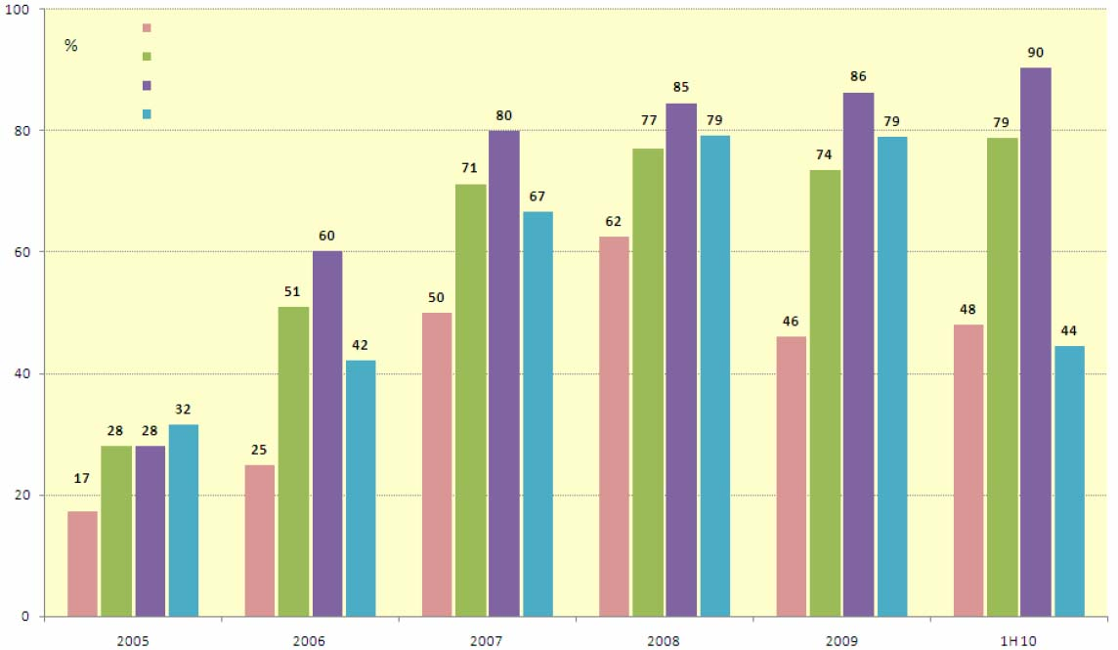
Source: MICEX, RT
Fig. 1

Stock trade is focused on quite limited range of instruments. Table 9 shows data concerning dynamics of changes in the stock of ten the most traded stock issuers for the recent years, table 8 contains the list of issuers deals with stocks of which on MICEX in the first half of 2010 were the most active (taking into account repos).
Table 8
The list of issuers deals with stocks of which on MICEX
were the most active
(at the end of the first half of 2010)

No | Issuer | The share in total volume (percent)
1 | ОАО Sberbank of Russia | 27.4
2 | ОАО Gazprom | 26.8
3 | ОАО LUKOIL | 7.7
4 | OAO MMC Norilsk Nickel | 7.0
5 | OAO NK Rosneft | 6.0
6 | OAO Bank VTB | 4.4
7 | ОАО Surgutneftegas | 3.1
8 | ОАО RusHydro | 2.2
9 | ОАО Stock Company Transneft | 2.1
10 | ОАО Tatneft | 1.5
 | TOTAL | 88.2
Source: MICEX

Table 9

The share of ten issuers deals with stocks of which
were the most active over 2005–2010.

 | 2005 | 2006 | 2007 | 2008 | 2009 | 1H10
TOTAL (percent) | 95.9 | 94.8 | 92.0 | 92.0 | 91.7 | 88.2
incl. OAO Gazprom | - | 32.0 | 28.4 | 31.9 | 24.7 | 27.4
incl. OAO Sberbank of Russia | 5.4 | 6.1 | 11.1 | 13.6 | 26.1 | 26.8
Based on MICEX data.

Concentration of deals with stocks remains extremely high, though it has a tendency towards weakening: at the end of the first half of 2010, the share of ten most liquid issuers comprised 88.2 percent, which is 3.5 items less that the one at the beginning of the year. The list of the most liquid stock issuers changes a little. In the first half of 2010 ОАО Sberbank of Russia leaded in liquidity which continues the tendency appeared in 2009.
Relation between roles of domestic and foreign trading floors in the overall structure of Russian stock turnover is a matter of substance for Russian securities market (see fig. 2).
Trading volumes of depositary receipts and stocks of Russian companies depositary receipts of which are traded in foreign exchanges
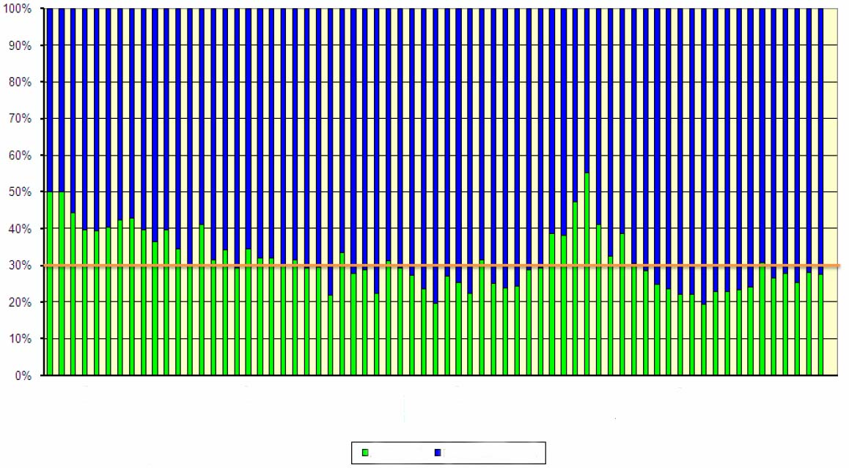
ADR,GDR Russian exchanges
Dec 04 | March 05 | June 05 | Sept 05 | Dec 05 | March 06 | June 06 | Sept 06 | Dec 06 | March 07 | June 07 | Sept 07 | Dec 07 | March 08 | June 08 | Sept 08 | Dec 08 | March 09 | June 09 | Sept 09 | Dec 09 | March 10 | June 10

Source: MICEX
Fig. 2
In the first half of 2010 like in previous four years except for crisis period in autumn 2008, relation trading volumes on domestic and foreign exchanges was at average 70 to 30 percent with certain fluctuation this or other way.

Corporate bonds

During the first half of 2010 the number of market issuers and market issues continued tending to decline as since 2007–2008 (see table 10).
Table 10

Number of corporate issuers and issues

period | Number of bond issuers | Number of bond issues
2004 | 168 | 199
2005 | 230 | 302
2006 | 370 | 488
2007 | 465 | 607
2008 | 463 | 650
2009 | 405 | 630
Q1 10 | 392 | 623
Q2 10 | 373 | 610
Source: CBONDS.
In the end of June 2010 the number of market issuers comprised 373 companies and the number of market issues was 610 that is relatively at 7.9 and 3.2 percent less than those at the beginning of the year. It should be noted that the number of issuers reduced greater than the number of issues.
Fig. 3 shows monthly diagrams of size corporate bond market (issues by nominal value in place) over 2009–2010 and table 11 does summary data at the end of the years 2005–2010 (both market and non-market issues).
Size of internal debt market
(at nominal value)
million
rubles
Corporate bonds
Subfederal and municipal bonds
Public bonds (incl. bonds of the Bank of Russia)
Jan 2009Feb 2009March 200-Apr 2009May 2009June 2009July 2009Aug 2009Sept 2009Oct 2009Nov 2009Dec 2009Jan 2010Feb 2010March 200-Apr 2010May 2010June 2010

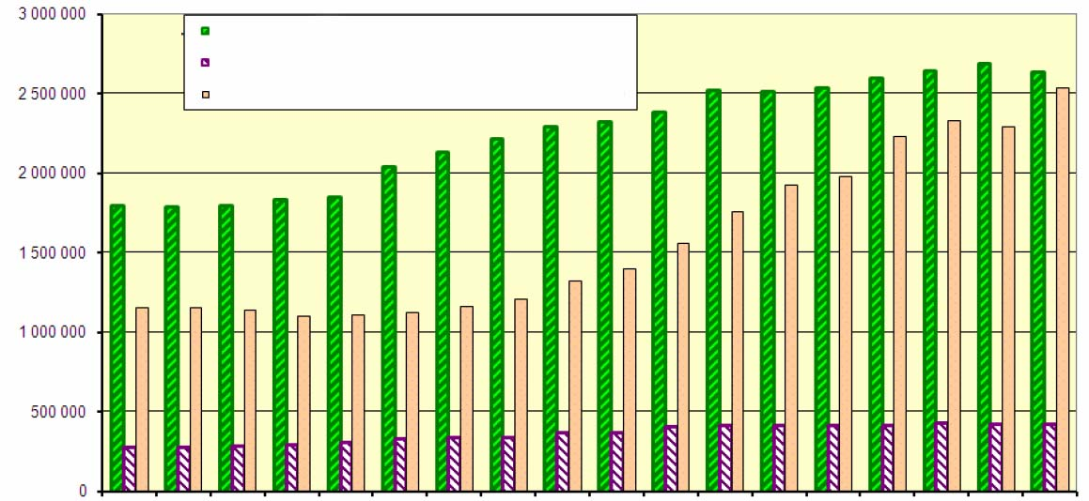

Source: CBONDS
Fig. 3
Table 11

Size of corporate bond market

Period | Size of corporate bond market | Size of corporate bond market / GDP
Period | bln. rubles | %
2005 | 481 | 2.23
2006 | 902 | 3.35
2007 | 1,257 | 3.80
2008 | 1,597 | 3.84
2009 | 2,526 | 6.48
Q1 10 | 2,600
Q2 10 | 2,643
Sources: CBONDS, Federal State Statistic Service.

In 2010 corporate bond market continued to grow since February till May at the average rate 1.5 percent per month; however June made apparent a slight drop. As a result at the end of the first half of 2010 volume of corporate bonds in circulation comprised 2,643 billion rubles, that is at 4.6 percent more than the one at the beginning of the year. In is characteristic that in 2010 the share of non-market issues tended to gradually reduce and by the end of the first half comprised 7.6%. In 2005–2007 this rate was 0.5 percent of total volume of corporate bonds in circulation at nominal value.
New issues of corporate bonds are offered extremely irregularly and largely depend on economic situation both in the country and in the world. Table 12 shows data concerning offering (summarily market and non-market issues) over 2009–2010.
Table 12
The offering of new issues of corporate bonds

Period | Volume of offering | Number of issuers | Number of issues
Period | bln. rubles | items | items
Q1 09 | 54 | 4 | 13
Q2 09 | 300 | 19 | 41
Q3 09 | 305 | 15 | 55
Q4 09 | 351 | 30 | 66
Q1 10 | 184 | 13 | 31
Q2 10 | 204 | 17 | 40
Source: CBONDS.

2010 noted middle offerings of corporate bonds, in some months, particularly in May; offerings were made in a limited volume. In general in accordance with CBONDS data at the end of the first half the volume of initial offerings comprised 388 billion rubles that is at 40 percent less than the one as for the second half of the previous year.
Fig. 4 shows monthly diagram of trading volumes (both exchange and off-exchange) in internal debt market in 2009-2010, table 13 shows summary data at the end of every year.
Total trading volume in internal debt market
(monthly)

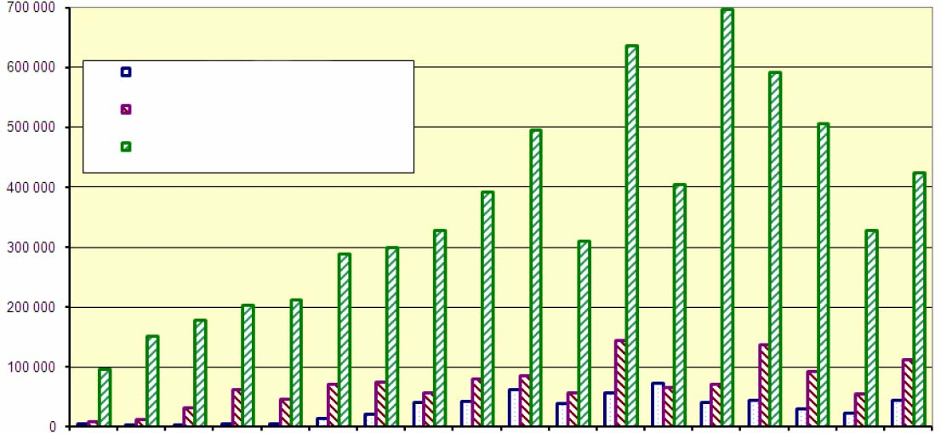
Public bonds
Subfederal and municipal bonds
Corporate bonds
million rubles

Jan 2009 | Feb 2009 | March 200- | Apr 2009 | May 2009 | June 2009 | July 2009 | Aug 2009 | Sept 2009 | Oct 2009 | Nov 2009 | Dec 2009 | Jan 2010 | Feb 2010 | March 200- | Apr 2010 | May 2010 | June 2010

Source: CBONDS
Fig. 4
Table 13
Volume of deals with corporate bonds

Period | Total turnover | The share of exchange deals in total turnover (estimative)
Period | bln. rubles | %
Q1 09 | 430 | 69
Q2 09 | 707 | 77
Q3 09 | 1,022 | 76
Q4 09 | 1,446 | 59
Q1 10 | 1,696 | 69
Q2 10 | 1,261 | 88
Source: CBONDS.
Note: Ignoring repos.

At the beginning of 2010 the volume of deals with corporate bonds continued to grow as since the second half of the previous year. Peak of turnovers accounted for February, when there was noted the record monthly volume of deals with corporate bonds. In accordance with CBONDS data it comprised almost 700 billion rubles. However March made visible recession in turnovers of corporate bonds. In general at the end of the first half of 2010 total volume of deals comprised 2,957 billion rubles that is at 20 percent more that the one in the second half of the previous year.
Russian internal corporate bond market has been developing mainly as exchanging market from the very beginning. During the second quarter of 2010 the share of exchange deals considerable increased compared to the second half of the previous year to 88 percent.
Exchange trade of corporate bonds is engaged at MICEX and RTS. Table 14 shows summary data concerning corporate bonds (including exchange bonds) which are traded on these Russian stock exchanges, table 15 shows data concerning bond trading volumes on MICEX in 2005-2010.
Table 14
Organized corporate bond market

Period | MICEX |  |  | RTS
Period | Number of bond issuers | Number of bond issues | including those in quotation lists (issuers/issues) | Number of bond issuers | Number of bond issues | including those in quotation lists (issuers/issues)
2005 | 202 | 250 | 46/62 | 4 | 4 | 1/1
2006 | 316 | 414 | 69/98 | 77 | 118 | 0/0
2007 | 445 | 577 | 149/207 | 79 | 120 | 0/0
2008 | 455 | 622 | 198/280 | 74 | 108 | 2/2
2009 | 418 | 702 | 167/317 | 57 | 78 | 3/3
1H10 | 391 | 681 | 172/342 | 63 | 84 | 2/2
Sources: MICEX, RTS.

So comparison of tables 10 and 14 show that organized market presents about 95 percent of all issues of corporate bonds.
With reference to MICEX data it can be noted that in the first half of 2010 the number of bond issuers continues tending to decline as since 2009. Along with this in the first half year of 2010 there was noted increase in the number of bond issuers in quotation lists.
Table 15
Corporate bond trading volumes on MICEX
Period | Corporate bonds |  | the share of repos in the volume of deals with corporate bonds
Period | Ignoring REPOs | With REPOs
Period | bln. rubles |  | %
Q1 09 | 300.4 | 907.3 | 66.9
Q2 09 | 553.8 | 1,3427 | 58.8
Q3 09 | 760.6 | 3,016.1 | 74.8
Q4 09 | 847.8 | 4,015.3 | 78.9
Q1 10 | 1,177.7 | 4,559.4 | 74.2
Q2 10 | 1,060.3 | 5,958.9 | 82.2
Source: MICEX

At the end of the first half of 2010 total volume of exchange deals with corporate bonds (ignoring repos) comprised 2,238 billion rubles that is at 40 percent more than the one for the second half of the previous year. The tendency which had appeared in recent years and continued in 2010 became sharp increase in volumes of repos in secondary turnover of corporate bonds (see fig. 1 and table 15). In the first half of 2010 the volume of repos comprised 78.7 percent. Thus organized corporate bond market as well as stock market is used to a great extend as money market against securities.
Corporate bond market is characterized by small concentration of trade volume. Table 16 shows data concerning ten bond issues exchange deals with which were most active in 2010.

Table 16
The list of corporate bond issues deals with which on MICEX were most active
(at the end of the first half of 2010)

No | Security | Issuer | The share in total volume (percent)
1 | Transnft 03 | ОАО Stock Company Transneft | 5.6
2 | Russian Railways – 10 bonds | ОАО Russian Railways | 3.6
3 | Sibmetin02 | ООО SIBMETINVEST | 3.0
4 | Sistema-03 | ОАО JSFC Sistema | 3.0
5 | Russian Railways – 23 bonds | ОАО Russian Railways | 2.6
6 | Sistema-02 | ОАО JSFC Sistema | 2.3
7 | Russian Railways – 18 bonds | ОАО Russian Railways | 2.1
8 | RZD BO-1 | ОАО Russian Railways | 2.0
9 | GazpromА13 | ОАО Gazprom | 2.0
10 | Russian Railways – 15 bonds | ОАО Russian Railways | 1.9
Total |  |  | 28.1
Based on MICEX data.

Therefor the secondary corporate bond market is focused on separate instruments to much lesser extent than the stock market. It should be however noted that concentration of deals with corporate bonds has a growth tendency. So in the first half of 2010 the share of ten the most liquid stock issues rose to 28 percent whereas at the end of the previous year it was 25 percent. It should be also stressed that the list of the most liquid corporate bonds was subject to more noticeable changes than the list of the most liquid stocks.
Compared to the previous year in the first half of 2010 duration of corporate bonds demonstrated a growth tendency (see details in section 1.6) and rose at 60 percent at average to the level in 670 days.
In 2008 a new instrument, exchange bonds, appeared in corporate bond market. The issue of exchange bonds does not require state registration and placement report, these functions are transferred to stock exchange which significantly shorten the period from decision to issue to commence of secondary trading session. The volume of deals with exchange bonds is trending upwards. The first half of 2010 noted further increase in the volume of trade in exchange bonds; turnover (taking into account repos) for six months was recorded at the level in 1,735 billion rubles that is over 16 percent in the total turnover of corporate bonds. One of issues of corporate bonds is included in the list of the most liquid instruments (see table 16).
Up to 2008 corporate bond defaults had an isolated nature. In 2008–2009 there appeared in corporate bond market a negative tendency related to the fact that a number of issuers had turned out to be unable to meet their liabilities in proper time and completely.
Tables 17.1 and 17.2 show data concerning number of bond issues, number of issuers and volumes of outstanding liabilities in 2010.
Table 17.1
Violations of corporate bond liabilities by issuers when performance
(number of issues and issuers of bonds)

Number of bond issues |  |  |  |  |  | Number of issuers
 | Default | Non-fulfilment of offer | Delay in fulfilment of offer | Technical default | Final total | Number of issuers
1H10 |  |  |  |  |  | 57
Total | 94 | 8 | 1 | 19 | 122
Coupon | 75 | 0 | 0 | 11 | 86
Offer | 0 | 8 | 1 | 0 | 9
Redemption | 19 | 0 | 0 | 8 | 27
Source: CBONDS.

Table 17.2
Violations of corporate bond liabilities by issuers when performance
(volume of outstanding liabilities, million rubles)

 | Default | Non-fulfilment of offer | Delay in fulfilment of offer | Technical default | Final total
1H10
Total | 21,995 | 3,826 | 649 | 5,424 | 31,893
Coupon | 5,327 | 0 | 0 | 404 | 5,731
Offer | 0 | 3,826 | 649 | 0 | 4,475
Redemption | 16,667 | 0 | 0 | 5,020 | 21,688
Source: CBONDS.

In the first half of 2010 the number of issuers which had allowed violations of different nature remained on the whole at the level of the previous year but volumes of outstanding liabilities reduced.

Public, subfederal and municipal bonds, bonds of the Bank of Russia

Fig. 5 shows monthly diagrams of size of internal public debt market in 2009-2010, table 18 shows summary data at the end of every year.

million rubles

Bond of the Bank of Russia
Public bonds
Size of internal public debt market
(at nominal value)
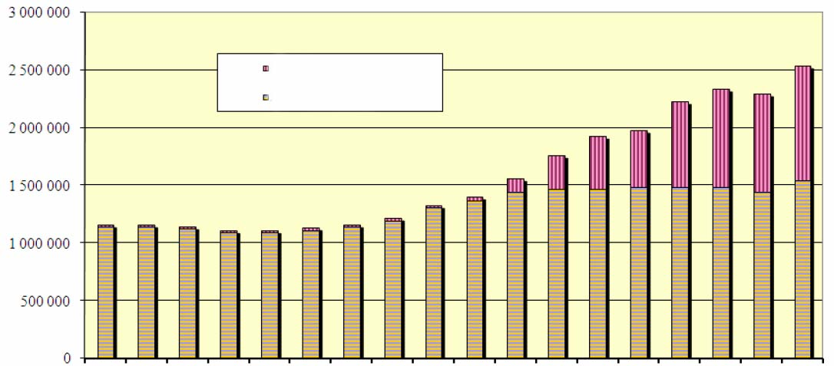
Jan 2009 | Feb 2009 | March 200- | Apr 2009 | May 2009 | June 2009 | July 2009 | Aug 2009 | Sept 2009 | Oct 2009 | Nov 2009 | Dec 2009 | Jan 2010 | Feb 2010 | March 200- | Apr 2010 | May 2010 | June 2010

Source: CBONDS
Fig. 5

The first half of 2010 noted slight increase expect for jump in June whereas in 2009, especially in the second half, the rate of increase in volume of public bonds in circulation had been up to 5 percent per month.
Table 18
Size of public bond market

Period | Size of public bond market | Size of public bond market / GDP
Period | bln. rubles | %
2005 | 722 | 3.34
2006 | 876 | 3.25
2007 | 1,047 | 3.16
2008 | 1,144 | 2.75
2009 | 1,470 | 3.77
Q1 10 | 1,487
Q2 10 | 1,542
Source: CBONDS.

In accordance with CBONDS data at the end of the first half of 2010 volume of public bonds which are traded in the internal market comprised 1,542 billion rubles at nominal value that is just 5 percent more than at the beginning of the year.
The size of secondary market and liquidity of public bonds are small compared to corporate bond market (see fig. 4) Public bond market is organized on MICEX. Table 19 shows data concerning turnover of public bond market in 2009-2010.
Table 19

Volume of deals with public bonds

Period | Public bonds
Period | bln. rubles
Q1 09 | 12.7
Q2 09 | 27.5
Q3 09 | 108.3
Q4 09 | 159.8
Q1 10 | 158.9
Q2 10 | 98.7
Source: CBONDS.

Analysing data from tables 15 and 19 shows that despite commensurability of volume of offerings at nominal value turnover of public securities is by one order less compared to corporate bonds.
In the first quarter of 2010 volume of deals remained at the level of the previous quarter but the second quarter recorded decline at 37 percent. As a result at the end of the first half of 2010 volume of deals with public bonds comprised 257 billion rubles that is at 4 percent less than the one as of the second half of 2009.
In the first half of 2010 public bond duration remained at the level as of at the end of the previous year (see details in section 1.6) and comprised 1,600 days at average.
2010 saw cardinal increase in volume of bonds of the Bank of Russia (see fig. 5). Increase in issues of these bonds began in November 2009 and continued during the whole first half of 2010. In accordance with CBONDS data, in the end of June volume of bonds of the Bank of Russia in circulation reached 999.8 billion rubles that is 2.4 times as of at the beginning of the year.
Bonds of constituents of the Russian Federation and municipal bonds are exceeded on volumes of issues both to public and corporate bonds (see fig. 3). In accordance with CBONDS data at the end of the first half of 2010 volume of subfederal and municipal bonds which are traded in the internal market comprised 427.3 billion rubles at nominal value.
Table 20 shows total volume of deals with subfederal and municipal bonds over 2000-2010.
Table 20
Volume of deals with subfederal and municipal bonds

Period | Total turnover | The share of exchange deals in total turnover (estimative)
Period | bln. rubles | %
Q1 09 | 55.6 | 74.5
Q2 09 | 181.1 | 87.3
Q3 09 | 213.5 | 89.4
Q4 09 | 290.5 | 85.7
Q1 10 | 275.4 | 88.4
Q2 10 | 263.1 | 77.4
Source: CBONDS.

The first half of 2010 is distinguished with stable and relatively hign tirnover, volume of deals summarily comprised 539 billion rubles that is at 7 percent more that for the second half of the previous year.
The share of exchange deals in total turnover of subfederal and municipal bonds is traditionally high and does not go below 70 percent, except for the end of 2008 when the share of exchange deals dropped to 58 percent due to signs of a crisis.
Exchange trade of subfederal and municipal bonds is engaged at MICEX and RTS. Table 21 shows summary data concerning subfederal and municipal bonds which are traded on Russian stock exchanges, table 22 show data concerning volumes of trade of these bonds on MICEX¹⁰.

Table 21
Organized subfederal and municipal bond market.

Period | MICEX |  |  | RTS
Period | Number of bond issuers | Number of bond issues | Number of bond issues in quotation lists (emitters/issues) | Number of bond issuers | Number of bond issues | Number of bond issues in quotation lists (emitters/issues)
2005 | 41 | 90 | 22/53 | 2 | 16 | 1/1
2006 | 50 | 105 | 22/49 | 14 | 35 | 0/0
2007 | 59 | 116 | 27/49 | 16 | 30 | 0/0
2008 | 45 | 116 | 27/53 | 10 | 21 | 0/0
2009 | 40 | 107 | 20/52 | 6 | 14 | 0/0
1H10 | 44 | 101 | 23/53 | 6 | 12 | 0/0
Sources: MICEX, RTS.

The first half of 2010 saw turning point of the tendency to decrease in number of issuers of subfederal and municipal bonds traded on stock exchanges which had appeared in 2008–2009.

Table 22
Trade volume of subfederal and municipal bonds
on MICEX

period | Bonds of constituents of the Russian Federation and municipal bonds |  | The share of repos in volume of deals with municipal bonds
period | without repo | with repo | The share of repos in volume of deals with municipal bonds
period | bln. rubles |  | %
Q1 09 | 39.2 | 183.4 | 78.6
Q2 09 | 115.7 | 599.9 | 80.7
Q3 09 | 161.5 | 1,392.1 | 88.4
Q4 09 | 247.3 | 1,907.2 | 87.0
Q1 10 | 212.7 | 1,775.1 | 88.0
Q2 10 | 185.1 | 2,261.2 | 91.8
Source: MICEX
At the end of the first half of 2010 volume of exchange deals with subfederal and municipal bonds (ignoring repos) comprised 397.8 billion rubles that is at 2.7 percent less than the one for the second half of the previous year.
The share of repos (see table 22 and fig. 1) in total exchange turnover of deals with subfederal and municipal bonds is trending upwards: it increased more than in three times compared to 2005 and exceeded 90 percent level. It should be noted that in 2010 the share of repos reduced to 45 per sent as for municipal bonds whereas it exceeded 92 percent as for subfederal bonds. Thus subfederal bond sector actually became money market against securities.

Investment units

Exchange trade of investment units is engaged at MICEX and RTS. Table 23 shows summary data concerning investment units which are offered on Russian stock exchanges, table 24 shows data concerning trading volumes of units.

Table 23
Organized investment unit exchange market

Period | MICEX |  |  | RTS
Period | Number of managing companies | Number of unit investment funds | including those in quotation lists (managing companies / unit investment funds) | Number of managing companies | Number of unit investment funds | including those in quotation lists (managing companies / unit investment funds)
2005 | 33 | 69 | 3/4 | 6 | 18 | 1/1
2006 | 48 | 114 | 4/4 | 10 | 22 | 3/3
2007 | 88 | 219 | 20/30 | 15 | 38 | 6/7
2008 | 99 | 306 | 25/43 | 23 | 49 | 8/11
2009 | 104 | 312 | 17/30 | 21 | 47 | 4/5
1H10 | 105 | 317 | 24/35 | 19 | 40 | 3/3
Sources: MICEX, RTS.

In the first half of 2010 number of unit investment funds, which are traded on stock exchanges, remained at the level of previous two years and comprised about 30 percent of total number of unit investment funds. The number of funds in quotation lists increased and returned at pre-crisis level.

Table 24
Trading volumes of investment units on MICEX and RTS

Period | Investment units
Period | bln. rubles
Q1 09 | 4.3
Q2 09 | 1.8
Q3 09 | 4.2
Q4 09 | 5.9
Q1 10 | 4.6
Q2 10 | 4.2
Sources: MICEX, RTS.

By tradition, exchange turnover of investment units is distinguished by a wide scatter of volumes of deals, from month to month amount of deals may change in 2–4 times. During the first half of 2010 exchange turnover of investment units was at the level somewhat below as one at the second half of the previous year.
Table 25 shows the list of the most liquid unit investment funds among those which are traded on MICEX.
Table 25
The list of unit investment funds deals with units of which were most active on MICEX (at the first half of 2010)

No | Managing company | Name of unit investment fund | The share in total volume (percent)
1 | ООО Managing Company YugraFinans | Closed-end investment fund ”YugraFinans - Nedvizhimost 2” | 15.4
2 | ZAO Managing company RWM Capital | Closed-end investment fund “Magistral” | 15.1
3 | OOO Managing company OLMA-FINANCE | Closed-end investment fund “Atlant” | 13.8
4 | ООО Managing Company YugraFinans | Closed-end investment fund “Territoriya Yugra” | 10.4
5 | ZAO Managing company Kollektivnye investitsii | Closed-end investment fund “Strategicheskie investitsii No. 2” | 10.1
6 | ОАО Managing company Evrofinansy | Closed-end investment fund “Proektny” | 7.0
7 | ZAO Managing company TradingInvestComp | Closed-end investment fund “Mozhaysky bereg” | 4.8
8 | ZAO Managing company RWM Capital | Closed-end investment fund “RMW Otel” | 2.9
9 | OOO Managing company Capital Invest | Closed-end investment fund “Capital Invest-proektny” | 2.9
10 | OOO Managing company ATLAS-KAPITAL | Closed-end investment fund “Krasnaya polyana” | 1.2
TOTAL |  |  | 83.7
Source: MICEX

Concentration of deals with investment units is traditionally high. The first half of 2010 the share of ten the most liquid funds remained at the level of the previous year at 84 percent.

Futures and stock options and stock indices

At present time exchange derivative instruments with securities and stock indices as underlying assets focus on RTS FORTS derivative market and MICEX derivative market. First trading in the FORTS market began in the second half of 2001. In the mid 2007 MICEX offered the first securities derivative contract on its exchange, representative volume of deals with derivative instruments appeared here no sooner than in 2009.

Table 26 shows instrument base of derivative market.

Table 26
Organized derivative market of stock contracts

Period | MICEX |  |  | RTS
Period | Futures | Options | TOTAL | Futures | Options | TOTAL
2005 | 0 | 0 | 0 | 9 | 6 | 15
2006 | 0 | 0 | 0 | 15 | 7 | 22
2007 | 1 | 0 | 1 | 40 | 18 | 58
2008 | 1 | 0 | 1 | 29 | 17 | 46
2009 | 5 | 0 | 5 | 21 | 14 | 35
1H10 | 5 | 0 | 5 | 21 | 10 | 31
Sources: MICEX, RTS.

In the first half of 2010 there were no significant changes in instrumental base. However in 2008-2009 due to general reduction of instrumental base in spot market the number of exchange-traded contract types decreased at 20 percent per year at average.
Table 27 shows summary data concerning FORTS market in respect of volumes of deals with derivative instruments connected with securities over 2005-2010, table 28 – the same for MICEX market.

Table 27

Results of trade of stock contracts and stock index contracts

on FORTS derivative market

Period | 2009 |  |  |  | 2010
 | Q1 | Q2 | Q3 | Q4 | Q1 | Q2
Futures contracts
Trading volume (billion rubles) | 1,342.5 | 2,779.7 | 3,062.5 | 4,609.6 | 4,518.3 | 6,414.3
incl. index trade | 1,095.3 | 2,274.5 | 2,414.4 | 3,879.8 | 4,011.3 | 5,737.4
incl. stock trade | 247.2 | 505.2 | 648.1 | 729.7 | 506.9 | 676.8
Trading volume (million contracts) | 62.5 | 106.8 | 112.9 | 116.5 | 88.1 | 129.5
incl. index contracts | 2.,1 | 38.5 | 36.9 | 47.6 | 45.4 | 65.7
incl. stock contracts | 35.4 | 68.3 | 76.0 | 68.9 | 42.7 | 63.8
Number of deals (million items) | 12.2 | 16.3 | 18.3 | 23.8 | 22.2 | 31.6
incl. deals with indices | 7.7 | 9.8 | 10.6 | 15.5 | 15.8 | 22.8
incl. deals with stocks | 4.5 | 6.5 | 7.7 | 8.3 | 6.4 | 8.8
Option contracts
Trading volume (billion rubles) | 52.1 | 86.8 | 128.9 | 168.3 | 154.1 | 298.5
incl. index trade | 40.2 | 59.4 | 93.0 | 135.9 | 125.7 | 252.4
incl. stock trade | 11.9 | 27.4 | 35.8 | 32.4 | 28.4 | 46.1
Trading volume (million contracts) | 3.1 | 5.5 | 5.2 | 4.2 | 3.6 | 6.6
incl. index contracts | 0.9 | 1.0 | 1.4 | 1.7 | 1.4 | 2.9
incl. stock contracts | 2.2 | 4.5 | 3.8 | 2.5 | 2.1 | 3.7
Number of deals (million items) | 0.1 | 0.2 | 0.2 | 0.3 | 0.3 | 0.5
incl. deals with indices | 0.1 | 0.1 | 0.2 | 0.2 | 0.2 | 0.4
incl. deals with stocks | 0.0 | 0.1 | 0.1 | 0.1 | 0.1 | 0.1
Total
Trading volume (billion rubles) | 1,394.6 | 2,866.5 | 3,191.4 | 4,777.9 | 4,672.3 | 6,712.8
Trading volume (million contracts) | 65.7 | 112.3 | 118.1 | 120.7 | 91.7 | 136.1
Number of deals (million items) | 12.3 | 16.5 | 18.6 | 24.1 | 22.5 | 32.1
Source: RTS.

Since the second quarter of 2009 till the end of the first half pf 2010 FORTS market saw turnovers increasing: at the end of six months of 2010 volume of deals increased at 43 percent in money terms compared to the second half of the previous year, at 28 percent – in terms of number of deals but dropped at 4.6 percent in terms of number of contracts. By the mid 2010 FORTS future contract market has completely recovered and even risen compared to pre-crisis period. FORTS option market began to grow, though as for its size it is at the level of the mid 2007. In FORTS market the ratio between futures and options lies anywhere from 96 to 98 percent by trading volumes. Niche of options, small as it was, became still narrower due to financial crisis and is recovering far slower than futures market.
One of reasons to minor volume of deals with options is high volatility. Fig. 6 shows diagrams of historical volatility (smoothing on the interval during 40 days), implied volatility and price of underlying asset of RTS index future option.
Implied and historical volatility of RTS index future option
Historical volatility (left scale)
Implied volatility (left scale)
Price of underlying asset (right scale)
Jan 1, 08Feb 1, 08March 1, 08Apr 1, 08May 1, 08June 1, 08July 1, 08Aug 1, 08Sept 1, 08Oct 1, 08Nov 1, 08Dec 1,08Jan 1, 09Feb 1, 09March 1, 09Apr 1, 09May 1, 09June 1, 09July 1, 09Aug 1, 09Sept 1, 09Oct 1, 09Nov 1, 09Dec 1,09Jan 1, 10Feb 1, 10March 1, 10Apr 1, 10May 1, 10June 1, 10July 1, 10
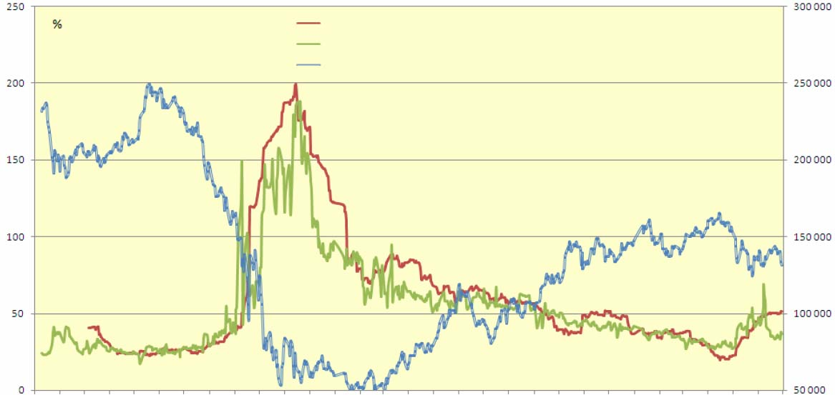

Source: DerEx
Fig. 6
Up to the mid April of 2010 volatility was reducing and reached the pre-crisis level (about 25 percent). Then, however, volatility surge became visible and by the end of June it has doubled.
Table 27

Results of trade of stock contracts and stock index contracts

on MICEX derivative market

Period | 2009 |  |  |  | 2010
 | Q1 | Q2 | Q3 | Q4 | Q1 | Q2
Futures contracts
Trading volume (billion rubles) | 0.0227 | 3.1914 | 13.479 | 45.11 | 151.83 | 253.36
incl. index trade | 0.0227 | 2.2956 | 12.102 | 35.54 | 135.23 | 203.39
incl. stock trade |  | 0.8958 | 1.376 | 9.57 | 16.60 | 49.97
Trading volume (million contracts) | 0.0009 | 0.1124 | 0.252 | 0.99 | 2.09 | 5.07
incl. index contracts | 0.0009 | 0.0232 | 0.103 | 0.27 | 0.97 | 1.47
incl. stock contracts |  | 0.0893 | 0.148 | 0.72 | 1.12 | 3.60
Number of deals (million items) | 0.0002 | 0.0033 | 0.047 | 0.26 | 0.95 | 2.03
incl. deals with indices | 0.0002 | 0.0024 | 0.035 | 0.10 | 0.45 | 0.71
incl. deals with stocks |  | 0.0010 | 0.012 | 0.16 | 0.50 | 1.32
Total
Trading volume (billion rubles) | 0.0227 | 3.1914 | 13.479 | 45.11 | 151.83 | 253.36
Trading volume (million contracts) | 0.0009 | 0.1124 | 0.252 | 0.99 | 2.09 | 5.07
Number of deals (million items) | 0.0002 | 0.0033 | 0.047 | 0.26 | 0.95 | 2.03
Source: MICEX

Since the second quarter of 2009 when new contracts (certain stock futures) were put in circulation MICEX derivative market experienced expansive growth; minimal trading volumes comprised 230 percent in money terms per quarter.
The structure of underlying assets of derivative contracts is dramatically changing. Underlying assets which are being offered or have been offered include stocks, bonds and stock indices. In 2009 niche of bonds as underlying assets disappeared. There were dramatic changes in ratio between the shares of stock indices and stocks. Being guided by FORTS market, it may be noted that the interest in stock index derivative contracts is trending upwards and by the and of the first half of 2010 volume of deals with stock index derivative contracts comprised 89 percent in money terms. At the end of the first half of 2010 in MICEX derivative market volume of deals with stock index derivative contracts comprised 85 percent of total volume of deals in money terms at average.
There are also dramatic changes in the ratio between volumes of derivative contract market and volumes of spot-market. Fig. 7 shows diagram that describes the ratio between volumes of deals with derivative contracts underlying asset of which is stocks and stock indices in money terns (summarily in the FORTS market and MICEX derivative market) and volumes of deals with stocks (summarily in all RTS markets and MICEX as well).

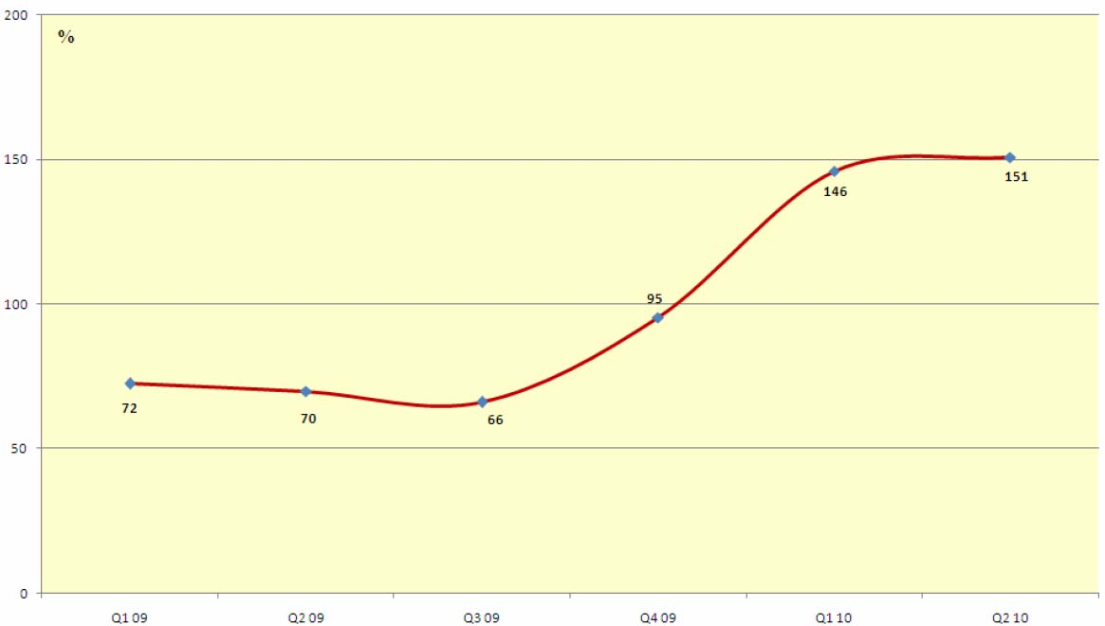
* ignoring repos
The ratio of trading volumes of derivative contracts underlying asset of which is stocks and stock indices and trading volumes of stocks in internal market*
Source: MICEX, RTS
Fig. 7
At the beginning of 2010 it was the first time when volume of deals in derivative market managed to exceed volume of deals in spot market at 150 percent. For comparison in 2009 this ratio lay anywhere from 60 to 70 percent.
In recent years there were dramatic changes in volumes of open positions and their distribution between different instruments on derivative market (see tables 28, 29).
Table 28

Open stock and stock index contract positions

on FORTS derivative market

Period | 2009 |  |  |  | 2010
 | Q1 | Q2 | Q3 | Q4 | Q1 | Q2
Futures contracts
Average volume of open positions, billion rubles | 17.8 | 33.3 | 37.3 | 47.1 | 50.7 | 62.6
incl. index positions | 11.0 | 22.7 | 24.3 | 31.9 | 34.5 | 39.9
incl. stock positions | 6.7 | 10.6 | 13.0 | 15.2 | 16.2 | 22.6
Average volume of open positions, million contracts | 1.3 | 1.8 | 1.9 | 1.7 | 1.7 | 2.5
incl. index positions | 0.3 | 0.4 | 0.4 | 0.4 | 0.4 | 0.5
incl. stock positions | 1.1 | 1.4 | 1.5 | 1.3 | 1.3 | 2.0
Option contracts
Average volume of open positions, billion rubles | 13.8 | 16.0 | 25.4 | 35.0 | 31.4 | 55.6
incl. index positions | 9.6 | 5.7 | 10.2 | 22.5 | 20.9 | 34.7
incl. stock positions | 4.1 | 10.3 | 15.2 | 12.5 | 10.4 | 20.9
Average volume of open positions, million contracts | 0.9 | 2.2 | 2.4 | 1.5 | 1.2 | 2.4
incl. index positions | 0.3 | 0.1 | 0.2 | 0.3 | 0.2 | 0.4
incl. stock positions | 0.6 | 2.1 | 2.2 | 1.2 | 0.9 | 2.0
Total
Average volume of open positions, billion rubles | 31.5 | 49.3 | 62.7 | 82.1 | 82.1 | 118.2
Average volume of open positions, million contracts | 2.2 | 4.0 | 4.3 | 3.2 | 2.9 | 4.8
Source: RTS.

In the first half of 2010 open positions in FORTS market continued growing since the mid of the previous year. AS a result at the end of the second quarter of 2010 average volume of open positions increased at 44 percent in money terms and at 47 percent in terms of number of contracts compared to the end of 2009. Volume of option contract open positions rose up at priority rates.
The share of stock indices is growing among different types of underlying assets in open positions in FORTS derivative market. During the period from the second half of 2009 to the first half of 2010 the share of indices comprised 66 percent at average.

Table 29

Open stock and stock index contract positions

on MICEX derivative market

Period | 2009 |  |  |  | 2010
 | Q1 | Q2 | Q3 | Q4 | Q1 | Q2
Futures contracts
Average volume of open positions, billion rubles | 0.00039 | 0.02397 | 0.0902 | 0.444 | 0.575 | 2.762
incl. index positions | 0.00039 | 0.00913 | 0.0637 | 0.363 | 0.417 | 2.103
incl. stock positions |  | 0.01484 | 0.0265 | 0.080 | 0.159 | 0.659
Average volume of open positions, million contracts | 0.00002 | 0.00166 | 0.0038 | 0.008 | 0.014 | 0.065
incl. index positions | 0.00002 | 0.00009 | 0.0005 | 0.003 | 0.003 | 0.016
incl. stock positions |  | 0.00157 | 0.0032 | 0.005 | 0.011 | 0.049
Total
Average volume of open positions, billion rubles | 0.00039 | 0.02397 | 0.090 | 0.444 | 0.575 | 2.762
Average volume of open positions, million contracts | 0.00002 | 0.00166 | 0.004 | 0.008 | 0.014 | 0.065
Source: MICEX.

MICEX derivative market for underlying assets related to securities is at the stage of active development and volume of open positions is growing at extremely swift rates, during the period from 2009 till the first year of 2010 average growth of open positions comprised 1.433 percent in money terms and 1,812 percent in terms on number of contracts per quarter. The share of stock indices in total volume of open positions is 75 percent.

The ratio between volumes of open positions and volumes of deals with futures and options has significant differences (see fig. 8).

The ratio between volume of open positions and trading volume of derivative contracts
FORTS futures FORTS options MICEX futures
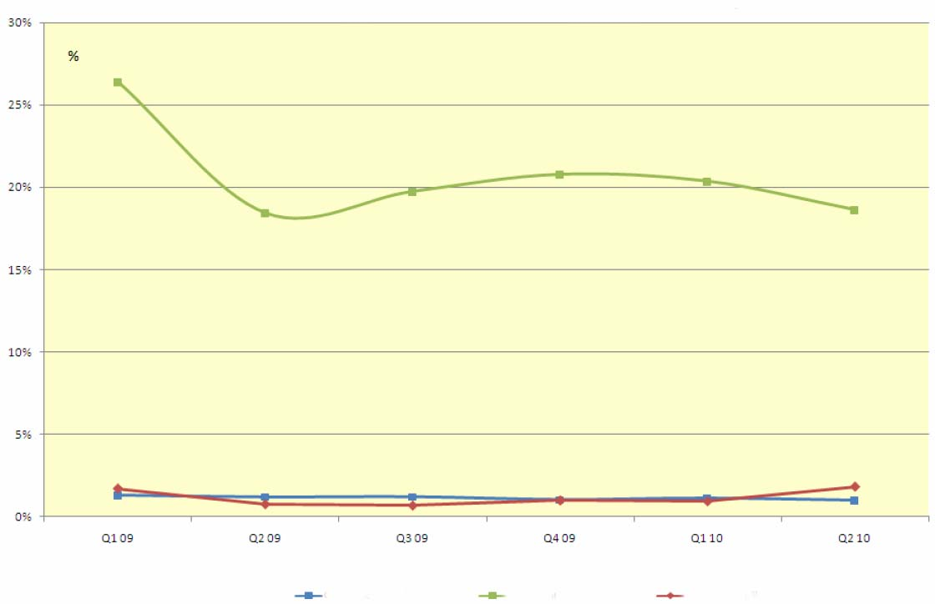
Source: MICEX, RTS
Fig. 8
As for futures this ratio is quite stable and lies anywhere from 1 to 5 percent. As for options since the mid 2009 till the end of the first half of 2010 the ratio between volume of open positions and volume of deals comprised 20 percent at average.
The ratio between call and put option open positions is an indicator of investment expectations of a quite importance. Fig. 9 shows diagram of difference between total open positions of RTS index future call and put options (in number of contracts) which is normalized to volume of put option open positions (coefficient of open positions). This diagram shows also RTS index in a relative scale for comparison.
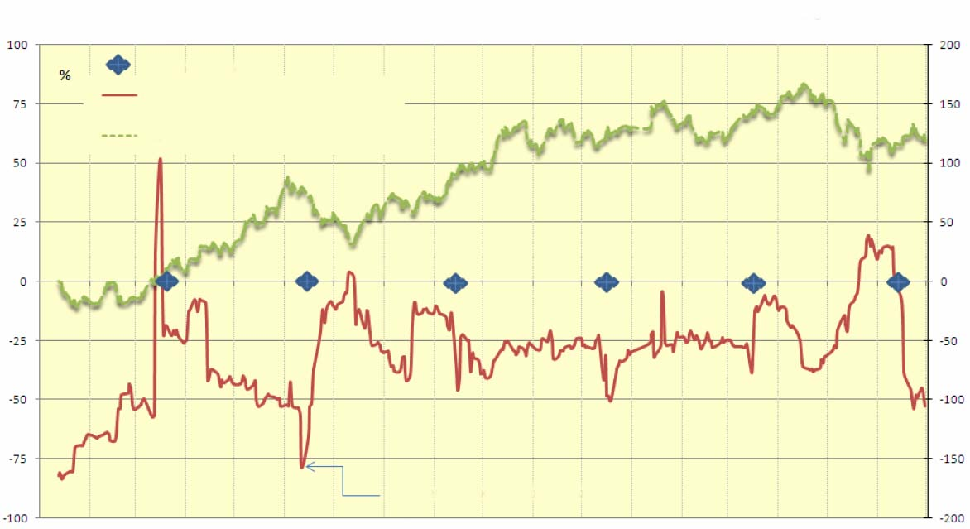
Jan 1, 09Feb 1, 09Mar 1, 09Apr 1, 09May 1, 09June 1, 09July 1, 09Aug 1, 09Sept1, 09Oct 1, 09Nov 1, 09Dec 1, 09Jan 1, 10Feb 1, 10Mar 1, 10Apr 1, 10May 1, 10June 1, 10July 1, 10
Ratio of volumes of open position of RTS index future call and put options
Expiration date
Open positions coefficient – left scale
RTS Index (relative) – right scale
allowance for short sales

In accordance with RTS and DEREX data
Fig. 9

During the first half of 2010 put option open positions dominated except for the period from the third ten days in May till the first ten days in June. Attention should be paid to the fact that behavior of coefficient of open positions and RTS stock index is in many respects of reflecting nature, in other words in index growth periods volume of put option open positions increases. On the contrary in index fall period there is increase in volume of call option open positions.
In May of 2008 there was introduced night trade session in RTS FORTS derivative market (see details in section 2.3b). Fig. 10 shows diagram of relative volumes of deals (in money terms) carried out during night session Daily share of deals carried out during night sessions is distinguished by extremely high variability, but on certain days it exceeded a half of total volume of deals. Median value of daily volumes of deals carried out during night session is trending upwards from year to year.

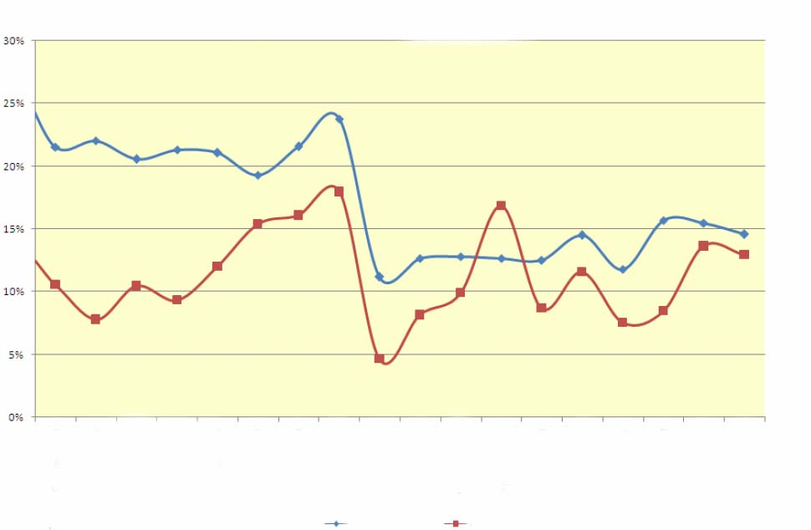
Jan 2009Feb 2009March 200-Apr 2009May 2009June 2009July 2009Aug 2009Sept 2009Oct 2009Nov 2009Dec 2009Jan 2010Feb 2010March 200-Apr 2010May 2010June 2010
Futures Options
Volume of deals carried out during night session in FORTS derivative market
(monthly)
Source: RTS
Fig. 10

It may be noted that the period since the mid 2009 till the end of the second quarter of 2010 with some minor exceptions made visible synchronism in dynamics of changes in volume of deals with futures and options carried out during night sessions. In the first half of 2010 month volume of deals with derivative contracts was subject to differently directed tendencies: Jump to 10–15 percent in February was followed by drop which in May changed into growth up to the February level.

Stock indices

At present time Russian and international organizations such us exchanges, information and rating agencies, investment banks, broker companies and so on calculate numerous indices of Russian stock market. The most known among them are RTS Index, MICEX Index, MSCI Russia, FTSE Russia for stock market; Corporate bond index IFX-Cbonds, Municipal bond index Cbonds-Muni, Corporate bond index MICEX CBI, Public bond index MICEX RGBI, Municipal bond index MICEX MBI for bond market; RUIF Indices calculated by the National Rating Agency for polled investment market. However by tradition, the indices calculated by MICEX and RTS are the most quoted.

Stock index

RTS Index is calculated since September 1, 1995. It is a consolidated index with base presently consisting of 50 stocks of the most capitalized and liquid issuers. The list of stocks for calculating indices is reviewed quarterly. Besides main RTS Index since the end of 2003 RTS SE calculates also RTS-2 Index for stocks of companies of “the second echelon”, at present time this index includes stocks of 69 issuers. Starting from 2005-2007 there are calculated the following branch indices:
- RTS – Oil and gas (RTSog);
- RTS – Metals and mining (RTSmm);
- RTS – Telecommunications (RTStl);
- RTS – Industry (RTSin);
- RTS – Commodities and retail (RTScr);
- RTS – Power industry (RTSeu);
- RTS – Finance (RTSfn).
Bases for calculation of branch includes include now from 8 to 14 issuers. When calculating the said indices RTS takes into account prices for securities denominated in US dollars.
In January 2010 RTS began to calculate one more consolidated index that is RTS Standard Index. This index is calculated based on deals with securities in the RTS Standard market. Its base for calculation includes stocks of 15 issuers; in contrast to other indices calculated by the exchange, this index is calculated based on stock prices denominated in rubles.
May 2010 was the first time when RTS began to calculate the regional index RTS Siberia Index which shows capitalization dynamics of issuers in the Siberian Federal District. Its base for calculation includes stocks of 10 issuers, calculation is also based on stock prices denominated in rubles.
MICEX Index is calculated since September 1, 1997. It is a consolidated index with base presently consisting of 30 stocks of issuers which present main economic sectors. Amendments in index base are made twice a year.
In 2005-2009 MICEX began calculating branch and capital indices.
- MICEX O&G – index of stocks of companies referred to oil and gas industry;
- MICEX PWR – index of stocks of companies referred to power industry;
- MICEX TLC – index of stocks of telecommunicational companies ;
- MICEX M&M – index of stocks of companies referred to metallurgical and mining industry;
- MICEX MNF – index of stocks of companies referred to engineering industry;
- MICEX FNL – index of stocks of companies referred to financial and bank industry;
- MICEX CGS - index of stocks of consumer sector;
- MICEX СНM – index of stocks of companies referred to chemical and petrochemical industry;

- MICEX LC – index of stocks of companies with high capitalization;
- MICEX MC – index of stocks of companies with standard capitalization;
- MICEX SC – index of stocks of companies with base capitalization;
Bases for calculation of branch and capital indices include now from 8 to 50 issuers.
When calculating indices MICEX takes into account prices for securities denominated in Russian rubles.
There is obvious correspondence between bases for calculating indices of oil and gas industry (RTSog, MICEX O&G), telecommunication industry (RTStl, MICEX TLC), power industry (RTSeu, MICEX PWR), metallurgical and mining industry (RTSmm, MICEX M&M), financial and bank industry (RTSfn, MICEX FNL), industry (RTSin, MICEX MNF) and also consumer sector (RTScr, MICEX CGS) among branch indices calculated by the leading stock exchanges.
Fig. 11, 12 and 13 show diagrams of RTS, MICEX, RTS-2 and RTS Standard indices over 2009-2010.
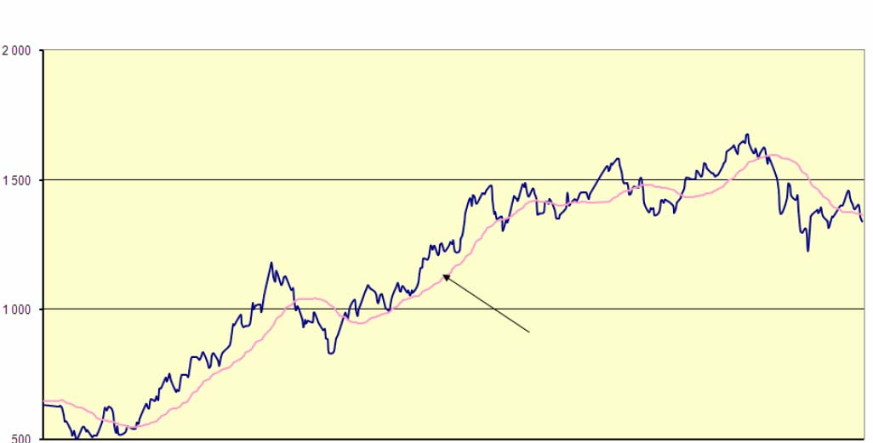
RTS Index
moving average (60 day interval)
Jan 1, 09Feb 1, 09Mar 1, 09Apr 1, 09May 1, 09June 1, 09July 1, 09Aug 1, 09Sept1, 09Oct 1, 09Nov 1, 09Dec 1, 09Jan 1, 10Feb 1, 10Mar 1, 10Apr 1, 10May 1, 10June 1, 10July 1, 10

Source: RTS
Fig. 11

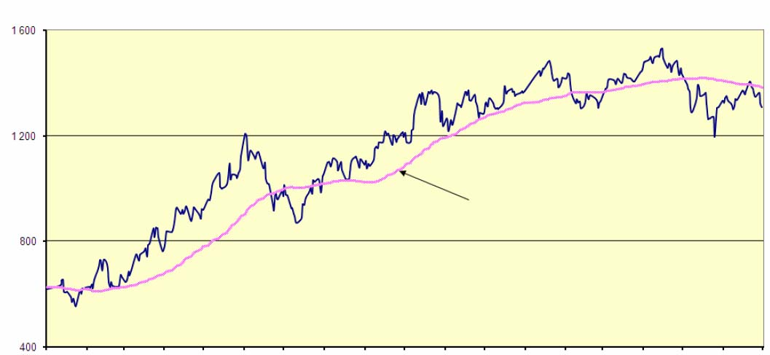
MICEX Index
moving average (60 day interval)
Jan 1, 09Feb 1, 09Mar 1, 09Apr 1, 09May 1, 09June 1, 09July 1, 09Aug 1, 09Sept1, 09Oct 1, 09Nov 1, 09Dec 1, 09Jan 1, 10Feb 1, 10Mar 1, 10Apr 1, 10May 1, 10June 1, 10July 1, 10

Source: MICEX
Fig. 12

RTS-2 Index
moving average (60 day interval)
Jan 1, 09Feb 1, 09Mar 1, 09Apr 1, 09May 1, 09June 1, 09July 1, 09Aug 1, 09Sept1, 09Oct 1, 09Nov 1, 09Dec 1, 09Jan 1, 10Feb 1, 10Mar 1, 10Apr 1, 10May 1, 10June 1, 10July 1, 10
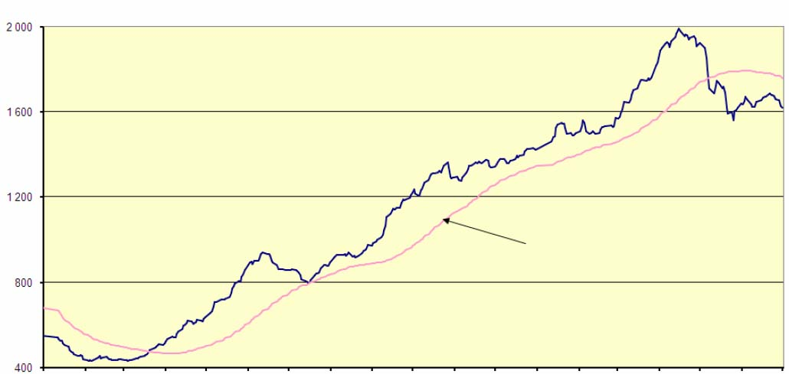

Source: RTS
Fig. 13
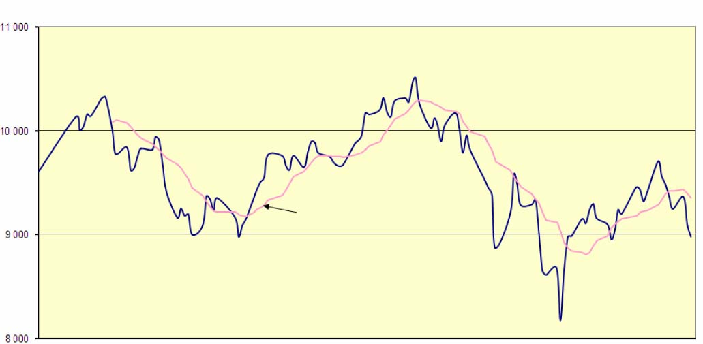
moving average (10 day interval)
RTS Standard Index
Jan 1, 10Jan 11, 10Jan 21, 10Jan 31, 10Feb 10, 10Feb 20, 10Mar 2, 10Mar ,12, 10Mar 22, 10Apr 1, 10Apr 11, 10Apr 21, 10May 1, 10May 11, 10May 21, 10May 31, 10June 10, 10June 20, 10June301, 10

Source: RTS
Fig. 14

During the first half of 2010, consolidated stock indices were influenced harmonic trend on; dynamic upward tendency, which had been typical for 2009, turned out to be lost.
All consolidated indices under consideration reached their maximum at one time – on April 15.
Then the time was ripe for downward stage, and the indices reached their minimum also at one time – on May 25. That day the indices sharply fell at one step at 5.5-6.5%, the next day they jumped up at the same rate. The first half of 2010 ended against the background of falling indices.
Table 30¹⁰ shows data concerning return by RTS and MICEX indices over recent years. In 2008 under the conditions of global financial crisis all analysed indices underwent one of the deepest falls during their entire history (66-78 percent per year). Along with this in 2009 Russian stock market showed in stock indices’ behaviour sharp return surge, one of the largest those during its entire history. Consolidated indices for stocks of "the first echelon” resulted in return over 120 percent and 160 percent for stocks of “the second echelon”.
Table 30
Return of stock indices
(percent per year)

 | 2005 | 2006 | 2007 | 2008 | 2009 | 1 H10
Consolidated indices
RTS Index | 83.52 | 70.94 | 19.23 | -71.48 | 128.71 | -14.67
RTS Std. Index |  |  |  |  |  | -12.43
MICEX Index | 83.08 | 67.69 | 11.57 | -66.47 | 121.14 | -8.93
RTS-2 Index | 69.32 | 42.27 | 43.17 | -78.29 | 160.36 | 27.42
Branch indices
Oil and gas industry
RTSog | 86.78 | 50.80 | 1.05 | -65.76 | 93.41 | -25.50
MICEX O&G | 91.95 | 47.95 | -3.57 | -58.42 | 126.33 | -7.86
Chemistry and petrochemistry
MICEX CHM |  |  |  |  |  | -27.26
Telecommunications
RTStl | 40.78 | 81.47 | 28.13 | -72.74 | 121.75 | 11.53
MICEX TLC | 39.10 | 65.98 | 14.56 | -75.55 | 187.00 | 19.09
Metallurgy and mining
RTSmm | 53.18 | 52.42 | 54.00 | -74.50 | 157.56 | 4.61
MICEX M&M | 74.60 | 51.69 | 42.61 | -71.96 | 212.20 | 18.66
Power industry
RTSeu |  |  | 31.96 | -80.33 | 132.98 | 26.77
MICEX PWR | 38.68 | 134.51 | 7.87 | -73.72 | 167.25 | 34.99
Industry
RTSin | 40.50 | 73.76 | 66.83 | -84.30 | 124.47 | 3.79
MICEX MNF | 28.90 | 69.62 | 60.57 | -85.72 | 189.05 | 11.93
Consumer commodities
RTScr | 92.51 | 51.24 | 29.31 | -79.54 | 230.80 | 37.44
MICEX CGS |  |  |  |  |  | 36.08
Finance
RTSfn |  |  | 14.30 | -78.37 | 124.63 | -26.61
MICEX FNL |  |  |  | -67.32 | 131.79 | 8.01
Capital indices
MICEX LC |  |  | 9.89 | -66.47 | 118.68 | -12.96
MICEX MC |  |  | 15.64 | -71.69 | 148.23 | 35.12
MICEX SC |  |  | 29.17 | -76.09 | 198.91 | 26.41
Based on RTS and MICEX data
The first half of 2010 sow negative return indices for stocks of “the first echelon”, but RTS-2 Index which characterized capitalization of stocks of “the second echelon” to the contrary showed increase in return. As for branch indices oil and gas industry, chemical and petrochemical industry appeared to be in negative. Power industry and consumer sector showed the largest return.

Bond index
Corporate bond index MICEX CBI is calculated from the beginning of 2003. Its base for calculation includes corporate issuers’ bonds allowed for circulation in MICEX, at that at least one international rating agency has assigned for these issuers long-term foreign currency credit rating or at least one national rating agency has assigned credit rating. According to S&P version minimal rating shall be B. To be included in base for calculation bond issue index shall in particular comply with the conditions as for issue volume, term to maturity, volume of deals.
The list of bond issues for calculating index MICEX CBI is reviewed quarterly. When calculating this index the agencies take into account prices for securities denominated in Russian rubles. At present time base for calculating this index includes 51 bonds of 18 issuers. The index is calculated by three procedures:
- total return (takes into account market value of bonds, accumulated coupon interest and paid coupon interest);
- clean price (takes into account market value of bonds ignoring accumulated coupon interest and paid coupon interest);
- gross price (takes into account market value of bonds and accumulated coupon interest).
In May 2010 rules for calculation of this index were changed that allowed to include exchange bonds into the base for its calculation and to deter issuers which have let default.
Fig. 15 shows diagram of index MICEX CBI based on total corporate bond return.
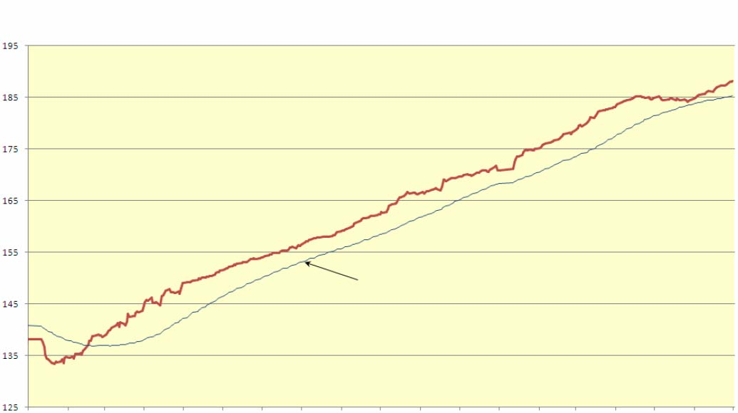
MICEX Corporate bond index
(MICEX CBI TR)
moving average (60 day interval)
Jan 1, 09Feb 1, 09Mar 1, 09Apr 1, 09May 1, 09June 1, 09July 1, 09Aug 1, 09Sept1, 09Oct 1, 09Nov 1, 09Dec 1, 09Jan 1, 10Feb 1, 10Mar 1, 10Apr 1, 10May 1, 10June 1, 10July 1, 10

Source: MICEX
Fig. 15
Corporate bond index IFX–CBONDS is a co-operative project of Index agency RTS-Interfax and agency CBONDS. It is calculated from the beginning of 2002. Its base for calculation includes corporate issuers’ bonds allowed for circulation on trade floors of MICEX, RTS and SPCEX. To be included in base for calculation bond issue index shall in particular comply with the conditions as for term to maturity, volume of deals, and number of selling days. The list of bond issues for calculating index IFX–CBONDS is reviewed every month. When calculating this index the agencies take into account prices for securities denominated in Russian rubles. At present time base for calculating this index includes 30 bonds of 21 emitters. The index is calculated by total return and clean price procedures.

Fig. 16 shows diagram of index IFX–CBONDS based on total corporate bond return.
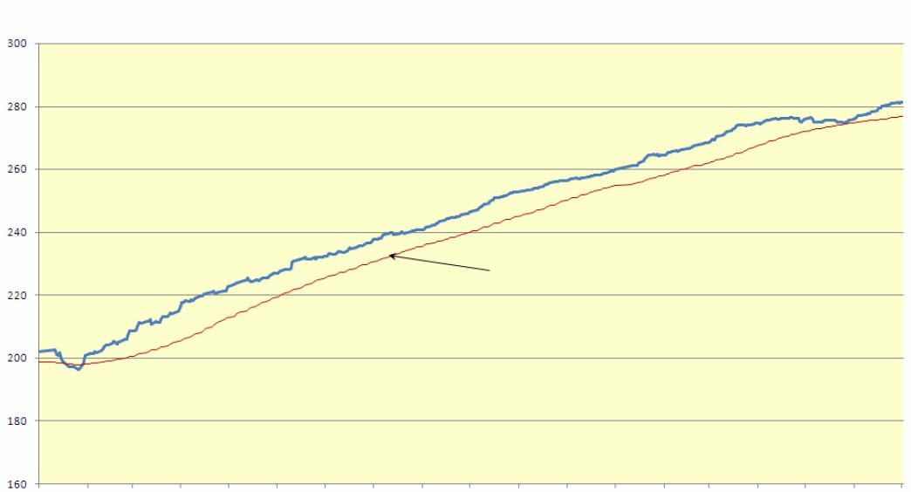
Index IFX–CBONDS
(total return)
moving average (60 day interval)
Jan 1, 09Feb 1, 09Mar 1, 09Apr 1, 09May 1, 09June 1, 09July 1, 09Aug 1, 09Sept1, 09Oct 1, 09Nov 1, 09Dec 1, 09Jan 1, 10Feb 1, 10Mar 1, 10Apr 1, 10May 1, 10June 1, 10July 1, 10

Source: CBONDS
Fig. 16
Besides index IFX–CBONDS there are also calculated indices characterizing average weighted duration and average weighted return to recovery of index bond portfolio. At that average weighted return to recovery is defined in two variants:
- “simple”: ignoring annual investments in coupons.
- effective: taking into account annual reinvestments in coupons.
Fig. 17 shows diagrams of average weighted duration and average weighted return to recovery of index bond portfolio IFX–CBONDS.
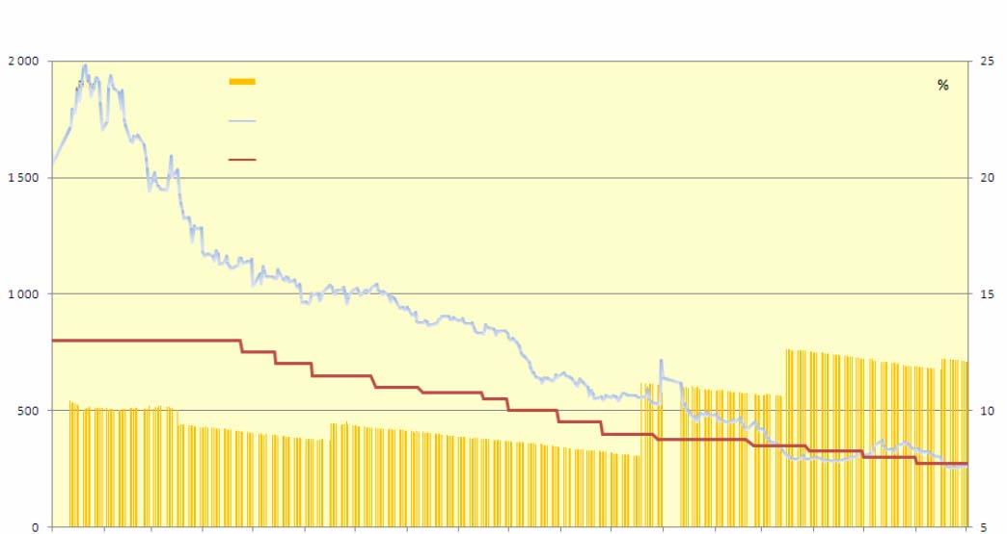
Index IFX–CBONDS
(duration and effective return)
IFX-Cbonds, index portfolio duration – left scale
IFX-Cbonds average weighed return (effective) – right scale
Refinancing rate of the Cenrtal Bank of Russia
days
Jan 1, 09Feb 1, 09Mar 1, 09Apr 1, 09May 1, 09June 1, 09July 1, 09Aug 1, 09Sept1, 09Oct 1, 09Nov 1, 09Dec 1, 09Jan 1, 10Feb 1, 10Mar 1, 10Apr 1, 10May 1, 10June 1, 10July 1, 10

Sources: the Bank of Russia, CBONDS
Fig. 17

In the first half of 2010 average total return of investors was increasing almost constantly (see fig. 15 and 16) except for downfall in May after which the increase recurred again.
In the first half of 2010 average return to corporate bond redemption (see fig. 17) and refinancing rate of the Bank of Russia were trended downwards from 11 percent in January to 7.8 percent in April. May was noted with increase in return. During this period and up to mid June average return exceeded the refinancing rate, the maximum spread was recorded on May 25 at the level 0.7 items.
In the first half of 2010 time structure of corporate bond market began to expand in contrast to 2009. While in 2009 average bond duration included in IFX–CBONDS Index comprised 420 days, the first half of 2010 it rose to 670 days.

Public bond index

Since December 31, 2002 MICEX, where turnover of public securities of the Russian Federation is organized, calculates indices and indicators of public securities return (return of state treasury bills, federal loan bonds).
Indices reflect changes in market value and consist of:
- Public bond index MICEX RGBI which is calculated by clean price procedure;
- Public bond index MICEX RGBI which is calculated by gross price procedure;
- Public bond index MICEX RGBI TR which is calculated by total return procedure.
These indices are calculated uninterruptedly in real-time mode as far as dealings with public bonds are settled.
Return indices are the weighed by market value returns to redemption and consist of:
- Effective return to public bond redemption indicator RGBEY;
- Gross return to public bond redemption indicator RGBY;
Return indices are calculated once daily by the close of session.
Fig. 18 shows diagram of MICEX RGBI-TR Index over 2009 – 2010. Since the mid 2005 total return of investors in public bonds grew at the rate not lower than growth of total returns in corporate bond sector (compare fig. 15 and 16). Along with this since April 2010 this rate slowed down and then growth stopped.
moving average (60 day interval)
MICEX Corporate bond index
(MICEX RGBI-TR)
Jan 1, 09Feb 1, 09Mar 1, 09Apr 1, 09May 1, 09June 1, 09July 1, 09Aug 1, 09Sept1, 09Oct 1, 09Nov 1, 09Dec 1, 09Jan 1, 10Feb 1, 10Mar 1, 10Apr 1, 10May 1, 10June 1, 10July 1, 10
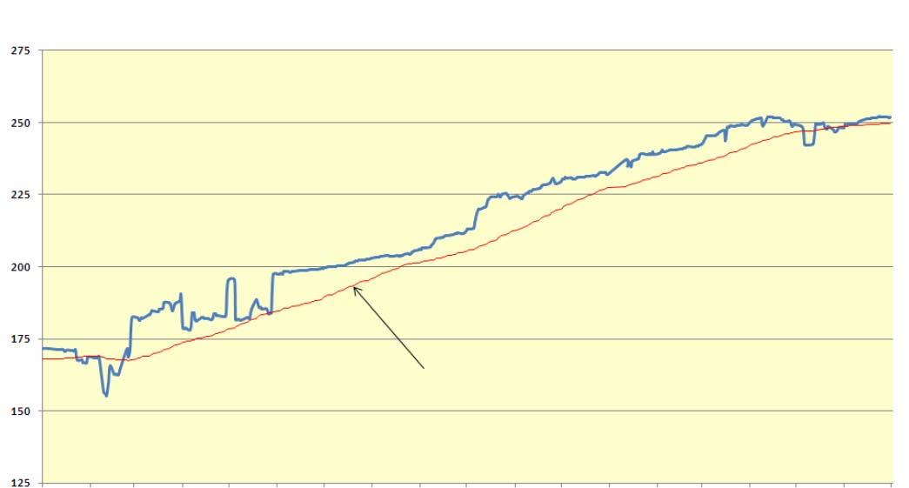

Source: MICEX
Fig. 18
Attention should be paid to the fact that on May 27-28, 2010 MICEX RGBI-TR Index sharply fell at one step at 0.3 item.
Fig. 19 shows diagram of effective return to redemption RGBEY and duration of public securities portfolio (duration of state treasury bills and federal loan bonds) disclosed by the Bank of Russia.
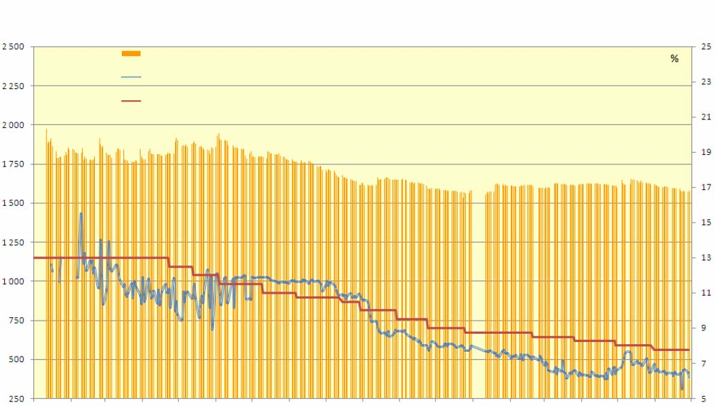
Duration of portfolio of state treasury bills and federal loan bonds – left scale
Average weighed return (effective) – right scale
Refinancing rate of the Central Bank of Russia – right scale
days
Jan 1, 09Feb 1, 09Mar 1, 09Apr 1, 09May 1, 09June 1, 09July 1, 09Aug 1, 09Sept1, 09Oct 1, 09Nov 1, 09Dec 1, 09Jan 1, 10Feb 1, 10Mar 1, 10Apr 1, 10May 1, 10June 1, 10July 1, 10
Effective return to redemption and duration of public bonds

Sources: the Bank of Russia, MICEX
Fig. 19

Since the third quarter of 2010 public bond portfolio duration set at the level 1,600 days. Also since the third quarter of 2009 average weighed public bond return to redemption and refinancing rate of the Bank of Russia began steadily falling from 11 to 6.3 percent by the end of the first year 2010. There was an abrupt jump of return in the end of May and, on contrary, one day deep drop in the second half of June.

Unit investment fund indices

Since July 1, 2003 the National Rating Agency has been recording family of unit investment indices (RUIF). This family includes four groups of funds: all funds (T), stock funds (S), bond funds (B) and mixed funds (M). And beside that calculation of indices counts value of investment unit as weighed by value of net asset of the fund (W) and without it. The indices are calculated every day. Fig. 20 shows general index with weighing by net asset value of RUIF WT over 2009–2010.
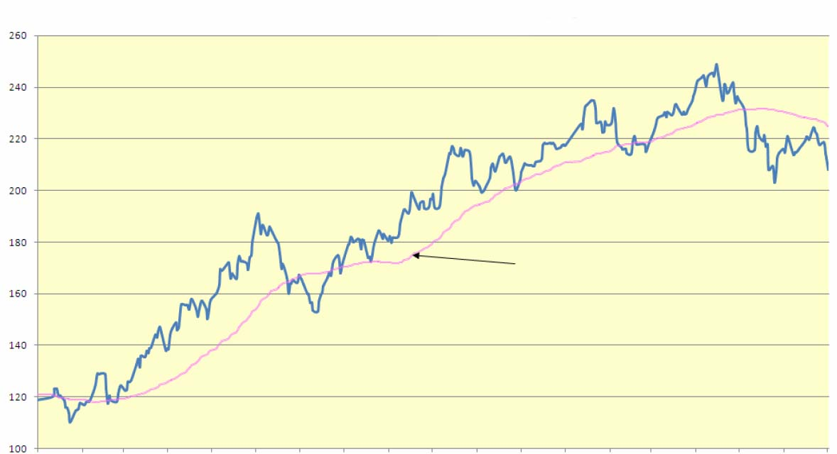
moving average (60 day interval)
Jan 1, 09 | Feb 1, 09 | Mar 1, 09 | Apr 1, 09 | May 1, 09 | June 1, 09 | July 1, 09 | Aug 1, 09 | Sept1, 09 | Oct 1, 09 | Nov 1, 09 | Dec 1, 09 | Jan 1, 10 | Feb 1, 10 | Mar 1, 10 | Apr 1, 10 | May 1, 10 | June 1, 10 | July 1, 10

Sources: the NPA
Fig. 20
Unit Investment fund index RUIF-WT

The period from 2009 to the first half of 2010 was characterized by upward trend of RUIF WT index along with wide multilateral fluctuations which have been continued till May 2010. Against this background there stand out significant declines. In 2010 there can be noted such decline at the beginning of the year (January – February) and deep drop at 25 percent from the mid April till the end of May as well.

Institutional Structure

Issuers. Public Offerings

Any joint-stock company is an issuer, for even during its establishment it places stocks (and is to register them). A limited liability company and, under certain conditions, a non-profit organization can be an issuer as well. Figures from the SPARK and the RusBonds databases, concerning issuers of securities, are presented in Table 31. Summary data concerning the number of issuers at domestic organized markets are presented in Table 32.

Table 31
Issuers of Securities

Period | The number of issuers of stocks and bonds | incl. open joint-stock societies | The number of issues of stocks and bonds
2005 | 460,431 | 62,960 | 463,670
2006 | 471,158 | 64,431 | 474,484
2007 | 481,591 | 65,706 | 483,962
2008 | 487,996 | 66,466 | 491,415
2009 | 523,172 | 72,601 | 526,641
1H 10 | 526,771 | 72,960 | 530,259
The source: the Interfax (the SPARK and the RusBonds databases).

In the first half of 2010, the total number of issuers (of both stocks and bonds) has increased by 7.6% compared to the beginning of the year.

Table 32
Issuers at Organized Exchange Market

Period | The MICEX |  | The RTS
Period | The number of issuers (stocks and bonds) | incl. ones in quotation lists | The number of issuers (stocks and bonds) | incl. ones in quotation lists
2005 | 385 | 93 | 262 | 46
2006 | 539 | 127 | 332 | 64
2007 | 670 | 229 | 354 | 88
2008 | 632 | 255 | 329 | 92
2009 | 602 | 230 | 353 | 87
1H10 | 567 | 232 | 333 | 85
The sources: the MICEX, the RTS.

No more than 1% of the total number of stocks and bonds issuers are presented at organized markets. In 2008 – first half of 2010 the number of issuers, presented at the exchange market was decreasing.

Public Offerings

In the first half of 2010, some revival of initial and secondary public offerings may be observed. Among large initial offerings the Holding Company RUSAL may be distinguished which was the first among Russian companies to place its stocks of total volume of 2.2 billion USD at the exchange in Hong Kong and the European Exchange Euronext.

Table 33
Public Stock Offerings of Russian Companies

Period | 2005 | 2006 | 2007 | 2008 | 2009 | 1H10
The volume of offerings (billion dollar) | 4.55 | 17.98 | 23.6 | 1.7 | 0.004 | 3.9
The number of companies | 13 | 24 | 25 | 7 | 1 | 13
The sources: the Project www.offering.ru/IPO in Russia, «Alfa Bank», Ernst&Young, the PBN Company, CRFR.

In 2007–2009, alternative trading floors for introducing of securities of innovative and small-cap companies were established at the MICEX and the RTS. The number of issuers and transaction volume at these floors were insignificant (for more details see Section 2.3.b)
In 2007–2009, laws and regulations that gave an opportunity for offering and circulating of foreign issuers’ securities on Russian trading floors were prepared. However, there have not been yet.

Investors

Investor means any person or institution that invests money into securities in order to get profit. There is no official ordered data on structure and quantitative characteristics of the investor base of the Russian securities market. Nevertheless, securities market professional participants, self-regulatory organizations and research groups are working on accounting and studying of the investor base.

a) Population

At this point population means “market investors” that are individual persons who consciously decided to invest at the securities market and occasionally employ services of brokers, trustees or purchased unit investment funds’ investment units.
There is no full and authentic statistics on the number of individuals who make transactions at the securities market. Taking into account data from different sources you can see the following far not complete picture of the situation.
The MICEX regularly discloses the information about the number and structure of traders’ customers, including individuals (hereinafter referred to as “the MICEX customers”), including those who have individual identification characteristics (unique customers).
Figure 21 shows data on the number of the MICEX customers - individuals (unique customers).

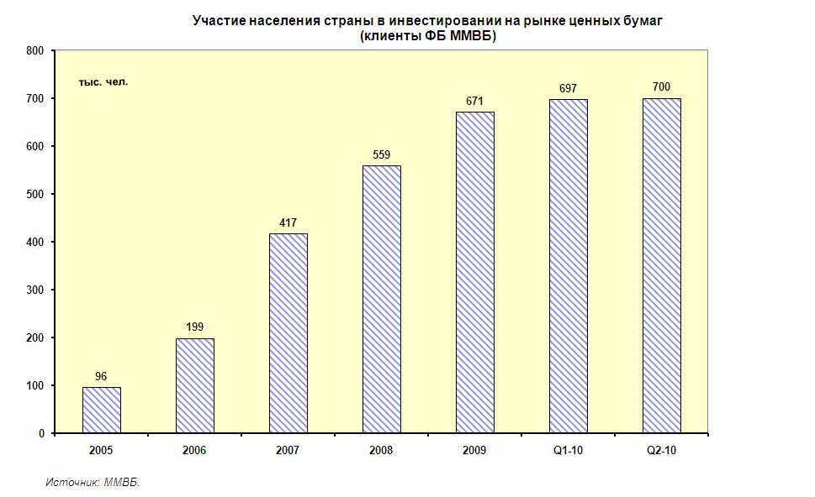
Participation of the Country Population in Investment at the Securities Market
(the MICEX Customers)
thousand people
The source: the MICEX

Figure 21
From mid 2007 and till the end of the first half of 2010 growth rates of the MICEX’s customers dipped down and compose on average 5–7% quarterly. In the second quarter of 2010 slight growth – 0.4% in total was recorded and the number of individuals – the MICEX’s customers amounted to 699,870 people that 4.2% more, compared to the beginning of the year.
A major characteristic of a private investor base is the number of so-called proactive investors, in other words, those who perform on securities market at least one transaction a month. Figure 22 presents data on proactive investors – the MICEX Stock Exchange individual person customers. Proactive individual - investors amount to 13–17% of the MICEX Stock Exchange unique customers total with a seasonal summer depression and overactivity in the beginning of the autumn, observed in their activity. Over the whole period of observation the maximum number of proactive customers was recorded in October 2009 – 119,838 people with downwards tendency observed later.

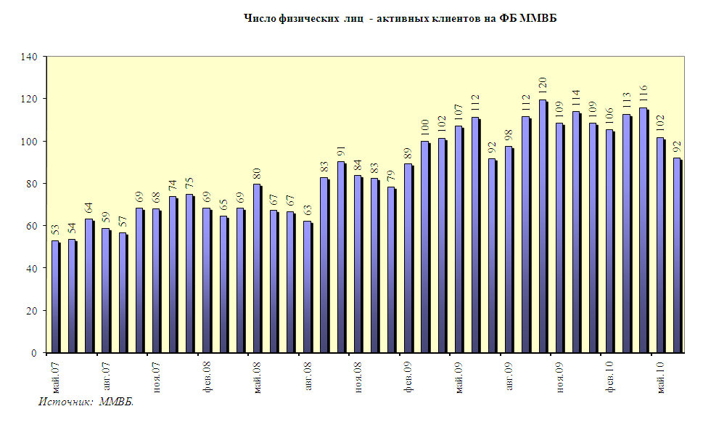
May 07

Aug 07

Nov 07

Feb 08

May 08

Aug 08

Nov 08

Feb 09

May 09

Aug 09

Nov 09

Feb 10

Number of Individuals-Proactive Investors at the MICEX Stock Exchange
The source: the MICEX.
Figure 22
According to the results of the first half of 2010 in comparison with the beginning of the year, the number of proactive investors has decreased for 19%.
Data on the number of unit investment fund investors – individual persons is even vaguer and not systematized enough. According to the National League of Management Companies, following the results of the second quarter of 2010 the number of unit holder not including former owners of privatization vouchers composes about 900 thousand people.
It is necessary to consider that a part of unit holders acquires units of funds being under management of different management companies as well as they invest into securities on their won, employing services of brokers and trustees. Thus, it is difficult to detect the number of citizens of the country investing at the stock market in one or another form.

b) Unit investment Funds

From a legal point of view, unit investment funds are property complexes that are not legal persons. Depending on abilities of a management company to present unit investment funds for redemption open-end, interval and closed-end funds may be created. Table 34 presents summary data on the dynamics of changing of the number of unit investment funds over 2005–2010.
Table 34

Number of Unit investment Funds

Period | Unit investment fund type |  |  | TOTAL
Period | Open-end funds | Interval funds | Closed-end funds | TOTAL
2005 | 201 | 59 | 121 | 381
2006 | 299 | 86 | 234 | 619
2007 | 455 | 95 | 398 | 948
2008 | 446 | 94 | 457 | 997
2009 | 410 | 85 | 605 | 1,100
Q1 10 | 401 | 81 | 644 | 1,126
Q2 10 | 396 | 80 | 678 | 1,154
The source: the National League of Management Companies.

In 2010 the tendency of the open-end funds quantity reduction continued, which appeared as early as in 2008. By the end of the first half of 2010 in comparison with the beginning of the year the number of open-end unit investment funds decreased by 3.4%. Moreover, from 2007 the quantity growth of closed-end funds has accelerated. Over the period from the beginning of 2010 and until the end of the first half-year the number of established closed-end funds increased by 12%. The niche of interval unit investment funds has been in the state of stagnation since 2006.
By the mid 2010, there were 1.154 unit investment funds that were 5% more than in the beginning of the year.
In 2008–2009 an opportunity to establish interval and closed-end funds for qualified investors, which units are limited in their turnover, appeared. By the end of the first half of 2010 over 39% of unit investment funds became funds for qualified investors, at the end of 2009 this indicator composed 35%. Out of the total amount of closed-end unit investment funds, about 67% are funds for qualified investors.
In compliance with applicable legislation, the information about a unit investment fund, investment units transferability of which is restricted, can only be provided to investment units holders and other qualified investors. As a result, the available public aggregated data on the net asset value of unit investment funds at the present time concerns only funds for not qualified investors, so they represent the situation not completely. Table 35 shows data on the net asset value of open-end and interval funds in 2005–2010.
Table 35

The Net Asset Value of Open-End and Interval Unit investment Funds
(billion rubles)

Period | Open-end fund | Interval fund | TOTAL | NAV/GDP (%)
2005 | 30.8 | 38.7 | 69.5 | 0.32
2006 | 91.1 | 59.6 | 150.7 | 0.56
2007 | 134.8 | 43.8 | 178.6 | 0.54
2008 | 47.1 | 13.2 | 60.3 | 0.15
2009 | 74.6 | 21.9 | 96.5 | 0.25
Q1 10 | 84.4 | 24.6 | 109.0
Q2 10 | 77.4 | 22.5 | 100.0
The source: the National League of Management Companies.

In 2009 – first half of 2010 some growth of net assets value of open-end and interval funds could be observed: thus, over first six months of 2010 it increased by 3.6%, however in absolute terms this value is 78 billion RUR less than against record in its value 2007.
Except the net asset value, the most important characteristic of unit investment funds is the amount of clear fund-raising. This data are the most illustrative for open-end unit investment funds, where unit distribution and redemption order taking is performed every working day. Figure 23 shows data on clear fund-raising of open-end unit investment funds.

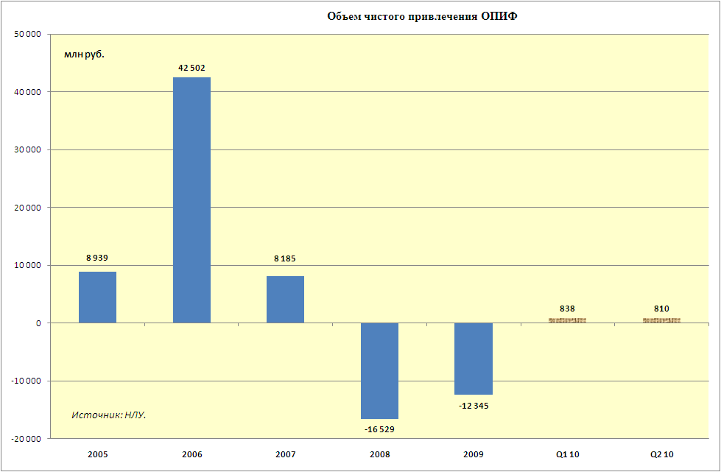
Amount of Clear Fund-Raising of Open-End Unit investment Funds

million RUR
The source: the National League of Management Companies
Figure 23

In the first half of 2010 capital outflow, observed over two previous years, changed for relatively slight inflow – a little more than 800 million RUR quarterly that, however, is incommensurable with the capital withdrawn during the previous two years.
The key element in a unit investment fund construction is a management company which offers investment units of unit investment funds and in compliance with Russian legislation is liable to their holders. Figure 24 shows summary data concerning the amount of management companies that manage unit investment funds over the last years.
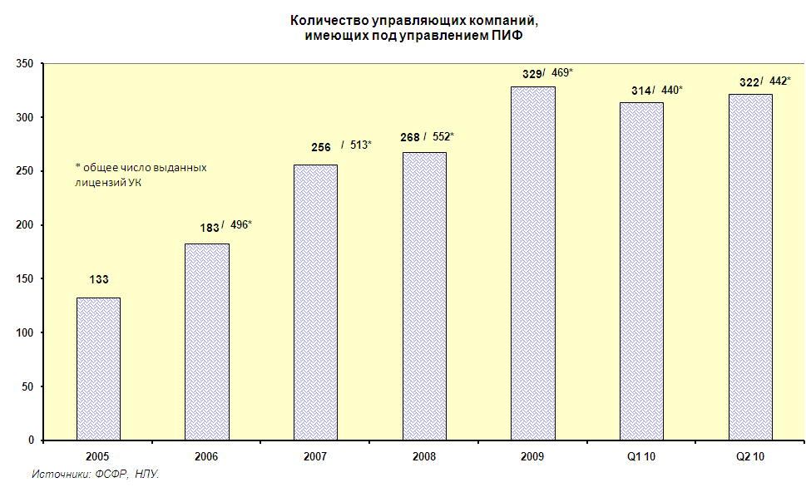
Amount of Management Companies that Manage Unit investment Funds

*total amount of licenses granted to management companies
The sources: the Federal Financial Markets Service, the National League of Management Companies

Figure 24
The first half of 2010 is marked with stabilization of the management companies quantity that manage unit investment funds at the level slightly lower than in the previous year. The total number of management companies is also stable and it is at the level of 440–450 institutions. Moreover, according to the results of 2009 the number of management companies reduced for more than 80 companies (15% in relative terms), that in general was the result of activity of the Federal Financial Markets Service of Russia aimed at cleanup of the market from the companies with licenses but not conducting any activity.

c) Bank Managed Mutual Fund

A bank-managed mutual fund (OFBU) is an investment product that is offered by credit institutions. OFBU is a property complex that includes the property that is delivered in trust management by different persons and the property that is acquired by a trustee in the process of trust management. From the legal point of view, OFBU in its essence is similar to unit investment funds, but the participation in it is not certified by securities. There are nearly 30 credit institutions, according to available data, involved in OFBU management activities; the data on the amount of funds and the net asset value in 2005–2010 are shown in Table 36.

Table 36
Bank Managed Mutual Funds

Period | Number of funds | incl. In RUR | incl.in currency | Net assets value (billion RUR)
2005 | 173 | 120 | 53 | 7.9
2006 | 239 | 170 | 69 | 17.1
2007 | 273 | 201 | 73 | 21.1
2008 | 291 | 215 | 76 | 7.5
2009 | 293 | 217 | 76 | 9.3
Q1 10 | 291 | 215 | 76 | 9.7
Q2 10 | 291 | 215 | 76 | 9.5
The source: investfunds.ru.

Pursuant to the data, OFBU are significantly smaller than unit investment funds both in the amount of the funds and in summary value of the net assets. Over 2009 – first half of 2010 there were no significant changes either in the number of funds or net assets value, this direction of polled investments is at the stage of stagnation and does not demonstrate any tendencies of post-crisis recovery.

d) Non-Governmental Pension Funds

According to the FFMS of Russia, 164 organizations had current licenses of NGPF according to the results of the first half of 2010, 133 of them (according to the data as of 01.11.09) were allowed to perform activities concerning mandatory pension insurance. During this period the quantitative composition of pension provision subjects has been settled, whereas in the year-early period the amount of NGPF reduced by more than 30%. It happened because some funds had their licenses cancelled, and for some of them the cancellation was a result of non-complying with the new requirements to property sufficient to provide statutory activity that increased from 30 million RUR to 50 million RUR from 01.07.09.
Data on NGPF active assets concerning non-governmental pension provision (pension reserves) and mandatory pension insurance (pension assets) are shown in Table 37.
Table 37
Investment Resources of NGPF
(billion RUR.)

Period | 2009 |  |  |  | 2010
Period | Q1 | Q2 | Q3 | Q4 | Q1 | Q2
Number of NGPF | no data | 170 | 173 | 164 | 164 | no data
Number of GPF that are allowed to perform activities concerning mandatory pension insurance | no data | 136 | 133 | 133 | 133 | no data
Pension reserves | 476.5 | 495.1 | 518.0 | 564.3 | 583.9 | 591.2
Pension assets | 46.9 | 67.3 | 71.7 | 77.2 | 115.4 | 142.0
TOTAL | 523.4 | 562.4 | 589.7 | 641.5 | 699.3 | 733.2
Investment resources NGPF/GDP (%) |  |  |  | 1.64
The sources: the FFMS of Russia, www. investfunds.ru.

In 2009 – first half of 2010 there an even growth of pension reserves at a quarter pace of 3–4% could be seen, except for the second quarter of 2010 when the growth composed only 1.2%. Pension assets grow from quarter to quarter abruptly, depending on transfer of assets from the Pension Fund of the Russian Federation. Thus in the first quarter of 2010 almost double increase in the pension assets amount was recorded.
According to the results of six months of 2010, investment resources of NGPF increased by 14% compared to the beginning of the year.

e) Investment of Pension Assets

The insured, who are employees whose employers pay pension contributions to the Pension Fund of the Russian Federation, having the funded component of a retirement pension, can transfer their pension accumulations to a non-governmental pension fund or deliver them under a state or private management company administration.
According to the data of the Pension Fund of the Russian Federation in the first half of 2010, 47 companies were allowed to management of pension accumulation resources. To the present day, the functions of the state management company are executed by State Corporation Bank for Development and Foreign Economic Affairs, OJSC (Vnesheconombank).
As a state management company, Vnesheconombank was entitled to invest pension accumulations just in government securities until 01.11.09. After certain legislative changes came into force, the investment opportunities of the state management company have extended. It gained the right to invest pension accumulations of citizens in two investment portfolios: an extended investment portfolio and state securities portfolio.
An extended investment portfolio includes government stocks of the Russian Federation, sub-federal and municipal stocks, corporate bonds, mortgage bonds, international financial organizations bonds and deposits in Russian credit organizations.
Investment portfolio resources of government securities can solely be placed in government securities of the Russian Federation and government-guaranteed corporate bonds.
Private management companies have more extended investment opportunities.
The data on pension accumulations that were transferred to non-governmental pension funds are presented in Table 38. Table 38 shows data on the net asset value of the pension accumulations resources, which were at Vnesheconombank and private management companies’ disposal in 2005–2010.
Table 38
Net Asset Value in which Pension Accumulations were Invested
(billion rubles)

Period | Vnesheconombank |  |  | Private management companies | TOTAL | Investment resources MC/GDP (%)
 | Extended investment portfolio | State securities portfolio | TOTAL | Private management companies | TOTAL | Investment resources MC/GDP (%)
2005 |  |  | 176.3 | 5.6 | 181.9 | 0.84
2006 |  |  | 267.1 | 9.4 | 276.4 | 1.03
2007 |  |  | 362.9 | 12.2 | 375.1 | 1.13
2008 |  |  | 343.1 | 7.1 | 350.2 | 0.83
2009 | 479.8 | 0.8 | 480.6 | 14.9 | 495.5 | 1.23
Q1 10 | 709.1 | 1.2 | 710.2 | 17.8 | 728.1
Q2 10 | 723.4 | 1.8 | 725.2 | 17.4 | 742.6
The sources: Vnesheconombank, the Pension Fund of the Russian Federation, www.investfunds.ru

From the beginning of the pension reform, the great majority of pension accumulations resources of the insured (over 97%) which were delivered under the trust management of management companies, were at Vnesheconombank disposal. Net assets value under management of the state management company is growing, except for the crisis 2008 year. According to the results of the first half of 2010, it composed 725 billion RUR, which is 50% more than at the beginning of the year. The main investment portfolio of the state management company has become an extended investment portfolio. Net assets value of pension accumulations, being under management of private management companies is subject to similar tendencies; according to the results of the first half of 2010, its growth has been less - by 17%.

f) Commercial Banks

Many Russian banks act at the securities market as professional participants, as well as investors.
Summary data on the amounts of different types of securities in credit organizations assets in 2005–2010 are presented in Table 39.
Table 39
Securities in the Credit Organizations Assets
(billion RUR)

Period | Securities (total) | % GDP | в том числе
Period | Securities (total) | % GDP | Debt securities* | Equity securities* | Portfolio of controlling stakes in subsidiaries and dependent joint-stock companies | Discounted bills
2005 | 1400.1 | 6.5 | 998.0 | 127.1 | 64.9 | 210.1
2006 | 1745.4 | 6.5 | 1251.4 | 185.0 | 79.8 | 229.2
2007 | 2250.6 | 6.8 | 1541.4 | 316.3 | 141.9 | 251.1
2008 | 2365.2 | 5.7 | 1760.3 | 193.4 | 212.0 | 199.5
2009 | 4309.4 | 11.1 | 3379.1 | 411.8 | 284.5 | 234.0
Q1 10 | 4981.0 |  | 3885.6 | 493.2 | 281.9 | 320.3
Q2 10 | 5308.4 |  | 4082.5 | 573.2 | 291.8 | 360.8
The source: the Bank of Russia.
* Before 01.02.08, without account of repurchase agreements securities.

Over the latest years, credit institutions have been actively increasing securities portfolio, the exception was 2008 when the growth composed only 5%. In 2009 – first half of 2010 the rates of growth have been restored. In the first half of 2010 the securities volume in assets of the credit institutions increased by 23%, compared to the beginning of the year, equity investments were growing at priority rates – 39%.
Debt securities in a total portfolio of credit organizations usually amounted to at least 70%. The proportion of stocks (not taking into account subsidiaries and dependent joint-stock companies) changes depending on market conditions. In 2009 – first half of 2010 it was in the range of 9.5–11%. In 2007, this indicator composed 14%. The proportion of bills is permanently decreasing, and by the end of the first half of 2010, it composed 6.8% of securities portfolio of credit institutions.

g) Foreign Investment Funds

The Russian securities market is a subject of unfailing interest for foreign investment funds. According to the “Interfax business service” (see Figure 25), the amount of foreign funds (that disclose the information about their activities) investing in local stocks and depository receipts decreased by 13% in 2009.
.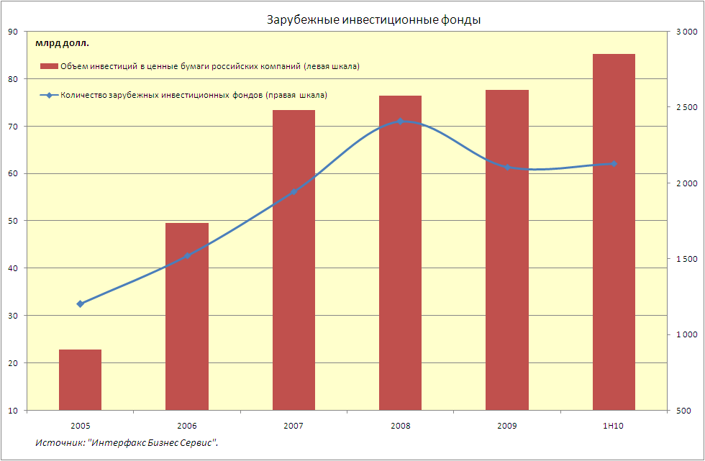
Foreign Investment Funds
billion dollars
Volume of investments in Russian companies securities (left scale)
Number of foreign investment funds (right scale)
The source: the “Interfax business service”
Figure 25

In the first half of 2010, number of funds increased very insignificantly and composed 2.128 funds.
The volume of investments of these funds into Russian companies’ securities (both in local stocks and in depository receipts) is constantly rising. However, the growth rate is considerably slowed down. According to the results of the first half of 2010, the volume of investments of foreign investment funds into Russian companies’ securities increased by 9.8% against the beginning of the year and amounted to 85.2 billion dollars. The relative fraction of Russian assets in foreign funds is low, 3.5% in average of total funds portfolio. About 70% of Russian assets are accumulated in foreign funds, located in Great Britain the USA.
There are few funds that specialize in Russia (the proportion of Russian assets is over 75% of the fund assets) (see Figure 26): from 2005 to the first half of 2010, the amount rose from 24 to 44.
There are much more so called global funds where the proportion of Russian assets does not exceed 10%. In the first half of 2010, the amount of such funds rose a little and amounted to 1,789 funds that is 10% less than in 2008 when the amount of global funds reached its maximum value.

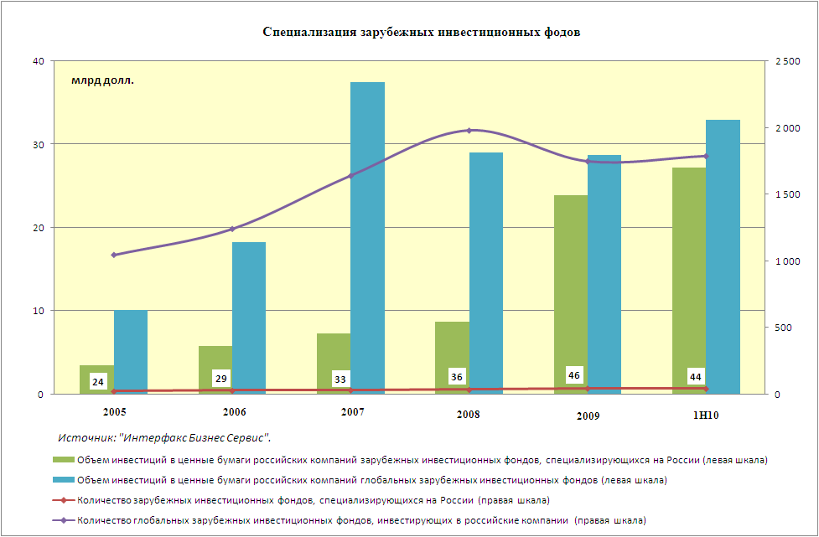
Specialization of Foreign Investment Funds
The source: the “Interfax business service”

 | The volume of investments in Russian companies securities by foreign investment funds that specialize in Russia (the left scale)  The volume of investments in Russian companies securities by global foreign investment funds (the left scale)  The amount of foreign investment funds that specialize in Russia (the right scale)  The amount of global foreign investment funds that invest in Russian companies (the right scale)

Figure 26
The volume of assets in the funds, specializing in Russia is constantly rising. In the first half of 2010, the rise continued, against the beginning of the year the increase made 14%, and the volume of assets reached 27.2 billion dollars. However, in 2009 the growth was much higher – 175%.
Global funds have a reverse tendency: in 2007–2009, the volume of Russian assets in them was constantly decreasing. In the first half of 2010, this tendency changed – over six months the volume of Russian assets in global funds increased by 14.7% and composed 32.9 billion dollars.
In general, the ratio of volume of foreign funds investments in Russian assets performed on Russian and foreign exchanges is estimated as 25% to 75%.
Besides foreign investment funds that disclose the information about their activities, there are foreign hedge funds that also invest in Russian assets; their activity is much less transparent, and that prevents their investments from estimation.

Professional Participants on Securities Markets

Slight growth in the number of professional participants of securities market, observed in 2006–2008 was substituted with downfall by 10%. This resulted from hardening of requirements to internal funds and tightening of attitude of the regulator to the companies, acting with legislation violations. By the moment of the review, compiling the total data for the first half of 2010 was missing.

a) Brokers, Dealers, Trust managers

Russian laws regulate three types of securities market participants’ activity: brokerage activity, dealer activity and securities management activity. In general, the definitions of these activities correspond with the perception that is accepted on developed markets, taking into account the following reservations:
- a brokerage activity as such does not include an accounting of customers’ securities rights, so the brokers that are willing to perform the accounting should obtain a depositary activity license;
- a dealer activity only includes the operations of securities sale that are accompanied by a public announcement of a purchase and/or selling price. That is why the companies that regularly perform securities operations, including the cases when they publicly offer to purchase or sell securities without announcing the price, are free from the regulation;
- a securities trust management differs from a trust management of unit investment funds and non-government pension funds, so there are two different types of licenses for these similar activities.
Data concerning the number of professional intermediaries’ current licenses in 2009-2010 are shown in Table 40.
Table 40
Licenses of Professional Intermediaries

Period | Q1 09 | Q2 09 | Q3 09 | Q4 09 | Q1 10 | Q2 10
Brokerage activity | 1,453 | 1,415 | 1,347 | 1,347 | 1,318 | 1,284
Dealer activity | 1,455 | 1,430 | 1,347 | 1,347 | 1,318 | 1,280
Securities management activity | 1,276 | 1,249 | 1,202 | 1,202 | 1,184 | 1,147
The source: the FFMS of Russia.

During the first half of 2010 the number of professional intermediaries licenses reduced by 4.5% against the beginning of the year. It was the result of the FFMS policy of displacing from the market the companies with securities market professional participants licenses available but not performing activities and not presenting accounts, refusal to continue a professional activity in the period of crisis, reducing business profitability, but generally, it was the result of response to hardening of the requirements to internal funds. Against expectations, measures on of requirements to internal funds hardening have not led to companies’ consolidation. Reduction of the number of professional participants of securities market is especially noticeable in regions.
Let us emphasize that we speak only about the number of granted licenses, but not about the number of organizations that operate on securities market. The majority of professional participants – intermediaries - on securities market have three or four licenses (brokerage, dealer, depository and securities management licenses). Nevertheless, the given statistics also gives adequate reflection of changes in the number of companies – professional participants of securities market.
Summary data on total volumes of transactions of professional market intermediaries are not revealed. Nevertheless, it is possible to specify the place of professional participants on Russian securities market in transactions on organized markets using the data presented by leading Russian stock exchanges.
Table 41 presents the list of traders that performed the greatest volume of transactions with non-state securities on the MICEX Stock Exchange during the first half of 2010. Altogether 643 organizations participated in trading during the half a year.
Table 41
List of Traders that Performed the Greatest Volume of Transactions with Non-State Securities on the MICEX Stock Exchange
(according to the results of the first half of 2010)

Seq. No | Name of organization | Transactions volume (purchase and sale) billion RUR | Proportion in the total volume (%)
1 | Sberbank of Russia, OJSC | 4,092.7 | 7.0
2 | Investment Company Troika Dialog, CJSC | 3,894.8 | 6.7
3 | JSCB CentroCredit, CJSC | 3,613.3 | 6.2
4 | FINAM, CJSC | 2,608.3 | 4.5
5 | VTB Bank, OJSC | 2,585.4 | 4.4
6 | BCS Company, LLC | 2,333.6 | 4.0
7 | VTB Capital, CJSC | 2,304.4 | 3.9
8 | Renaissance Broker , LLC | 1,820.1 | 3.1
9 | Promsvyazbank, OJSC | 1,284.8 | 2.2
10 | OTKRITIE Brokerage house, OJSC | 1,261.7 | 2.2
11 | ALOR+, LLC | 1,199.1 | 2.1
12 | VTB 24, CJSC | 974.6 | 1.7
13 | ATON, LLC | 824.3 | 1.4
14 | GPB, OJSC | 771.5 | 1.3
15 | Investment Company ZERICH Capital Management, OJSC | 762.9 | 1.3
16 | Bank of Russia | 760.0 | 1.3
17 | URALSIB, OJSC | 758.4 | 1.3
18 | Saint-Petersburg Bank, OJSC | 753.8 | 1.3
19 | UBRD, OJSC | 742.0 | 1.3
20 | National Bank TRUST, OJSC | 734.9 | 1.3
TOTAL |  |  | 58.3
The source: the MICEX.

Thus, turnover concentration of trading participants at the MICEX Stock Exchange is very high – the rate of the top ten most active operators takes 44% of the total turnover, and that of the top twenty companies – 58%. Both the list of leaders and turnover concentration ratio over the period under review do not differ significantly from the results of the previous year.
Specialization in different types of securities is characteristic for many participants of trading at the MICEX Stock Exchange. Tables 42 and 43 present similar lists individually for stock transactions and transactions with corporate bonds.

Table 42
List of MICEX Traders that Performed the Greatest Volume of Stock Transactions
(according to the results of the first half of 2010)

Seq. No | Name of organization | Transactions volume (purchase and sale) billion RUR | Proportion in the total volume (%)
1 | Investment Company Troika Dialog, CJSC | 3,010.3 | 10.5
2 | FINAM, CJSC | 2,593.7 | 9.1
3 | BCS Company, LLC | 2,086.5 | 7.3
4 | Sberbank of Russia, OJSC | 1,646.0 | 5.7
5 | VTB Capital, CJSC | 1,565.0 | 5.5
6 | Renaissance Broker , LLC | 1,420.1 | 5.0
7 | ALOR+, LLC | 1,181.5 | 4.1
8 | OTKRITIE Brokerage house, OJSC | 1,149.3 | 4.0
9 | VTB 24, CJSC | 900.8 | 3.1
10 | Investment Company ZERICH Capital Management, OJSC | 761.1 | 2.7
11 | ATON, LLC | 739.5 | 2.6
12 | GPB, OJSC | 582.8 | 2.0
13 | Saint-Petersburg Bank, OJSC | 513.1 | 1.8
14 | BANK CREDIT SWISS (MOSCOW), CJSC | 496.8 | 1.7
15 | ALFA_BANK, OJSC | 433.1 | 1.5
16 | VTB Bank, OJSC | 403.7 | 1.4
17 | JSCB CentroCredit, CJSC | 403.6 | 1.4
18 | KIT Finance, LLC | 401.7 | 1.4
19 | JSCB Probusinessbank, OJSC | 359.2 | 1.3
20 | Promsvyazbank, OJSC | 357.4 | 1.2
TOTAL |  |  | 73.3
The source: the MICEX.

Table 43
List of MICEX Traders that Performed the Greatest Volume of Corporate Bonds Transactions
(according to the results of the first half of 2010)

Seq. No | Name of organization | Transactions volume (purchase and sale) billion RUR | Proportion in the total volume (%)
1 | VTB Bank, OJSC | 1,359.0 | 6.3
2 | Sberbank of Russia, OJSC | 1,196.8 | 5.5
3 | JSCB CentroCredit, CJSC | 867.1 | 4.0
4 | Promsvyazbank, OJSC | 760.4 | 3.5
5 | Investment Company Troika Dialog, CJSC | 750.6 | 3.5
6 | National Bank TRUST, OJSC | 719.2 | 3.3
7 | VTB Capital, CJSC | 680.2 | 3.1
8 | UBRD, OJSC | 593.6 | 2.7
9 | Bank of Russia | 591.7 | 2.7
10 | Raiffeisen BANK, CJSC | 540.0 | 2.5
11 | MDM Bank, OJSC | 465.3 | 2.2
12 | THE BANK OF KHANTY-MANSIYSK, OJSC | 454.7 | 2.1
13 | RIC-finance, LLC | 450.6 | 2.1
14 | URALSIB, OJSC | 446.3 | 2.1
15 | RONIN, LLC | 439.3 | 2.0
16 | NOMOS-BANK, OJSC | 416.2 | 1.9
17 | ING BANK (EURASIA), CJSC | 397.4 | 1.8
18 | Vnesheconombank | 370.8 | 1.7
19 | ICB Sovcombank, LLC | 362.8 | 1.7
20 | Ursa Capital, LLC | 327.3 | 1.5
TOTAL |  |  | 56.4
The source: the MICEX.

The greatest traders concentration could be seen in stock transactions (the first ten traders provide 56% of the volume of transactions, and the first twenty – nearly 75%). As for corporate bonds, the turnover concentration among traders is lower (37 and 56% correspondently). Lists of leaders as well as turnover concentration ratio according to different securities types over the period under review do not differ significantly from the results of the previous year either.
It is typical that the greatest activity in transactions with bonds was performed by credit organizations as well as by the Bank of Russia and Vnesheconombank.
Traders are entitled to operate both at customer’s expense (customer trading) and at their own expense. Table 44 shows data on the companies that performed the greatest amount of customer trading on the MICEX Stock Exchange in the first half of 2010. It is important to mention that unlike the data presented in Tables 42-44, this table shows the data that only concern the companies that permitted the MICEX Stock Exchange to reveal the information about their volumes of customer trading.
Table 44
List of Traders that Performed the Greatest Amount of Customer Trading on the MICEX Stock Exchange
(according to the results of the first half of 2010)

Seq. No | Name of organization | Customer transactions volume (purchase and sale) billion RUR
1 | Investment Company Troika Dialog, CJSC | 3,894.8
2 | FINAM, CJSC | 2,608.3
3 | BCS Company, LLC | 2,333.6
4 | ALOR Group of Companies | 1,324.6
5 | OTKRITIE Brokerage house, OJSC | 1,261.7
6 | VTB 24, CJSC | 956.2
7 | ATON, LLC | 823.5
8 | Investment Company ZERICH Capital Management, OJSC | 762.9
9 | RONIN, LLC | 644.6
10 | Investment Company VELES Capital, LLC | 605.2
The source: the MICEX.

Compared to the results of 2009 the list of traders with the greatest amount of customer trading has not changed significantly.
Table 45 contains a list of traders that performed the greatest volume of non-state securities transactions in all trading regimes on RTS Classica, RTS Exchange market as well as on RTS Standard market during the first half of 2010. The total amount of trader organizations is 140.
Table 45
List of Traders that Performed the Greatest Amount of Securities Transactions on
RTS Securities Market
(according to the results of the first half of 2010)

Seq. No | Name of organization | Transactions volume (purchase and sale) billion RUR | Proportion in the total volume (%)
1 | OTKRITIE Brokerage house, OJSC | 992.1 | 31.2
2 | Investment Company Troika Dialog, CJSC | 702.7 | 22.1
3 | ALOR+, LLC | 556.1 | 17.5
4 | Investment Company IT Invest, OJSC | 405.9 | 12.8
5 | IF OLMA, OJSC | 250.4 | 7.9
6 | FC Infina, CJSC | 34.0 | 1.1
7 | JSCB Metallinvestbank, OJSC | 31.7 | 1.0
8 | BCS Company, LLC | 30.4 | 1.0
9 | FINAM, CJSC | 18.7 | 0.6
10 | IFC DVM-INVEST, CJSC | 18.1 | 0.6
TOTAL |  |  | 95.5
The source: RTS.

Thus, taking into account that a less amount of organizations participates in trading on RTS Securities Market, than on the MICEX Stock Exchange, the operations concentration is much higher here – nearly 7% of all traders provided over 95% of trading turnover, and at the same time the volume of operations of just one investment company exceeded 30% of the total turnover. According to our estimates, transactions concentration of the RTS Securities Market participants tends to growth. It is also necessary to emphasize that the list of turnover leaders at the RTS Securities Market does not change significantly.
The concentration of clearing organizations operations on RTS FORTS is the same high (see Table 46).
Table 46
List of Traders that Performed the Greatest Volume of Derivative Contracts
Transactions on FORTS
(according to the results of the first half of 2010)

Seq. No | Name of organization | Transactions volume (purchase and sale) billion RUR | Proportion in the total volume (%)
1 | Investment Company IT Invest, OJSC | 3739.8 | 14.5
2 | BCS Company, LLC | 3322.9 | 12.9
3 | Otkritie Group of Companies | 3203.3 | 12.4
4 | Investment Company ZERICH Capital Management, OJSC | 2178.5 | 8.4
5 | Alor Group of Companies | 1922.9 | 7.4
6 | FINAM, CJSC | 1254.7 | 4.9
7 | Investment Company Troika Dialog, CJSC | 994.8 | 3.9
8 | Alfa-Bank, OJCS | 988.1 | 3.8
9 | KIT Finance, LLC | 806.4 | 3.1
10 | VTB 24, CJSC | 644.5 | 2.5
TOTAL |  |  | 73.8
The source: RTS.

Thus, the top ten out of 137 clearing companies made 73% of trading turnover at this market for the first half of 2010. According to our estimates, transactions concentration of the RTS derivative market on the contrary has a tendency for reduction.

b) Trading and Clearing Infrastructure

The trading and clearing infrastructure of the Russian securities market is formed by securities market professional participants that perform the following types of activities:

- the settlement of securities market trade activities (including stock exchanges);
- clearing activities;
- depository activities as clearing depositories.
Besides the infrastructure includes non-banking credit companies which act as clearing organizations.
The number of organizations with licenses of trade organizers, stock exchange or license of a clearing organization is stable over the recent years and changes very insignificantly. According to the FFMS of Russia by the end of the first half of 2010, nine organizations have trade organizer or stock exchange licenses, and eleven organizations have clearing organization licenses.
As a result of market rivalry and objective integration, process two leading infrastructure centers that form today the organized securities market and derivatives market in Russia – the MICEX Group and the RTS Group– have been formed.

The MICEX Group is a vertically integrated trading and clearing infrastructure including:
- Moscow Interbank Currency Exchange, CJSC;
- MICEX Stock Exchange, CJSC;
- The National Depository Center, CJSC;
- Non-Banking Credit Organization MICEX Clearing House (CJSC);
- Joint-Stock Commercial Bank National Clearing Center, CJSC.
- MICEX — Information Technologies, CJSC.
The MICEX Group supports several trading regimes:
- the government securities market;
- a basic trading regime;
- a negotiated deals regime;
- a REPO trading regime.
- derivative market.
Values of property capital of the MICEX Group Companies, related to securities circulation are given in Table 47.

Table 47
Property Capital of Companies, Being a Part of the MICEX Group
(million RUR.)

 |  | MICEX Stock Exchange, CJSC | National Depository Center, CJSC | MICEX, CJSC | MICEX Clearing House, CJSC
Functions at non-state securities trading organization |  | Trade organizer | Depository | Clearing | Clearing organization
Period | Q1 09 | 337.9 | no data | no data | 2,930.9
Period | Q2 09 | 210.5 | 919.3 | 4,993.7 | 3,394.3
Period | Q3 09 | 347.8 | 1,087.2 | 5,116.0 | 3,834.1
Period | Q4 09 | 495.7 | 1,150.5 | 4,668.4 | 4,085.1
Period | Q1 10 | 721.9 | 1,643.6 | 5,813.6 | 4,424.8
Period | Q2 10 | 416.5 | 1,289.9 | 4,756.5 | 4,759.1
The source: the MICEX.
The basis of the trading mechanism on the government securities market (the organizer Moscow Interbank Currency Exchange, CJSC) is an “order-driven market” principle, which is a competing orders market where a transaction is performed automatically when conditions of offsetting orders meet. Transactions are performed according to the principle of “delivery versus payment” when 100% of preliminary asset deposit is done. The trade settlement is to be done on the date of agreement (Т+0).
The MICEX Equity Market (the organizer: MICEX Stock Exchange, CJSC) is also based on the “order-driven market” principle, “delivery versus payment” when 100% of preliminary asset deposit is done and a trade settlement is performed on the date of agreement (Т+0).
In a negotiated deals regime (NDR) traders have an opportunity to quote securities by making zero-address orders (invitation to offer for all traders) and make bilateral (non-anonymous) transactions using offsetting address orders (a transaction offer on the part of one trader to another trader). At the same time traders, while making a transaction, define a settlement date that is to be between the current trading date (Т+0) and 30 calendar days after the date of agreement (Т+30). This regime allows traders to make transactions either with a total provision control, or without a provision control.
The REPO trading regime allows making transactions with any settlement date starting with the next day after the date of agreement through the chosen date of its settlement. The date of settlement of the second part of a REPO transaction is the date Т+x+k, where Т+x is an appropriate settlement date of the first part of a REPO transaction, and k is the REPO transaction term (k takes on a value of 0 to 180 calendar days, and x takes on a value of 0 to 2 clearing days).
The clearing of the transactions that were made on the MICEX Stock Exchange is done by MICEX, CJSC. The clearing of traders net-obligations of completed transactions is done according to accounting documents of MICEX, CJSC as a clearing center and by MICEX Clearing House (monetary assets clearing organization) and by NDC, CJSC (clearing securities depository).
In the beginning of 2010, a new trading regime MICEX+ was introduced at the MICEX Securities Market. Peculiarity of this regime is a possibility to make transactions under the terms of partial preliminary assets depositing and settlements Т+n. Centralized clearing is carried out at making transactions in this regime, functions of the central counterparty (CC) are performed by MICEX, CJSC. Trades in this regime are carried out with stocks from MICEX Index and high-security bonds (at the present moment that is 30 stocks and 3 bonds). All traders within the limits established upon them may make transactions in this regime. Traders have an opportunity to make transactions in regimes “CC- general trades regime”, “CC- NDR”, “CC-REPO”.
Derivative Market. The MICEX Group established single market of derivatives, organizationally divided into several segments, including derivatives for securities and stock indexes and market for other financial assets (currency, interest rates). The organizer of trades of derivatives for securities and stock indexes is the MICEX Stock Exchange, CJSC and the organizer of trades for other financial assets – the MICEX, CJSC. Functions of clearing organization at the MICEX Derivative Market are performed by MICEX, CJSC. Settlements based on the trading results are carried out via the MICEX Clearing House. Execution of derivative contracts on securities is performed via NDC, CJSC.
The regime of integrated delivery and settlements on derivative contracts on securities and transaction at the stock market was introduced in March 2010.
Trades in different regimes are executed from 10:00 a.m. to 7:00 p.m.
Some specialized trading floors have also been established in the MICEX Group.
The Market for Innovations and Investments (MII) has existed since 2007, initially it was called the Sector for Innovation and Growth Companies (IGC), in the mid 2009 after signing of an agreement between the MICEX and ROSNANO it got its present name. This market is oriented at high-tech companies and destined for their financing with stock mechanisms application, including holding of private placements among funds and qualified investors. In 2007 – first half of 2010 six placements were made at this market, including one in 2010. Total volume of placements according to the data of different sources composed about 75 million dollars. Total turnover with stocks of the companies, carried out placement at this market, composed about 3.5 billion RUR in 2007–2009 and 2.2 billion RUR in the first half of 2010.
The Sector MICEX Discovery was established in 2008 as a part of the common market of the stock exchange with a special procedure of stock introduction and companies’ selection criteria. The stocks included in this sector are introduced to trading at the initiative of the stock, which uses a company selection system and information sponsorship institution for cushioning of risks. During 2008 – 2010, this sector included stocks of nearly 40 Russian companies. According to the results of 2008-2009, the volume of stock transactions of these issuers amounted to 14.5 billion RUR and 27.5 billion RUR in the first half of 2010.
Although alternative grounds – the MII Sector and MICEX Discovery demonstrate tendency to growth in the total volume of stock transactions (including REPO transactions) but make no more than 0.1%.
In May 2010, the General Shareholders Meeting considered the issue of the MICEX Group transfer for “the unified stock”, the first stage of which should be integration of NDC, CJSC with MICEX Clearing House, CJSC.

Summary results of trading non-state securities and derivative contracts at the MICEX Stock Exchange in 2009–2010 considering all regimes are given in Table 48.
Table 48
Summary Results of Trading Non-State Securities and Derivative Contracts
at the MICEX Stock Exchange

Period | Volume of trading at stock market |  | Volume of trading at derivative market
Period | billion dollars | billion RUR | billion RUR
Q1 09 | 203.5 | 7,064.7 | 0.0
Q2 09 | 305.4 | 9,766.1 | 3.2
Q3 09 | 376.1 | 11,759.2 | 13.5
Q4 09 | 419.1 | 12, 074.0 | 45.1
Q1 10 | 435.6 | 12, 998.6 | 151.8
Q2 10 | 538.1 | 16, 230.0 | 253.4
The source: the MICEX.

Rise in the turnover started to develop only at the end of 2009 and continued during the whole first half of 2010. Consequently, according to the results of this half-year the volume of non-state securities transactions at the MICEX Stock Exchange composed 29.2 trillion RUR that is 22.5% more than for the second half of the previous year.
During the first half of 2010, the volume of outstanding commitments at the MICEX Stock Exchange reduced abruptly: over this period, eight outstanding transactions with total volume of 58 million RUR were recorded. To compare, in 2008–2009 1,509 outstanding commitments were recorded with the total volume 40.6 billion RUR.
The RTS Group is an integrated trading and clearing infrastructure that includes:
- Non-Commercial Partnership Stock Exchange Russian Trading System;
- Stock Exchange Russian Trading System, OJSC;
- Non-Commercial Partnership Saint Petersburg Stock Exchange;
- RTS Clearing Center, CJSC;
- Non-Banking Credit Organization RTS Clearing House (LLC);
- Depository Clearing Company, CJSC.
RTS Group supports several trading regimes:
- Exchange Market (market T+0);
- RTS Standard Market
- RTS Classica;
- FORTS.
The trading organizer is Stock Exchange Russian Trading System, OJSC. Non-Commercial Partnership Saint Petersburg Stock Exchange performs the stock trading of GAZPROM, OJSC.
Values of property capital of the RTS Group, related to securities circulation are given in Table 49.
Table 49
Property Capital of Companies, Being a Part of the RTS Group
(million RUR)

 |  | Stock Exchange Russian Trading System, OJSC | Depository Clearing Company, CJSC | RTS Clearing Center, CJSC | RTS Clearing House, LLC
Functions at non-state securities trading organization |  | Trade organizer | Depositary | Clearing | Clearing organization
Period | Q1 09 | no data | no data | no data | 1,216.8
Period | Q2 09 | no data | 1,031.2 | no data | 1,282.2
Period | Q3 09 | no data | 1,058.9 | no data | 1,326.4
Period | Q4 09 | no data | 1,087.5 | no data | 1,301.3
Period | Q1 10 | 694.6 | 1,099.8 | 1,783.9 | 1,345.5
Period | Q2 10 | 716.8 | 943.1 | 1,550.9 | 1,349.8
The source: RTS.
RTS Exchange Market is based on the following principles: order-driven market and 100% of a preliminary asset deposit, payment method - “delivery versus payment” on Т+0; quotes and clearing are in rubles. RTS Clearing Center, CJSC acts as a clearing center, Depository Clearing Company, CJSC is a clearing depository; RTS Clearing House is a clearing credit organization.
RTS Standard is based on the order-driven market principle; partial deposit is acceptable, payment method is “delivery versus payment” on Т+4; quotes and clearing are in rubles. RTS Clearing Center, CJSC acts as a clearing center, Depository Clearing Company, CJSC is a clearing depository; RTS Clearing House is a clearing credit organization. While clearing, a “central counterparty clearing” method is used. At present time, nearly 20 securities are introduced for trading. RTS Standard provides an evening trading session. The main trading session starts at 10:00 a.m. and closes at 6:45 p.m., which is followed by a clearing session. The evening trading session is held from 7:00 p.m. to 11:50 p.m., the clearing is held at 2:00 p.m. of the following day.
In April 2010, a new opportunity to execute REPO transactions with the central counteragent with clearing from one to four days for zero-address and address proposals was introduced at RTS Standard.
RTS Classica operates in two trading modes:
- RTS Classica is a non-anonymous trading mode that means a closing of a transaction on the basis of non-anonymous quotes (quote-driven market), the absence of a preliminary asset deposit, quotes in US dollars, and an opportunity to choose a clearing date (Т+0 to Т+30), clearing method (“delivery versus payment” or free delivery), and the currency of settlement (both rubles and foreign currency). A clearing center and clearing depository are not used. RTS Clearing House or J.P Morgan Chase Bank are used for “delivery versus payment” clearing, and any bank - in a free delivery mode.
- RTS Classica with an anonymous trading mode that means an anonymous order auction (order-driven market), partial preliminary asset deposit, clearing method is “delivery versus payment” (Т+4), quotes and clearing are in US dollars. RTS Clearing Center, CJSC acts as a clearing center, Depository Clearing Company, CJSC - as a clearing depository, RTS Clearing House as J.P Morgan Chase Bank are clearing credit organizations.
While clearing of the most liquid securities “central counterparty clearing” method is used (nine stocks at present time).
FORTS is based on an anonymous order auction (order-driven market). Clearing and delivery are performed at the end of contract circulation. Quotes and clearing are done in rubles. RTS Clearing Center, CJSC acts as a clearing center, Depository Clearing Company, CJSC is a clearing depository; RTS Clearing House is a clearing credit organization. The main trading session closes at 6:45 p.m., which is followed by a clearing session. The evening trading session is held from 7:00 p.m. to 11:50 p.m., the clearing is held at 2:00 p.m. of the following day. Unified delivery and clearing at FORTS and RTS Standard are introduced in March 2010.
Besides, in the framework of RTS there is a system of indicative quotation, RTS Board, based on the following principles: entering of indicative quotes of securities that were not introduced to trading at RTS Stock Exchange, the absence of preliminary deposit of securities and monetary resources, US dollar quotes, an opportunity to choose a clearing date (Т+0 to Т+30), clearing method (“delivery versus payment” or free delivery), the currency of settlement (both rubles and foreign currency). A clearing center and clearing depository are not used. RTS Clearing House or J.P Morgan Chase Bank are used for “delivery versus payment” clearing, and any bank - in a free delivery mode.
In 2007–2008 RTS Group realized specialized trading floors:
- RTS START – for introduction of small-cap companies to the open market;
- RTS Global – for entering of indicative quotes of foreign securities, closing of off-exchange transactions, and for transaction clearing in Depository Clearing Company, CJSC.
From the date of launching of these floors, the volumes of transactions are insignificant.
From May 2010, the trading session at all markets of the RTS Group starts 30 minutes earlier – at 10:00 a.m...
Summary trading results at various markets of the RTS Group in 2009–2010 are presented in Table 50.

Table 50
RTS Trading Results of Non-State Securities and Derivative Contracts

Period | RTS Classica | RTS Exchange Market | RTS Standard | The Exchange Market of Saint Petersburg Stock Exchange | FORTS | RTS Board
Period | billion dollars | billion RUR | billion RUR | billion RUR | billion RUR | billion dollars
Q1 09 | 0.4 | 1.0 |  | 0.3 | 1,790.4 | 9.4
Q2 09 | 0.6 | 7.0 | 217.9 | 0.6 | 3,253.7 | 19.8
Q3 09 | 0.6 | 1.6 | 542.3 | 0.3 | 3,736.7 | 30.1
Q4 09 | 0.8 | 2.0 | 796.3 | 0.2 | 5,388.4 | 49.7
Q1 10 | 0.7 | 1.8 | 672.5 | 0.1 | 5,268.2 | 34.4
Q2 10 | 0.6 | 3.9 | 894.3 | 0.2 | 7,639.1 | 35.8
The source: RTS.

By the end of the first half of 2010, the main spot market at RTS became RTS Standard, which shows rapid growth pace from the moment of its launch, except for the first quarter of 2010. Other RTS spot markets are characterized with high changeability of turnover from quarter to quarter.
According to the Provision on the Information Presentation, stock exchanges collect information about off-exchange securities transactions that are listed in quotation lists of stock exchanges. Figure 28 shows a graph characterizing the proportion of reported off-exchange transactions in the summary volume of exchange (not taking into account REPO transactions) and reported off-exchange transactions performed (reported) in the MICEX Stock Exchange and the RTS.

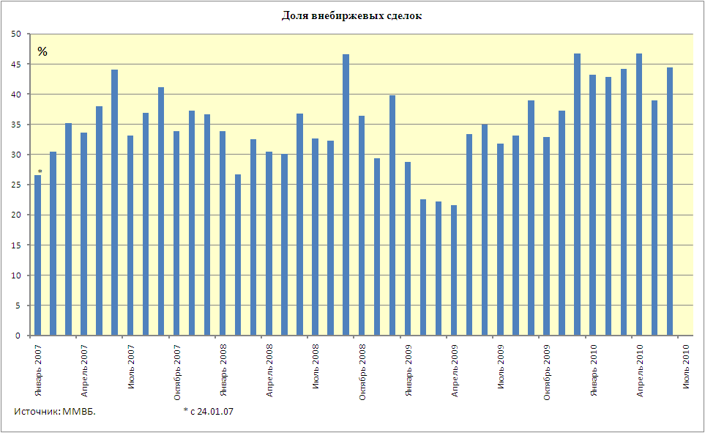

Jan 2007

April 2007

July 2007

October 2007

Jan 2008

April 2008

July 2008

October 2008

Jan 2009

April 2009

July 2009

October 2009

Jan 2010

April 2010

July 2010

Volume of Off-Exchange Transactions
The source: the MICEX *from 24.01.07

Figure 28
From May, 2009 to the end of the first half of 2010 the volume of off-exchange transactions started to grow intensively, in some months exceeding the level 45%; average value for six months of 2010 amounted to 43%, this is the maximum average value since the time of information provision on off-exchange transactions. To compare, in February – March 2009 the proportion of off-exchange transactions fell down to the value a little higher than 20%.

c) Accounting System

There are two alternative ways of securities entitlement account that have equal legal force at Russian securities market: according to personal accounts in a register system and according to deposit accounts in depository. Registrars, depositaries, and issuers who independently maintain a register of their shareholders as a whole form the accounting system of securities market. Registrar and depository activities are licensable.
A registrar is a securities market professional who maintains a register of securities holders (compilation, recording, process, storage and presentation of the data that form the register system of securities holders). A registrar acts on the basis of an agreement with a securities issuer; people who open an account in the register do not enter into an agreement with a registrar. An issuer that has less than 50 shareholders is entitled to maintain the register independently or enter into an agreement with a registrar. If there are more than 50 shareholders, an issuer shall delegate the maintaining of the register to a registrar, although the issuer remains in charge of the register maintaining.
A depository provides services for accounting and certification of securities rights, accounting and certification of securities transfer, and securities storage (certificated securities). A depository acts on the basis of an agreement with a securities holder or another person that have other rights in respect of securities (a depository agreement).
Depositaries in Russia, according to the world practice, are divided into clearing and custodian depositaries. Clearing depositaries are the depositaries that perform securities clearing according to clearing results and all the operations concerning depositary accounts of securities market traders in settlement of the transactions performed through trade organizers. Custodian depositaries are all other depositories.
Table 51 shows data on the amount of current registrar and depository licenses.
Table 51
Licenses of Registrars and Depositories

Period | 2005 | 2006 | 2007 | 2008 | 2009 | 1H 10
Type of activity
Registrar activity | 82 | 73 | 66 | 59 | 50 | 48
Depositary activity | 743 | 831 | 787 | 789 | 761 | 741
The source: the FFMS of Russia.

Thus, according to Table 51, over the recent years the amount of registrar has obviously shown the tendency for reduction. The same tendency has been characteristic of depository activities since 2007.

Regulatory framework and activities

In the Russian Federation the securities market regulatory base is formed by several laws (“On Securities Market”, “On the Protection of Rights and Legal Interests of Investors on Securities Market”, “On Mortgage-Backed Securities”), that define general rules, operating at the securities market and subordinate laws (mainly by RF Government's Decisions and Orders of the FFMS of Russia), establishing special standards. The activities of some institutions are regulated by special laws: “On Investment Funds”, “On Non-Governmental Pension Funds”, “On Resources Investment of for the Funded Component of a Retirement Pension Financing”, “On Savings and Mortgage System of Housing Supply for Military Population” which are also accompanied by a considerable volume of subordinate regulation.
In the first half of 2010 significant changes took place in the regulatory framework related to the securities market regulation.
On January1, 2010 Order of the FFMS of Russia came into force , approving a new Provision on procedure of issue by the FFMS of Russia of permits for placement and (or) arrangement of circulation of equity securities of Russian issuers outside the Russian Federation, including placement and circulation of securities of foreign issuers, confirming the rights in respect of securities of Russian issuers. This Provision extends the list of documents, provided for permit obtaining by the FFMS of Russia, as well as it defines the requirements for the data, contained in the application for its obtaining in more details. The document establishes new standards of placement and (or) circulation of Russian issuers’ stocks outside of the Russian Federation. In particular, the number of the Russian issuers’ stocks, placement and (or) circulation of which are supposed to be carried out outside of Russia (including placement and circulation of foreign securities) shall not exceed 25% from the total amount of the issuer’s stocks of the same category, if the issuer’s stocks are listed in quotation list “A” (of the first or second level) of the stock exchange; 15% – if the Russian issuer’s stocks are listed in quotation list “B” of the stock exchange and 25% – if the applicant is the issuer of foreign securities with the place of establishment in the country with the relevant body of which there is an agreement concluded by the FFMS of Russia , providing the procedure of their interaction.
In February 2010, the FFMS of Russia approved the list of foreign institutions, carrying out recording of rights to securities, which may be attracted for the purposes of rights recording to securities, admitted for circulation in the Russian Federation. Russian depositaries have a right to open accounts for their customers in such organizations. The lists include 63 institutions.
Moreover, by its Order the FFMS of Russia established requirements to the broker, signing the prospectus of the foreign issuer. As of signing the prospectus such broker shall have the amount of internal funds at least 150 million RUR and to conduct brokerage activity for at least for 3 years and during the last three years to tender services for arrangement of placement or placement of at least ten issues of equity securities.
From 13.03.2010 amendments, introduced into the Provision on Issue Procedure by the FFMS of Russia of Permit for Placement and (or) Arrangement of Circulation of Equity Securities of Russian Issuers outside the Russian Federation came into force. These amendments establish terms of obtaining of permits for arrangement of circulation outside of Russia for the Russian issuers’ securities, included in quotation list “A” by the stock exchange. One of such terms is signing of the application for obtaining of circulation arrangement permit by Russian depository. Such depository shall satisfy a set of conditions. Firstly, it should carry out its activity for at least 7 years; secondly, the amount of its internal capital as well as market value of securities, accepted for depositary service shall make at least 150 billion.
In March, 2010 Order of the FFMS of Russia dated 23.03.2010 No 10-19/pz-n established requirements to depositaries, carrying out recording of rights for securities of foreign issuers, accepted for public placement and (or) public circulation in the Russian Federation. Thus, the depositary shall execute its activity for at least one year and it is obliged to render services, related to profit receipts on securities of foreign issuers and other payments, accrued to holders of foreign stocks, each depositor.
Issues, related to the registration procedure of prospectus of foreign issuers and the procedure of decision-taking of such securities admission for placement and (or) public circulation in the Russian Federation by the FFMS of Russia are regulated by a new Order of the FFMS of Russia. The document provides mandatory terms for admission of securities of foreign issuers for placement and public circulation in the Russian Federation and the list of documents, submitted by the foreign issuer to the FFMS of Russia.
On 20.04.2010 Order of the FFMS of Russia dated 09.02.2010 No 10-5/pz-n “On Approval of the Provision on the Scope and Calculation Procedure of Indexes, Characterizing the Level of Liquidity (Estimated Liquidity) and the Level of Investment Risk of Securities, which are the Basis for the Federal Executive Body to Take Decision on Admission of Securities of Foreign Issuers for Public Placement and (or) Public Circulation in the Russian Federation” came into force. The indexes, characterizing the level of liquidity include the difference between the best-asked price for sale and the best bid price for securities, the volume of submitted applications for sale and purchase of securities, as well as securities trading volume. The indexes of securities investment risk for different securities types include the international credit rating, the value of the mean square deviation of securities price change or the term of the issuer’s existence and whether he has losses according to his accounting reports. Formulas for calculation of the specified indexes are approved.
The Federal Law dated 25.11.09 No 281-FZ implemented some changes to the Tax Code Law «Concerning the Securities Market” and other individual legal acts of the Russian Federation. The amendments, in particular, specify the procedure of maintenance of tax records for derivative transactions when applying accrual method as well as for REPO transactions.
Significant changes are introduced into the procedure of income taxation of individuals on transactions with financial instruments of derivative transactions. The procedure of transaction, established for derivative transactions which underlying asset is securities is extended for transactions with other financial instruments of derivative transactions. Balancing of income and expenditures on transactions with financial instruments of derivative transactions and on transactions with relevant underlying asset is provided. Taxpayers are entitled to transfer the losses on transactions with publicly traded securities and derivative transaction financial instruments, received during the current tax period, to the next tax period (within 10 years) in order to reduce relevant tax base. Tax treatments of personal income on repo transactions, coming into force from January 1, 2011 are established. Earlier the repo agreements, concluded by individuals were considered as two independent transactions of securities sale and purchase. In compliance with amendments, the tax base on the specified transactions shall be defined as interest income on loans, making the difference between the securities price for the first and second repo leg. Income balancing in the form of the received interests for one-repo transactions with expenditures in the form of the accrued interests for other repo transactions shall be provided.
Amendments to Chapter 25 of the Tax Code excluded transactions with financial instruments, performed by clearing institutions and providing clearing and settlements for such transactions from the tax base on corporate profits tax. Besides, the amendments establish equal tax treatment for exchange and off-exchange derivatives, as well as they provide a possibility of attribution of losses from such transactions to the financial result, regardless of the fact whether such transactions were carried out for the purpose of hedging or not.
Concepts of financial instrument, financial derivative and REPO agreement were introduced to Law “Concerning the Securities Market”. Requirements to the REPO agreement were established, the cases were given when it should be assumed to terminate obligations under the second part of the REPO agreement without obligations execution in kind after execution of the first part of the REPO agreement. The REPO agreement, subject for execution by an individual, may be concluded if one of the parties under such agreement is a broker, dealer, depositary, manager, clearing institutions or credit organization or such agreement is concluded by the broker at the expense of an individual.
Specific features of agreement conclusion, being financial derivatives were defined. Thus, traders at the stock exchange trading may conclude agreements, being financial derivate under the condition that the other party under such agreement is a clearing institution. Concluding of agreements, being financial derivatives and meant for qualified investors may be carried out only via brokers. The law established an opportunity to acknowledge several financial derivatives as one agreement, should the parties of such agreements conclude the general agreement – unified agreement. The general agreement may provide grounds and termination procedure for obligations under all the agreements, being financial derivatives, concluded between the parties under the terms, established by the specified general agreement.
Besides, some amendments to the definition of the brokerage activity and activity on securities management, providing better distinguishing of these activity types were introduced.
To develop amendments, introduced to the Federal Law “Concerning the Securities Market”, the FFMS of Russia approved the Provision on Financial Derivatives Types. The financial derivate include optional agreement (contract), futures agreement (contract), exchange derivative agreement (contract), off-exchange derivative agreement (contract), swap agreement (contract). The Provision determined underlying assets of the specified agreements (securities, products, currency, interest rates, inflation rate, official statistical information, physical, biological or chemical environmental indicators, circumstances indicative of non-performance or improper performance of obligations by legal entities, states or municipal units, circumstances provided by federal laws or regulatory legal acts of the federal executive body for the securities market and in which regard it is unknown whether they occur or not and etc.).
The Order of the FFMS of Russia dated January 26, 2010 introduced amendments to the Licensing Procedure of the Professional Activity Types at the Securities Market, to the Provision on Trade Organization at the Securities Market and to the Provision on Information Presentation about Transactions Conclusion. According to these amendments the person has a right to hold the position of the sole executive body of the licensee only provided he has working experience of at least two years in organizations and positions, defined by the Order. In compliance with the amendments, introduced to the Provision for the Activity on Trade Organization at the Securities Market, the main trading session is acknowledged trading, held within the trading session from 9 a.m. to 7 p.m. of local time but not to 6 p.m. as it was acknowledged before. At the same time the approach is preserved, in compliance with which transactions, concluded during the evening (supplementary trading session) are cleared on the following trading day.
On January 28, 2010 by its Order, coming into force on 04.06.2010, the FFMS of Russia approved a new Provision on Specialists of the Securities Market. The document extends the list of persons who are acknowledged as specialists of the securities market, and, on this basis, they shall satisfy some special requirements. It is directly provided that for the purposes of the Provision specialists of the securities market do not include employees of subdivisions whose only function is accounting keeping, legal support of the company’s activity, informational and technical support of the company’s activity or economic activity execution.
In general, higher qualification requirements to specialists of the financial market are established, compared to the requirements, established before by the applicable Provision on Financial Market Specialists, approved by Order of the FFMS of Russia dated April 20, 2005 No 05-17/pz-n. For example, higher professional education is a mandatory requirement for all specialists of the organization.
Except particular provisions, on March 8, 2010 the Provision on Activity Licensing of Exchange Intermediaries and Exchange Brokers, Concluding Agreements, Being Financial Derivatives, the Underlying Asset of which is Exchange Commodity in the Exchange Trade came into force. The document defines terms and procedure of issue, suspension and cancellation by the federal executive body for the securities markets of licenses for concluding agreements (financial derivatives) the underlying asset of which is exchange commodity by exchange intermediaries and exchange brokers. The capital requirement to the exchange intermediary in the amount of at least 2 million RUR was introduced as a license one, as well as the requirement of availability of at least one employee whose obligations involve maintaining internal account of exchange transactions, made in the exchange trading and at least 1 employee (controller) whose obligations involve internal control over compliance of the intermediary’s activity with legislation and its internal documents. In its Letter dated 24.06.2010 No 10-VM-02/14483 “Concerning Reports Submission by Exchange Intermediaries (Brokers)” the FFMS of Russia clarified the procedure of reports submission by exchange intermediaries (brokers).
To divide activity of professional participants of the securities market and exchange intermediaries, the FFMS of Russia in its Letter dated 08.06.2010 No 10-VM-02/12945 clarified that in exchange trading concluding of agreements, being financial derivatives, the underlying asset of which is securities and currency shall be carried out by professional participants, having licenses for execution of brokerage, dealer activity and activity on securities management. Availability of the license of the exchange intermediary and (or) exchange broker for this purpose is not required.
By Order of the FFMS of Russia dated 06.05.2010 No 10-31/pz-n, coming into force from 16.07.2010, effect of the Provision on the Calculation Procedure of Internal Funds of the Professional Participants of the Securities Market, Management Companies of Investment Funds, Unit investment Funds and Non-Governmental Pension Funds is also extended on commodity exchanges and exchange intermediaries.
The procedure and terms of disclosure of information on internal funds calculation in the Internet by professional participants of the securities market, as well as management companies of investment funds, unit investment funds and non-governmental pension funds were defined. Internal funds shall be calculated as of the last calendar day of each month in compliance with the procedure, established by the FFMS of Russia. Information on internal funds calculation shall be disclosed in the Internet within a month following the one when the calculation has been made.
Should a professional participant have an Internet site, which is used to distribute information on the offered products and services and indicated in informational and advertising materials or service agreements, then information on internal funds calculation shall be disclosed on the specified site. Should a professional participant have more than one site, then information on internal funds calculation shall be disclosed on each site. Moreover, the information on internal funds calculation shall be also disclosed on the site, the e-mail address of which includes the domain name, rights to which belong to the professional participant. The relevant Order of the FFMS of Russia came into force on 22.05.2010.
Resolution of the Government of the Russian Federation dated January19, 2010 No 9 “On Introducing of Amendments to Resolution of the Government of the Russian Federation dated November 4, 2003 No 669” specified functions of federal executive bodies, executing state regulation of NGPF. At the present time, the FFMS of Russia in coordination with the Ministry of Health Care and Social Development of Russia approve a standard form of the service agreement of a specialized depositary in regard to pension assets and mandatory terms of the trust management agreement, concluded by the non-governmental pension fund with the management company.
In April the amendments to the Provision on Requirements to the Procedure and Terms of Information Disclosure, Related to the Activity of Incorporated Investment Funds and Management Companies of Unit investment Funds came into force. The procedure of information disclosure by its publishing in the Internet was specified and requirements for the disclosed information format were established.
Order of the FFMS of Russia dated 10.11.2009 No 09-45/pz-n came into force on 19.03.2010 has established requirements for utilization of financial derivatives in the scope of assets of investment funds and NGPF when investing accumulations for housing provision of military men, as well as requirements, directed to risks restriction when investing to financial instruments for derivative agreements; the cases when conclusion of repo agreements are assumed have been established.
In June 2010 the Order of the FFMS of Russia, regulating the procedure of temporary administration appointing into the management company and specialized depositary of investment funds, unit investment funds and GNPF in cases, provided by Federal Law dated 29.11.2001 No 156-FZ “Concerning Investment Funds” came into force. It is established that temporary administration is appointed by the FFMS of Russia based on a special conclusion; the scope, rights and obligations of temporary administration have been defined. In particular, the temporary administration shall carry out inventory and inspection of property, the trust management of which was executed by the management company or control over which disposal was executed by the specialized depositary, determine creditors and debtors of the management company and size of their claims and etc. Activity of the temporary administration is terminated by the order of the FFMS of Russia.
Order of the FFMS of Russia No10-10/pz-n, came into force on 25.04.2010, established the procedure of attestation of signature authenticity of individuals – securities holders on the documents on transfer of rights for securities and rights, vested by securities. Should the individual – securities holder apply to a professional participant of the securities market for attestation of authenticity of his signature, he shall make endorsement with his own hand and put handwritten signature in the presence of the professional participant’s employee who shall preliminary identify the person, applying for his signature attestation. All cases of personal signature attestation are subject for registration in a special register book.
Amendments to the Regulations of the Federal Financial Markets Service and Standard Provision on Territorial Body of the Federal Financial Markets Service were introduced. These amendments specified powers of the Head of the FFMS of Russia and powers of its territorial bodies. In particular, powers of the Head of the FFMS of Russia includes appointment and dismissal of all civil personnel of the central office (earlier – only heads of administrations their deputies and assistants of the Head of the FFMS of Russia). The Order extended the list of financial markets’ participants’ inspection of which the territorial bodies of the FFMS of Russia are entitled to conduct. The latter are also provided with a right to participate in the work of temporary administrations, appointed to non-governmental pension funds, management companies and specialized depositaries in cases, established by regulatory acts.
Order of the Ministry of Finances of the Russian Federation No 37n dated May 4, 2010 approved the Procedure of Rating Agencies Accreditation and Register Maintenance of the Accredited Rating Agencies. Both Russian and foreign legal entities may be accredited. The purpose of rating agencies accreditation is supporting of trust building to the activity of rating agencies by confirmation of their competence in credit rating assignment. The document established the procedure of accreditation, grounds for refusal in accreditation, procedure of register maintenance of the accredited rating agencies and grounds for deprivation of accreditation.
At the end of July, 2010 Federal Law No 224-FZ “Concerning Counteraction to Illegal Use of Insider Information and Market Manipulation and on Introducing Amendments to some Legislative acts of the Russian Federation” was approved. The law gives basic definition to the concept “insider information” with reference to regulatory acts of the FFMS of Russia, data, related to insider information is determined; list of insiders is established; actions, related to market manipulation are revised, compared to the way they are defined now in the Law “On Securities Market” by the article, applicable at the present time; restrictions on insider information use are established.
Civil, administrative and criminal responsibility (in the form of imprisonment for the term of up to four years) is provided for market manipulation and insider information use. Earlier criminal responsibility was established only for price manipulation.
Standards on criminal responsibility for insider information use shall come into force in three years time from the date of official publishing of the Federal Law “Concerning Counteraction to Illegal Use of Insider Information and Market Manipulation and on Introducing Amendments to some Legislative acts of the Russian Federation”.
The law also directly provides that performing transactions, accompanied by use of insider information and (or) being market manipulation shall not be the ground to acknowledge them as invalid.
Access of the FFMS of Russia to the information, composing the bank secret, provided by the law, shall open an opportunity to join MMOU IOSCO (Multilateral Memorandum of Understanding of the International Organization of Securities Commissions).
Except for individual provisions, the law shall come into force on January 27, 2011.

Counteraction of the Legitimization of the Proceeds of Crime

According to Article 5 of the Federal Law dated August 7, 2001 года No 115-FZ “On the Counteraction of the Legitimization (Laundering) of the Proceeds of Crime and the Financing of Terrorism” professional securities market participants shall take measures directed to the counteraction of the legitimization of the proceeds of crime and the financing of terrorism. The regulatory basis of the sphere, besides the above-mentioned law, is formed by subordinate legislation of the Government of the Russian Federation, the Federal Financial Monitoring Service of Russia (Rosfinmonitoring), the FFMS of Russia and the Bank of Russia.
In the Letter dated 09.02.2010 No 10-VM-04/2373 the FFMS of Russia advised to the officials, responsible for observation of Regulations of Internal Control for the Purposes of Counteraction of the Legitimization (Laundering) of the Proceeds of Crime and the Financing of Terrorism, to take measures, directed at prevention of stock market instruments application in the schemes of monetary funds legalization when executing official duties by them, including: conducting of inspection of transactions in which respect there are suspicions that they are being carried out for the purpose of legitimization (laundering) of proceeds. The FFMS of Russia recommends including the information on the results of such inspections into the quarter report.
Resolution of the Government of the Russian Federation No 123 introduced amendments, in particular to the Provision on Information Presentation to the Federal Financial Monitoring Service (Rosfinmonitoring) by the organizations, performing transactions with monetary assets or other property. The list of the specified organizations also includes operators on payment acceptance and credit consumer’s co-operative societies.

Taxation at the Securities Market

The Russian Federation is a country with a traditional taxation system.
Table 52 presents basic taxes and rates that were applicable to profit (corporate profits tax that perform taxable activity concerning securities operations in the Russian Federation, and individual tax for the income from securities and securities operations) in 2010.

Table 52

Basic Taxes and Rates

Individual Persons
Income | Resident rate, % | Non-resident rate, %
Stock dividends of Russian companies | 9 | 15
Interest rate of the mortgage-backed bonds, issued till January 1, 2007 | 9 | 30
Another income from securities and securities transactions | 13 | 30
Legal Entities
Income | Resident rate, % | Non-resident rate, %
Subsidiary companies dividends, provided certain terms are observed (equity stake is over 50%, the possession lasts over one year etc.; if it is a foreign company, it shall not be situated in an offshore area) | 0 | Not applicable
Russian and foreign organizations dividends | 9 | 15
State and municipal securities interest rate, interest rates of the mortgage-backed bonds, issued after January 1, 2007, and the interest rate of the income of the management company promoters of the mortgage collateral gained on the ground of the purchase of mortgage participation certificates, given by a mortgage collateral manager after January 1, | 15 | 15
Municipal bonds interest rate, for a period of not less than three years, issued before January 1, 2007, and the mortgage-backed bonds interest rate, issued before January 1, 2007 and , and the interest rate of the income of the management company promoters of the mortgage collateral gained on the ground of the purchase of mortgage participation certificates, given by a mortgage collateral manager before January 1, 2007 | 9 | 9
Other securities and securities transactions ways of income | 20 | 20

The Russian Federation concluded international treaties with 74 countries to avoid double taxation. According to these treaties a company that is registered in a country and gaining income from resources in two countries (Russia and the country that has entered into the treaty), pays taxes in one country: either in Russia or in the country that has entered into the treaty, at a reduced interest rate.
The list of offshore areas, the registration in which will not allow the companies to transfer tax-free dividends into Russia as provided by Clause 3 of Article 284 of the Tax Code of the Russian Federation includes 42 areas.
In the first half of 2010, the Ministry of Finances of the Russian Federation by Letter dated 24.03.2010 No 03-04-05/2-124 clarified that an institution- tax agent cannot account expenses on acquiring of securities by an individual, received by him without participation of the tax agent. Such expenses may be accounted by the individual on his own filing a tax return to the tax authority at the end of the tax period.
By Letter dated 29.04.2010 No 03-03-05/98 the Ministry of Finances of Russia clarified the procedure of account of losses on derivative transaction financial instruments for the purposes of corporate profit taxation. According to the Ministry of Finances of Russia, losses on derivative transaction financial instruments which were carried out by the tax payer with foreign organizations in compliance with the foreign law and subject for judicial protection in compliance with applicable legislation of foreign states may be accounted for corporate profit taxation purposes in compliance with the procedure, established by Chapter 25 of the Tax Code of the Russian Federation.

The Russian system of securities market regulation has been established at the time of securities market formation and in many respects played a positive role on its development. In general, this system takes into account an international experience of securities markets regulations and meets universal tendencies of regulation development in this sphere. However, it has a number of national features. The main of them is a complex-structured distribution of regulatory and monitoring authorities in the sphere of financial markets between two institutions. By the present time a considerable part of certain functions in the sphere of securities market itself was transferred to one government agency – the Federal Financial Markets Service, but the Central Bank of the Russian Federation, the Ministry of Finance of the Russian Federation and the Ministry of Healthcare and Social Development of the Russian Federation exercise certain functions.

Federal Financial Markets Service of Russia
The Federal Financial Markets Service (the FFMS of Russia) is the main regulatory government agency on the Russian securities market at present time. It is equivalent to a ministry in its status because it is governed directly by the Government of the Russian Federation and has both regulatory and supervising and monitoring authorities.
The activity of FFMS of Russia is regulated by the Law “On Securities Market” and the Provision on FFMS of Russia that was approved by the Decision of the Government of the Russian Federation dated June 30, 2004 No 317. According to this Decision, the FFMS of Russia is a federal executive body that has the following authorities: submission of regulations, supervision and monitoring in the sphere of financial markets, excluding insurance, banking and auditing activities.
The FFMS of Russia regulates all basic parties of securities market: issuers, professional participants, collective investment institutions, including NGPF and investors in some aspects. The FFMS of Russia is independent in its activities, that is, it does not have to act in accordance with any other body. However being an executive body, it is governed by the Government of the Russian Federation which have the power to suspend or cancel any act of the FFMS if Russia.
Concerning the issuers, the FFMS of Russia has authority to affirm securities issuance standards, the procedure of state registration of securities and placement reports, the registration of securities issues and placement reports and securities prospectuses (excluding government and municipal securities). Besides, the FFMS of Russia inspects issuers and in the event of violations, it issues instructions to the issuers, and if needed, it is entitled to suspend securities issuance and file legal actions to declare the securities issuance invalid. The FFMS of Russia also specifies the procedure of introduction of Russian issuers’ securities to initial public offering and circulation outside the Russian Federation.
Concerning professional securities market participants, the FFMS of Russia approves the requirements to the professional securities activities regulations and adequacy standards of internal funds, performs licensing of professional activities on securities market, and registers certain internal documents of professional participants. It also inspects professional participants and, if needed, it can issue instructions to the professional participants, prohibit or suspend the performance of certain operations on securities market, and suspend or cancel offenders’ licenses.
Concerning collective investment institutions the FFMS of Russia licenses the activities of non-governmental pension funds, incorporated investment funds, management companies, and specialized depositories, registers the regulations of unit investment funds trust management and mortgage collateral trust management, the regulations for non-state pension funds, and specialized depositories documents. The FFMS of Russia affirms the requirements for the asset structure of incorporated investment funds and unit investment funds and inspects all the above-mentioned subjects and issues instructions to them.
The FFMS of Russia also specifies the procedure of the assets market value calculation and net asset value in which the pension accumulations resources, formed into non-governmental pension funds are invested, the procedure of calculation of the investment results of the pension accumulations resources for their reflection on retirement accounts of funded part of the retirement pension . The FFMS of Russia, in coordination with the Ministry of Healthcare and Social Development of the Russian Federation, establishes the non-governmental pension funds report forms, the report procedure and terms, the standards of dissemination and disclosure of information about non-governmental pension funds activities, and mandatory provisions of a trust management agreement that is concluded by a non-governmental pension fund with a management company, approves the standard form of the service agreement of the specialized depositary in relation to pension accumulation reserves.
Besides, the FFMS of Russia establishes the report forms for management companies, specialized depositories and actuaries, and the procedure and terms of their submission.
The FFMS of Russia also regulates the securities introduction to public placement, circulation, quotation and listing, takes measures to suspension of unfair advertising at the securities market, issues methodological materials and recommendations on the aspects within the framework of its competence. If needed, it is entitled to go to court and the court of arbitration with claims and legal statements. An important function of the FFMS of Russia is the authority to try cases of administrative offences within the framework of its competence, and apply the sanctions established by administrative laws.
It is important to mention that the competence of the FFMS of Russia has a number of significant omissions concerning credit organizations: the FFMS of Russia is not entitled to establish prudential measures, and regulate their securities issuance. The powers of the FFMS of Russia do not apply to the issuance and circulation of government and municipal securities.

The Central Bank of the Russian Federation
The Central Bank of the Russian Federation is not a part of executive bodies system and performs its functions in accordance with a special Law “On the Central Bank of the Russian Federation (the Bank of Russia)”. Its powers concerning the commercial bank regulation are also specified by the Law “On Banks and Banking Activities”. As an institution, it is responsible for the organization of monetary circulation and the stability of the banking system of Russia, the Bank of Russia has a number of authorities that more or less affect securities market and its participants.
Thus, the Bank of Russia, in cooperation with the Government of the Russian Federation, develops and implements a common state monetary policy and that influences many indexes of the securities market. Having an aim to realize the monetary policy, it acts as an issuer of its own bonds and implements operations with government securities and its own bonds at the open market, being a major figure there.
Being a banking system regulator, the Bank of Russia specifies the peculiarities of the procedure of credit organizations securities issuance and registers the issuances of certain securities. It performs banking supervision of the credit organizations and banking groups’ activities, including of the activities as investors on securities market. Concerning the activities of credit organizations as professional participants of securities market, the Bank of Russia, in fact, specifies the rules of certain operations performance (e.g., securities trust management, the rules of depositary registration etc.). At last, by means of participation in infrastructure organizations capital on securities market (e.g. MICEX), the Bank of Russia performs an “indirect regulation” of securities market.
Moreover, the Bank of Russia specifies the rules of banking activities, accounting and reporting for the banking system of the Russian Federation.
Therefore, though the regulatory powers of the Bank of Russia towards the participants of securities market are only applied directly to credit organizations that operate at the market, in general, the influence of the institution at the financial market is very great. Using the powers, mentioned above, the Bank of Russia basically is the second important state regulator of the securities market.

The Ministry of Finance of the Russian Federation
According to the Provision on the Ministry of Finances (approved by the Decision of the Government of the Russian Federation of 30.06.04 No 329), it performs a number of functions concerning the securities market and its participants. First of all, the Ministry of Finance of Russia approves the terms of issuance and circulation of federal state securities and resolutions on the certain issuances of the securities, and placement reports. At the same time, the Ministry of Finance of Russia is an issuer of federal state securities.
The Ministry of Finance is a regulatory body in relation to state securities of the entities of the Russian Federation and municipal securities. It performs state registration of issuance and circulation terms of these securities and approves the standards of the disclosure of information on these securities.
Besides that, the Ministry of Finance of Russia is a regulator of the sphere of pension accumulations investment for the funded component of a retirement pension financing, and an insurance companies regulator, including the aspect of investment in securities (the function of supervision concerning insurance companies is performed by the Federal Insurance Supervision Service governed by the Ministry of Finance).
Moreover, the Ministry of Finance performs accreditation of rating agencies and adopts regulatory legal acts concerning the procedure of accounting maintenance and accounting statements preparation.

The Ministry of Healthcare and Social Development of the Russian Federation
According to the Provision on the Ministry of Healthcare and Social Development of the Russian Federation (approved by the Resolution of the Government of the Russian Federation dated 30.06.2004, No 321) it performs functions concerning the development of the state policy and regulation, including the regulation in the spheres of pension provision, non-governmental pension provision and social insurance.
The Ministry of Healthcare and Social Development of the Russian Federation adopts regulations that specify the procedure of notification of the State Pension Fund of the Russian Federation and an authorized federal body about new mandatory pension insurance agreements by non-governmental pension funds, the requirements to pension schemes applied in non-governmental pension funds, and approves standard insurance regulations for non-governmental pension funds.

Other State Authorities

The law enforcement system at the securities market also includes taxation authorities, financial control and monitoring authorities, an anti-monopoly authority, judicial system, and law-enforcement authorities. A detailed description of their functions, however, is beyond the scope of the present review.

Self-Regulatory Organizations
Among state authorities the securities market regulatory system also includes self-regulatory organizations (SRO). They are founded by professional participants of the securities market in order to provide the conditions of their professional activities performance, maintaining professional ethic standards at the securities market, the interest protection of the securities holders and other customers of professional participants of the securities market, and an establishment of the rules and standards for performing securities transactions that provide the efficiency of securities market activities. SRO can also be founded by management companies.
SRO are founded in the form of a non-profit organization. They establish compulsory rules of professional activity at the securities market and securities transactions performance standards for their participants, and control compliance with the rules. A SRO membership is voluntary.
At present time, there are five organizations in Russia that have a status of SRO of professional participants of securities market and collective investment institutions:
- The Russian National Association of Securities Market Participants (NAUFOR) includes brokers, dealers, managers, and depositories. It has 343 members. NAUFOR has a central office in Moscow and branches in 14 regions of the country;
- The Professional Association of Registrars, Transfer Agents and Depositories (PARTAD) includes 83 depositories and registrars;
- The National Securities Market Association (NSMA) includes companies that have licenses for brokerage, dealer, depository activities, and securities trust management: in general, they are credit organizations. NSMA integrates 253 organizations;
- National League of Management Companies (NLMC) includes 69 organizations, integrates management companies of unit investment funds and non-governmental pension funds;
- Non-profit Partnership of Professional Participants of the Stock Market of the Ural Region (PUFRUR) is a single SRO, at the present time, the central office of which is situated not in Moscow, but in Yekaterinburg. PUFRUR integrates 18 professional participants of securities market of the Ural Region.
It is important to mention that professional participants of securities market can quite often be members of several SRO at the same time. That is why it is impossible to give an accurate estimate of professional market community involvement into self-regulatory mechanisms. Nevertheless, according to our estimation, in average 30–35% of the total amount of the securities market professional participants are members of at least one self-regulatory organization; the highest level of participation in SRO is among registrars - over 70%. There are quite a number of SRO members among exchange trading participants.

Calendar of the Main Events of the First Half of 2010

January | 01 Amendments to the Tax Code in the part, regulating taxation of individuals on transactions with securities and financial derivatives, including the ones, allowing balancing profit and loss from transactions at the spot-market and the derivative market came into force. The amendments also cancel taxation of individuals at exchange (conversion) of investment units  01 Amendments to the Law “Concerning the Securities Market” in a part of bond holders defense, in particular, by the means of tightening of requirements to the guarantors came into force  22 Fitch Rating reviewed rating forecast for Russia from “negative” to “stable” and confirmed a long-term rating at the level of BBB  25 The Ministry of Economic Development and the Federal Antimonopoly Service determined five electronic trading platforms for arrangement of state and municipal procurement, including MICEX-Information Technologies, CJSC and Index Agency-RTS, LLC  29 Order of the FFMS of Russia dated 02.11.09 No 09-44/pz-n “On Introducing Amendments to some Orders of the FFMS of Russia” extended powers of the territorial bodies of the FFMS of Russia came into force
February | 02 Resolution of the Government of the Russian Federation dated 19.01.10 No 9 came into force. The Resolution redistributed powers of the federal executive bodies, performing regulation of non-governmental pension funds activity  06 Order of the FFMS of Russia dated 04.02.10 No 10-27/pz-n “On Repeal of Order of the FFMS of Russia “Concerning Institutions, Designated for Receipt of Professional Participants of the Securities Market Accounting” came into force  06 Order of the FFMS of Russia dated 19.11.09 No 09-49/pz-n “Concerning the Procedure and Terms of Accounting Submission by Professional Participants of the Securities Market” came into force. It is established that accounting is submitted to territorial bodies of the FFMS of Russia at the location of the professional participant in paper or electronic form or in the form of an electronic document with electronic digital signature  09 Meeting of the Council for Financial Markets Development under President of the Russian Federation was held  12 The Accounts Chamber published the report on activity inspection results of the FFMS of Russia  15 The MISEX Stock Exchange introduced a new trading regime “MICEX+”, providing partial pre-depositing of assets and settlements T+3  16 Trading of stocks of Intertradeinvest, OJSC was suspended at the MISEX Stock Exchange  24 The FFMS of Russia imposed restrictions on execution of transactions of ten participants of the financial market  25 A section with information on regulations, directed to the address of financial market participants, imposing restrictions on transactions execution was developed at the site of the FFMS of Russia  29 Trading of stocks of Fincominvest, OJSC was suspended at the MISEX Stock Exchange
March | 11 Collegiate body of the Accounts Chamber of the Russian Federation considered the inspection results of presentation execution to the FFMS of Russia  12 RTS introduced integrated stocks delivery and settlements at the markets FORTS and RTS Standard  13 Order of the FFMS of Russia dated 10.06.09 No 09-21/pz-n ( in edition dated 12.11.09) “On Approval of the Provision on the Issue Procedure of Permit for Placement and (or) Arrangement of Circulation of Equity Securities of the Russian Issuers outside of the Russian Federation by the FFMS of Russia” came into force  15 The MICEX introduced integrated stocks delivery and settlements at the derivative and stock markets  19 Order of the FFMS of Russia dated 10.11.09 No 09-45/pz-n “On Approval of the Provision on Reduction (Restricting) of Risks, Related to Trust Management of the Investment Funds Assets” came into force. Requirements to utilization of financial derivatives in the scope of unit investment funds and non-governmental funds assets were established  24 Meeting of the Head of the FFMS of Russia with the Council of the National Association of Pension Funds of Russia was held  25 The FFMS of Russia admitted the fact of manipulation with stocks of Fincominvest, OJSC and Intertradeinvest, OJSC  28 Order of the FFMS of Russia dated 26.01.10 No10-3/pz-n “On Introducing Amendments to some Orders of the FFMS of Russia” came into force. In particular, working experience of the person, holding the position of the sole executive body at licensing was raised from one to two years  29 Terroristic explosions in Moscow underground. They did not affect the stock market behavior  30 The FFMS of Russia published information on the results of the scheduled inspection of NAUFOR  30 Order of the FFMS of Russia dated 09.02.10 No10-6/pz-n “On Approval of the List of Foreign Institutions, Executing Account of Rights for Securities, in which Russian Depositaries are Entitled to Open Accounts”. The List includes 63 institutions – banks, clearing and depositary companies of Europe, America, Asia and the CIS.
April | 02 The FFMS of Russia imposed restrictions on transactions execution by six participants of the financial market  07 The representative of the main stockholder of the MICEX, CJSC – the Bank of Russia stated that the MICEX Group might propose incorporation with RTS  09 The FFMS of Russia derivativeed to the MICEX Stock Exchange an order to suspend trading of stocks of Fincominvest, OJSC and Intertradeinvest, OJSC until the relevant instruction  12 The FFMS of Russia published the list of 51 companies which activity has features of “financial pyramids”  13 The FFMS of Russia canceled licenses of nine organizations from those which transactions had restricted before  14 RTS informed about creation of the representative office in Great Britain  15 “Week of Financial Literacy in Regions of Russia” started – the project of the group for financial education under the FFMS of Russia. Within the framework of the project lectures, conferences and workshops, aimed at the widest audience – school children, students, teachers, journalists, issuers and etc., were held in Nizhny Novgorod, Kazan, Samara and other cities  16 RTS introduced a possibility to execute REPO transactions at RTS Standard  16 The Securities and Exchange Commission of the USA (SEC) lodged a civil suit against one of the largest banks of the country Goldman Sachs, accused it of fraud with the use of structural products. The news provoked downfall of stock indexes all over the world. Russian stock indexes fell by 2.5%  20 President of the Russian Federation conducted a meeting on the issues of the International Financial Center creation  20 Order of the FFMS of Russia dated 09.02.10 No 10-5/pz-n “On Approval of the Provision on the Scope and Calculation Procedure of Indexes, Characterizing Liquidity Level and Level of Investment Risk of Securities, Being the Basis for Decision-Taking on Admission of Securities of Foreign Issuers for Public Placement and (or) Public Circulation in the Russian Federation by Federal Executive Body for the Securities Market” came into force  20 Order of the FFMS of Russia dated 04.03.10 No 10-13/pz-n “On Approval of Requirements to the Broker, Signing the Prospectus of the Foreign Issuer” came into force. The broker, signing the prospectus (that is required for placement of foreign securities in the Russian Federation) shall have internal capital of at least 150 million RUR and carry out brokerage activity for at least three years  25 Order of the FFMS of Russia dated 23.03.10 No10-20/pz-n “On Approval of the Registration Procedure of Prospectus of Foreign Issuers and Admission of Securities of Foreign Issuers for Placement and (or) circulation in the Russian Federation” came into force  27 NAUFOR addressed to the FFMS of Russia with a request to take measures against the company, having features of “the financial pyramid”  27 Rating Agency Standard&Poor’s reduced rating of Greece, Portugal and Spain  28 Administrative sanction in the form of fine was imposed on the MICEX Stock Exchange, CJSC
May | 01 President of the Russian Federation approved the list of instructions following the results of the meeting on April. It was decided to appoint A.S. Voloshin as the head of working group on creation of the International Financial Center  04 Order of the FFMS of Russia dated 04.03.10 No10-13/pz-n “On Approval of the Provision on the Financial Derivatives Types” came into force. Types of agreements, being financial derivates were determined. Definitions of “optional agreement”, “futures agreement”, “exchange derivative agreement”, “off-exchange derivative agreement”, “swap agreement” were given  06 The stock market of the USA experienced sudden price downfall, to a great degree explained by technological factors. Downfall of summary stock indexes in the USA exceeded 9%  07 The FFMS of Russia distributed an informational letter concerning the situation at international financial markets, warning Russian participants of the securities market from unreasoned actions. Downfall of Russian stock indexes made 5.6%  09 At unscheduled meeting of ministries of finances of countries of the European Union it was decided to develop the stabilization fund in the amount of 60 billion euro with possibility of its further increase up to 500 billion euro  12 5th Annual Conference of NAUFOR “Russian Stock Market” was held  17 The main trading session at the market of RTS Group starts at 10:00 a.m.  19 Financial regulator of Germany imposed a ban on “short sales” of debt instruments of the euro-zone countries and CDS for debts of the euro-zone countries till the end of the first quarter of 2011. The main European trading floors experienced quotation decrease. Russian summary indexes reduced by 3–4%  19 An executive official of the Bank of Russia publicly stated numerous violations in the activity of Sberbank of Russia, OJSC and necessity to withdraw the Bank of Russia from the shareholders of this issuer. At the general negative background of the Russian securities market considerable downfall of stock quotations of Sberbank of Russia, OJSC took place  20 General Shareholders Meeting of the MICEX, CJSC was held, among the others the issues of “single item issue” and incorporation of the National Depositary Center, CJSC and the MICEX Clearing House, CJSC were considered  21 The FFMS of Russia and German Stock Exchange Deutsche Borse signed the Memorandum of Understanding  22 Order of the FFMS of Russia dated 11.02.10 No 10-7/pz-n “Concerning the Procedure and Terms of Disclosure of the Information on Internal Capital Calculation by Professional Participants of the Securities Market” came into force. It was established that calculation of internal funds shall be executed as of the last calendar month. The information is disclosed in the Internet within the month, following the one when the calculation was made  25 It was reported that troops of North Korea were brought to full alert posture and might start military actions against South Korea and its allies. The stock markets of Asia experienced downfall of indexes. Russian stock indexes experienced the deepest downfall – 5.6-6.5% for the first half-year  25 The representative of the National Depositary Center, CJSC announced that the depositary planned to render service to its customers on loans granting in securities
June | 03 It is announced that R.A. Aganbegyan was appointed as President of the MICEX, CJSC. K.N. Korishchenko would continue work in the MICEX Group as Senior Vice President of the MICEX, CJSC and General Manager of the MICEX Stock Exchange, CJSC  03 The meeting of the Council for Financial Markets Development under President of the Russian Federation was held  04 Upon request of the FFMS of Russia Yandex blocked the site, located at the service for development and placement of free sites narod.ru, which used the abbreviation of the service for consulting services advertisement  04 Order of the FFMS of Russia dated 28.01.10 No 10-4/pz-n “On Approval of the Provision on Specialists of the Financial Market” came into force. More detailed definitions of the financial market’s specialists and positions for holding of which certificate availability is required are given. Requirements for certification of the non-governmental pension fund are introduced (come into force from 01.10.10)  14 Rating Agency Moody’s Investor Service reduced the rating of Greece  15 It was announced about withdrawal of the National Depositary Center, CJSC from the scope of shareholders of the Depositary Clearing Company, CJSC. Upon transaction completion the rate of the RTS Stock Exchange, OJSC in the authorized capital of the Depositary Clearing Company, CJSC composed 97.8%  18 The FFMS of Russia cancelled securities issues of Fincominvest, OJSC and Intertradeinvest, OJSC  18 Order of the FFMS of Russia dated 25.03.10 No 10-25/pz-n “On Approval of the Procedure of Access Provision of Citizens and Organizations to the Information Resource and the Scope of Data on the Activity of the FFMS of Russia, Placed on the Internet Site of the FFMS of Russia” came into force. It determined the scope of information, placed on the official site of the FFMS of Russia, including general information, information on legislation, data on inspection results, statistical information etc.  18 The State Duma of the Russian Federation adopted in the second reading the Law “Concerning Counteraction to Illegal Use of Insider Information and Market Manipulation”  25 Administrative sanction in the form of fine was imposed on the RTS Stock Exchange, OJSC  29 The FFMS of Russia imposed restrictions on transactions execution of ten participants of the financial market

Emerging Stock Markets Review, Global Stock Markets Factbook, S&P, share series of 2006-2010.
Market issues mean issues of bonds which take part in secondary turnover.
This table and table 21 show no data concerning bond trading on RTS due to relatively small volumes (on RTS Organized and Exchange markets total volume of all deals with corporate, subfederal and municipal bonds including market and two-sided deals comprised 0.15 billion rubles in 2005, 8.24 billion rubles in 2006, 1.23 billion rubles in 2007, 6.21 billion rubles in 2008, 0.034 billion rubles in 2009, 0,027 billion rubles in the first half of 2010).
Taking into account auction mode and negotiated deals mode as well as deals with exchange bonds. Deals in procedure of initial offering are ignored.
Taking into account repos and exchange bonds.
Data concerning exchange bonds are presented by MICEX.
Average volume of open positions in these tables is arithmetic average of daily open positions for a period.
The funds, which have completed their establishment, are considered.
Law dated 26.11.01 No156-FZ “Concerning Investment Funds”, Art. 52, Cl. 3.
The Law dated J18.07.9 No182-FZ “On Introducing Amendments to the Laws “On Non-Governmental Pension Funds” and “On the Investment of the Resources for the Funded Component of a Retirement Pension Financing”.
Securities, acquired at both internal and external markets are taken into consideration.
Hereinafter this section takes into account all trading modes and repo agreements.
Stock transactions, corporate bonds transactions, sub-federal and municipal stocks transactions, investment units transactions, including REPO operations transactions were taking into account.
Stocks and corporate bonds transactions, sub-federal and municipal bonds transactions, investment units transactions, including REPO operations were considered. For FORTS – futures and options transactions with all kinds of basic assets (data). Data on RTS Standard is given with account of the main and supplementary evening trading sessions.
Order of FFMS of Russia dated 22.06.06 No 06-67/pz-n “On Approval of the Provision of the Information Presentation about Transactions Closing”.
Order of the FFMS of Russia dated 10.06.2009 No 09-21/pz-n “Concerning Approval of the Provision on the Issue Procedure by the Federal Financial Markets Service of Permit for Placement and (or) Arrangement of Circulation of Equity Securities of Russian Issuers outside the Russian Federation”.
Order of the FFMS of Russia dated 09.02.2010 No 10-6/pz-n “On Approval of the List of Foreign Institutions, Carrying out Recording of Rights for Securities in which Russian Depositaries are Entitled to Open Accounts for a Person, Acting in the Interests of other Persons to Provide Recording of Rights for Securities of Foreign Issuers, Accepted for Public Placement and (or) Public Circulation in the Russian Federation”.
Order of the FFMS of Russia dated 25.02.2010 No 10-12/pz-n “On Approval of Requirements to the Broker, Signing the Prospectus of the Foreign Issuer”.
Order of the FFMS of Russia dated 12.11.2009 No 09-46/pz-n “On Implementation of Amendments to the Provision on the Issue Procedure by the Federal Financial Markets Service of Permit for Placement and (or) Arrangement of Circulation of Equity Securities of Russian Issuers outside the Russian Federation, approved by Order of the FFMS of Russia dated 10.06.2009 No 09-21/pz-n”.
Order of the FFMS of Russia dated 23.03.2010 No 10-19/pz-n “On Approval of Requirements to Depositaries, Carrying out Recording of Rights for Securities of Foreign Issuers, Admitted for Public Placement and (or) Public Circulation in the Russian Federation”.
Order of the FFMS of Russia dated 23.03.2010 No 10-20/pz-n “On Approval of Registration Procedure of Prospectus of Foreign Issuers and Admission of Securities of Foreign Issuers for Placement and (or) Pubic Circulation in the Russian Federation by Decision of the Federal Executive Body for the Securities Market”.
Federal Law dated 25.11.2009 N 281-FZ “On Introducing of Amendments to the First and Second Parts of the Tax Code of the Russian Federation and Individual Legal Acts of the Russian Federation”.
Order of the FFMS of Russia dated 04.03.2010 No 10-13/pz-n “On Approval of Provision on Financial Derivatives Types”.
Order of the FFMS of Russia dated 26.01.2010 No 10-3/pz-n “On Introducing of Amendments to some Orders of the Federal Financial Markets Service”.
Order of the FFMS of Russia dated 06.03.2007 No 07-21/pz-n “On Approval of Licensing Procedure for Professional Activity Types at the Securities Market”.
Order of the FFMS of Russia dated 09.10.2007 No 07-102/pz-n “On Approval of the Provision for Activity on Trade Organization at the Securities Market”.
Order of the FFMS of Russia dated 22.06.2006 No 06-67/pz-n “On Approval of the Provision on Information Presentation about Transactions Conclusion”.
Order of the FFMS of Russia dated 28.01.2010 No 10-4/pz-n “On Approval of the Provision on Financial Market Specialists”.
Resolution of the Government of the Russian Federation dated 02.03.2010 No 111 “On Approval of the Provision on Activity Licensing of Exchange Intermediaries and Exchange Brokers, Concluding Agreements, Being Financial Derivatives, which Underlying Asset is Exchange Commodity in the Exchange Trade”.
Letter of the FFMS of Russia dated 08.06.2010 No 10-VM-02/12945 “Concerning Participants of Exchange Trading in Process of which Agreements, Being Financial Derivatives are Concluded”.
Order of the FFMS of Russia dated 06.05.2010 No 10-31/pz-n “On Introducing of Amendments to Order of the FFMS of Russia dated October 23, 2008 No 08-41/pz-n “On Approval of the Provision on Calculation Procedure of Internal Funds of Professional Participants of the Securities Markets, Management Companies of Investment Funds, Unit investment Funds and Non-Governmental Pension Funds”.
Order of the FFMS of Russia dated 11.02.2010 No 10-7/pz-n “Procedure and Terms of Information Disclosure on Internal Funds Calculation in the Internet by Professional Participants of the Securities Market, as well as Management Companies of Investment Funds, Unit investment Funds and Non-Governmental Pension Funds”.
Order of the FFMS of Russia dated 24.12.2009 No 09-63/pz-n “On Introducing of Amendments and Additions to the Provision on Requirements to Procedure and Terms of Information Disclosure, Related to the Activity of Incorporated Investment Funds and Management Companies of Unit investment Funds, as well as to the Scope of the Disclosed Information, Approved by Order of the FFMS of Russia dated 22.06.2005 No 05-23/pz-n”.
Order of the FFMS of Russia dated 10.11.2009 No 09-45/pz-n “On Approval of the Provision on Reduction (Restriction) of Risks, Related to Trust Management of Investment Funds Assets, Placement of Pension Reserves Assets, Investment of Pension Assets and Accumulations for Housing Provision of Military Men, as well as on Approval of Amendments to some Regulatory Legal Acts of the Federal Financial Markets Service”.
Order of the FFMS of Russia dated 25.03.2010 No 10-23/pz-n “On Approval of the Provision on Temporary Administration in the Management Company and Specialized Depository”.
Order of the FFMS of Russia dated 18.02.2010 No 10-10/pz-n “On Approval of the Provision on Procedure of Authenticity Signature Attestation by Professional Participants of the Securities Market”.
Order of the FFMS of Russia dated 02.11.2009 No 09-44/pz-n “On Introducing of Amendments to some Orders of the Federal Financial Markets Service”.
Order of the FFMS of Russia dated 30.03.2006 No 06-34/pz-n “Concerning Regulations of the Federal Financial Markets Service “.
Order of the FFMS of Russia dated 22.06.2006 No 06-69/pz-n “Concerning Territorial Bodies of the Federal Financial Markets Service”.
Federal Law dated 27.07.2010 No 224-FZ “Concerning Counteraction to Illegal Use of Insider Information and Market Manipulation and on Introducing Amendments to some Legislative acts of the Russian Federation”.
Letter of the FFMS of Russia dated 09.02.2010 No 10-VM-04/2373 “Concerning Prevention Measures of Stock Market Instruments Application in the Schemes of Monetary Funds Legitimization”.
Resolution of the Government of the Russian Federation dated 04.03.2010 No 123 “On Introducing Amendments to some Acts of the Government of the Russian Federation Concerning the Issues of Counteraction of the Legitimization (Laundering) of the Proceeds of Crime and the Financing of Terrorism”.
Order of the Ministry of Finances of Russia dated 13.11.07 No 108n “On Approval of the List of States and Territories, Providing Beneficial Tax Treatment and (or) not Provided Information Disclosure and Presentation at Financial Transactions Execution (Off-Shore Areas)”.
Letter of the Ministry of Finances of Russia dated 29.04.2010 No 03-03-05/98 “Concerning the Procedure of Losses Account on Derivative Transaction Financial Instruments for Corporate Profit Taxation Purpose”.
According to the FFMS of Russia and SRO sites at the end of the first half of 2010.

